- 观众注册成功后，前台确认页及邮件页（媒体页只需要加温馨提示文字，不用预约时间）
加上文字：见截图位置
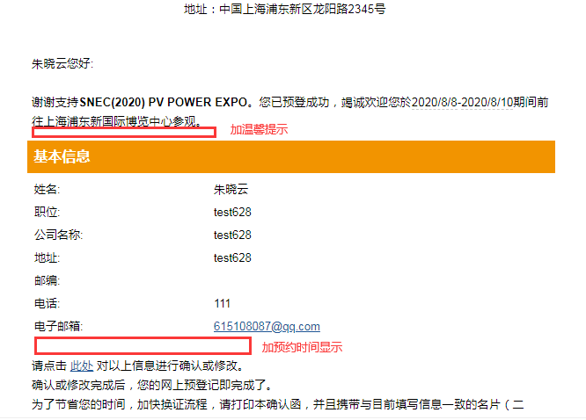

温馨提示：本届展会实行实名入场制度。所有进馆人员须同时满足四项条件：人证一致（人脸识别）、佩戴口罩、绿色“随申码”及体温正常。
All personnel entering exhibition hall must: present valid ID, wear a mask, show green Health QR Code, and take body temperature check. Overseas visitors must provide COVID-19 RNA Test Report (obtained when arrive in Shanghai) and Notice on Release from Medical Quarantine.

您所选的参观日期：XXXXXXX
Your visit date: XXXXX

- 手机版，验证选国家的时候，下拉框上移了
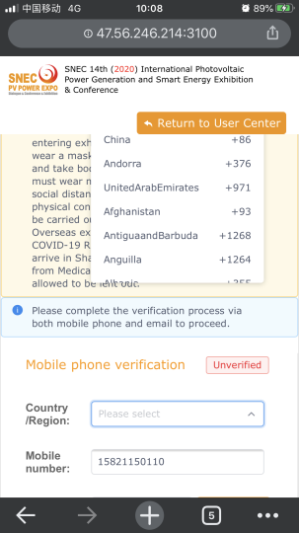

- 观众注册页，文字修改：
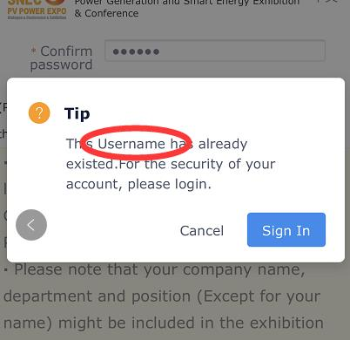
（1）邮箱如果已经注册，会弹出来这个对话框，要改成
This email has been registered, please login or try another.
（2）下面的按钮文字要改成Login

- 身份证注册删掉后还报已存在（华铮）
- 由于文字有修改，加了人脸识别的字，所以请在以下位置同步文字：
- “我的二维码”页面文字更新：仅中文（绿色随申码超链保留）
温馨提示：本届展会实行实名入场制度。所有进馆人员须同时满足四项条件：人证一致（人脸识别）、佩戴口罩、绿色“随申码”及体温正常。

（2 ）中文版三验证页面，中文上方提示里也在人证一致后面加上人脸识别
（3）英文版三验证页面，文字修改（绿色随申码超链保留）
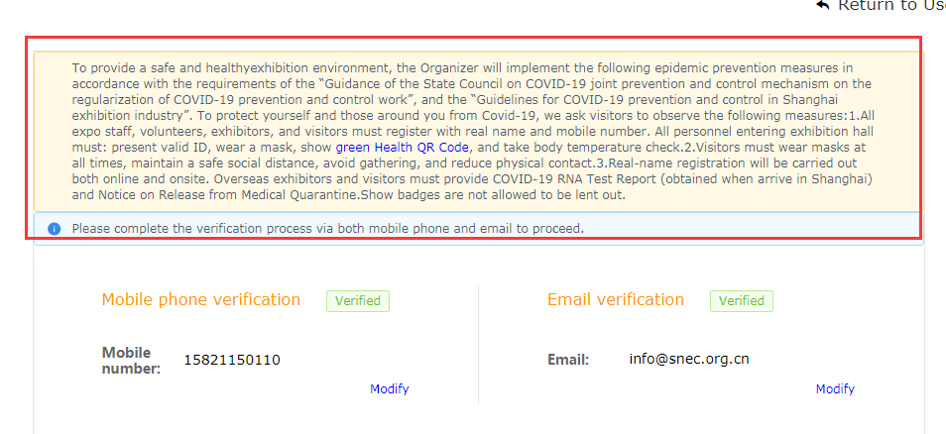
To provide a safe and healthy exhibition environment, the Organizer will implement the epidemic prevention measures in accordance with the requirements of the government. To protect yourself and those around you from Covid-19, we ask visitors to observe the following measures:1.All expo staff, volunteers, exhibitors, and visitors must register with real name and mobile number. All personnel entering exhibition hall must: present valid ID, wear a mask, show green Health QR Code, and take body temperature check.2.Visitors must wear masks at all times 3.Overseas exhibitors and visitors must provide COVID-19 RNA Test Report (obtained when arrive in Shanghai) and Notice on Release from Medical Quarantine.Show badges are not allowed to be lent out.

