Proposal of New energy value chains position presentation
Prepared by DNV GL

PROPOSAL
In recent years, the global energy structure has accelerated to low-carbon, carbon-free direction of evolution. The development of clean, low-emission new energy and renewable energy has become the global energy transformation trend, which has also become a hot spot for countries to create new economic growth points, seize the commanding heights of future development.
Some 3% of global energy consumption today is used to produce hydrogen. Only 0.002% of this hydrogen, about 1,000 tonnes per annum, is used as an energy carrier. Hydrogen can be an effective decarbonization agent if it is produced with a low carbon footprint. Such hydrogen can heat buildings, fuel transport, provide heat to industry, and be a medium to valorize surplus power from renewables. As DNV GL recently published 2018 Energy Transition Outlook indicates, with main motivation of decarbonization, hydrogen can become a major clean energy carrier in a world struggling to limit global warming. The paper also moderate uptake of hydrogen in this role towards 2050, then significant growth towards 2100.
Hydrogen energy connects different fields and sectors. DNV GL covers the entire hydrogen value chain and is involved in numerous hydrogen initiatives and maintains relations with key stakeholders, providing a thorough and integrated understanding of projects, assets, technologies and markets.

ABSTRACT

Scope and content
This paper reviews the global energy situation, analyzes the development of hydrogen energy in recent years, and combines global energy policies and regional development priorities to predict the future development direction and application fields of hydrogen energy.
Organizations
The presentation is organized as follows.
Section 1 provides audiences with an overview of possible hydrogen value chain constellations.
Section 2 describes the context for decarbonization through hydrogen and how hydrogen can contribute to decarbonization for the main application areas.
Section 3 states several approaches of the hydrogen applications as examples.
Section 4 estimates the demand for hydrogen as an energy carrier in 2030, and projects the possible total demand for hydrogen (as a feedstock and as an energy carrier) in 2050.
Key points

Hydrogen value chains introduction
Hydrogen can be produced in several ways, as shown in Figure 1. However, the primary driver for uptake of hydrogen as an energy carrier is decarbonization. This implies that emphasis will be placed on producing hydrogen in ways that allow hydrogen value chains to have a lower carbon footprint than alternative competing energy value chains, including alternative hydrogen value chains.

Hydrogen policies, decarbonization context and markets
This section draws on the 2014 Assessment Report by the Intergovernmental Panel on Climate Change (IPCC) on climate change mitigation in order to describe the scale of the decarbonization challenge for respective economic sectors.

Hydrogen applications
The main applications considered are: Hydrogen as fuel for mobility; Hydrogen for heating in buildings; Hydrogen for decarbonization of industrial processes; and hydrogen for valorization of excess electricity from variable renewable power.
- Uptake in 2030 and 2050
The estimated demand for hydrogen as an energy carrier in 2030 is summarized in Table 5.
Figure 3 shows the market share of the total H2 demand (94 Mt) in the respective industries.

Significance
This paper could provide a basic foresee of the future development trend for the hydrogen energy industry, at the same time, the assumptions brought up in the paper could be a reference for the further investigation in the hydrogen field.

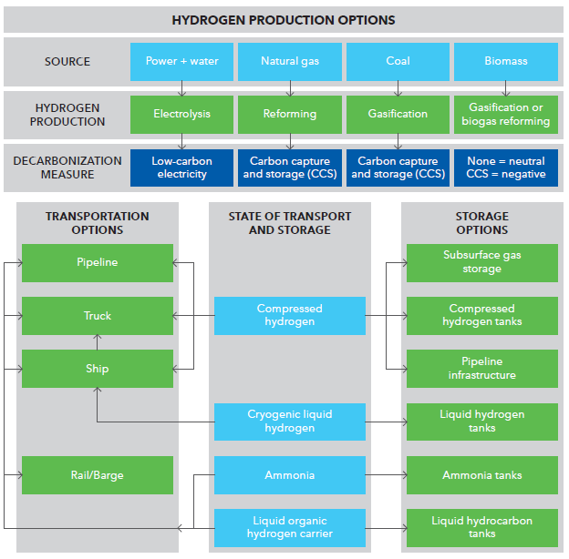
Figure 1: Overview of main options for production, transport and storage of hydrogen. Source: DNV GL

Table 1: Estimated demand for hydrogen in 2030
Application | Hydrogen demand (Mtpa)
Building heating | 3.6
Light vehicles | 0.3–0.8
Heavy vehicles | 0.0–0.1
Industry heat | 0
DRI steelmaking | 0.1
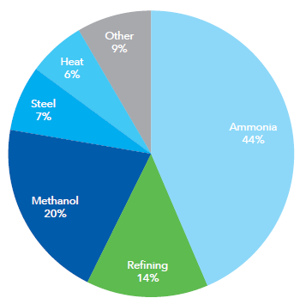
Figure 3: Market share of demand for hydrogen in 2050 for different industries. Source: DNV GL

BIOGRAPHY— (to be determined)

Noort, Albert van den

Senior consultant
Flow & Fuel Advisory

Groningen (NLGRQ) , Netherlands
Albert.vandenNoort@dnvgl.com

Albert van den Noort holds a Master of Science and PhD degree in respectively Chemical Engineering and Applied Physics. His PhD was an extension of his Masters work at the University of Twente, where he studied complex fluids by means of particle based simulation methods using statistical thermodynamics. He joined DNV GL in 2009, as a specialist and project manager. Since 2011 he has focused mainly on the topic 'Smart Energy Systems'. Albert coordinated the Smart Energy team of DNV GL in his role as Head of Section. Currently he works as senior consultant in the field of energy transition with a special focus on the role of hydrogen.

“2018 Energy Transition Outlook: A global and regional forecast to 2050.” DNV GL. 2018. https://eto.dnvgl.com/2018.
‘Climate change 2014: Mitigation of climate change. Contribution of working group III to the fifth assessment report of the Intergovernmental Panel on Climate Change’, IPCC (2014), Cambridge University Press, Cambridge, UK, and New York, NY, US. www.ipcc.ch/report/ar5/wg3

