Introduction
Hydrogen, owing to the advantages of its renewability and zero emission property, has gained sufficient attention as a source of eco-friendly energy. Storage technology is a key component to utilize the hydrogen as a fuel source in automatic and aerospace industries. The type IV storage vessel is a promising product because of its long service life and excellent barrier properties to hydrogen. However, its capacity to resist the internal pressure almost depends on the wound reinforced composites. Thus, the promotion of mechanical performance for composite overwrapping is considered as an economical choice as it allows the hydrogen storage at a high pressure.
Various experimental and numerical studies are conducted to explore the damage behavior of the type IV storage vessel under the bursting pressure. The results show the initial damage always happens at the cylinder section and dome section near the equator. Besides, a more flexible winding pattern for dome section is introduced by non-geodesic trajectories winding pattern which utilizes the friction between the fiber and workpiece surface to resist the slip line action. These previous findings indicate that the tensile failure of individual composite layer can occur simultaneously by through adjusting the cross-sectional shapes of the dome part, which thereby leads to a maximum pressure bearing capacity for hydrogen storage structures. This research will contribute to the low-cost and high-safety commercial application for hydrogen energy.
Numerical Method and results
The paper aims to explore the influence of cross-section shape of dome part on the bearing capacity of filament-wound type IV storage vessel. Firstly, the non-geodesic trajectories of winding angle are derived by the introduce of slippage coefficient, and the corresponding differential equation is solved by fourth order Runge-Kutta method. Thus, the various dome section for storage tank is established. Subsequently, a quarter of the cylinder is selected to establish the finite element model with T700 composite reinforcement, polyethylene liner and 6061-T6 metal boss using C3D8R solid element, as illustrated in Fig.1(a). The Hashin damage criteria and progressive damage model controlled by damage variable range from 0 to 1 is applied to describe the damage initiation and evolution, and the corresponding flow chart is showed in Fig. 1(b).
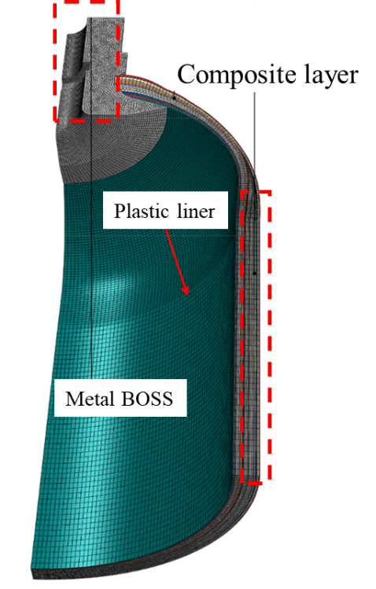
(a) mesh model (b) progressive damage process flow diagram
Fig.1 the Finite element model of storage vessel, (a) mesh model; (b) damage process flow diagram
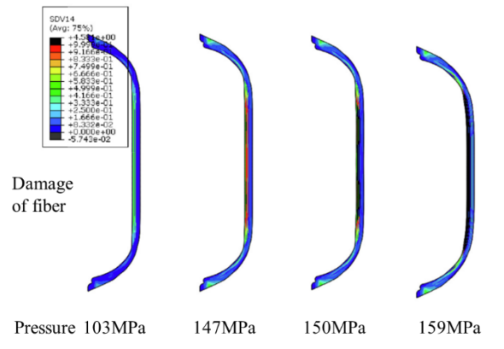
(a) the damage process for fiber (b) the burst pressure vs slip coefficient
Fig. 2 the numerical results of, (a) damage process for fiber; (b) burst pressure vs slip coefficient
The numerical results indicate that the damage of fiber appears in the cylinder section and large angle position in the dome section, and has a tendency of developing from inside to outside (Fig.2(a)). With the increasement of slippage coefficient, the spiral winding angle of the dome section is increased, leading to the enhancement of circumferential bearing capacity for composite layer (Fig.2(b)). Thus, under the allowable range for slippage coefficient, the storage vessel performs the excellent mechanical performance when the maximum value of 0.2 is selected.
摘要
塑料内胆纤维全缠绕(IV型)储氢气瓶具有轻量化、抗疲劳、抗腐蚀等优点，在汽车、航天储氢领域中极具应用前景。非测地线缠绕具有工艺稳定、设计灵活度高等特点，已成为IV型储氢气瓶纤维缠绕工艺的研究焦点。为了研究该缠绕工艺对IV型储氢气瓶承压性能的影响规律，本文引入滑移系数建立了稳定的非测地线缠绕轨迹微分方程，并利用仿真软件建立了IV型复合材料气瓶的有限元模型，模型采用Hashin准则和渐进失效理论描述碳纤维增强复合材料的损伤失效行为。仿真结果表明，模型可以预测复合材料的损伤演化过程。

