(ii) an extended abstract (up to 2 pages, including figures and tables) by Dec. 20, 2019
Applying for ITO deposition on a-Si:H passivating layer
using four targets facing sputtering cathode and its effect
Hiroshi Iwata
Head of R&D, Director
Keihin Ramtech Co., Ltd.
- Background
We developed low damage sputtering cathode (called RAM Cathode) using four targets facing sputtering technology. We applied for HIT-PV which had high transmittance very thin a-Si:H passivation layer to increase its efficiency. Because, the thin passivation is easy to break by sputtering damage[1]. The advanced properties of RAM Cathode are shown in this abstract.

- Experimental
iVoc and Carrier Lifetime are measured by test pieces shown by Fig1. RAM Cathode and Rotary Cathode were used for ITO sputtering deposition on a-Si:H(i) passivating layer. The schematics of these sputtering concept are shown by Fig2.
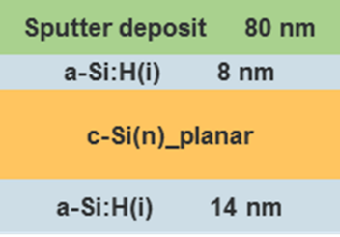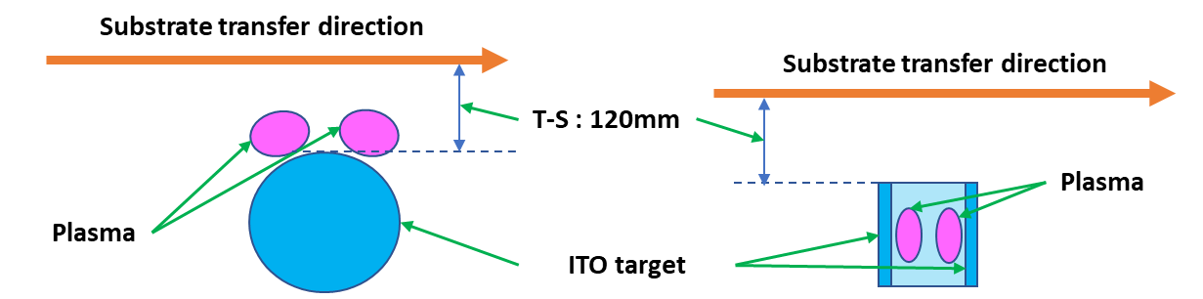
Fig1. Test piece stacking (a) Rotary Cathode (b) RAM Cathode
Fig2. Schematics of the sputtering concept
- Results
The results are shown by Fig3 and 4, Table1 to 3. These say that RAM Cathode has a potential for increasing efficiency of HIT-PV.
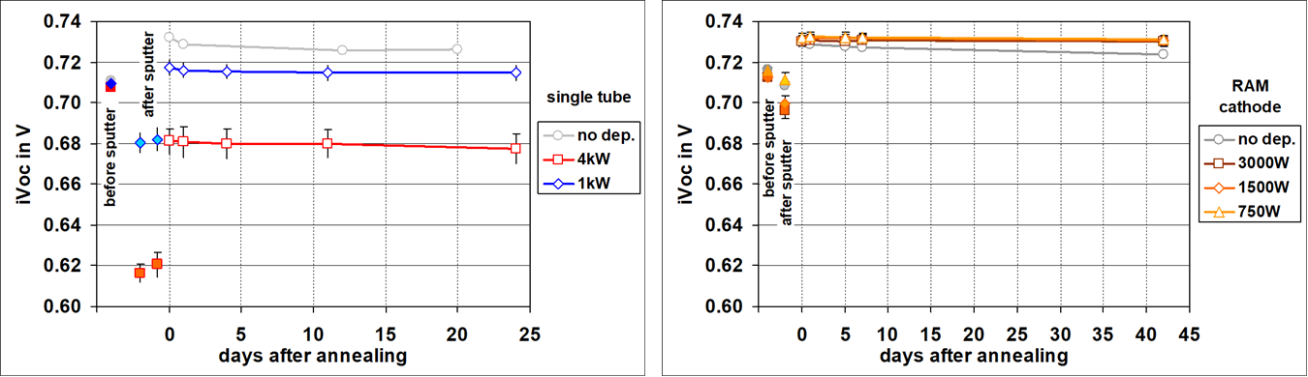
(a) Rotary Cathode (b) RAM Cathode
Fig3. Results of iVoc measurement [2]

Table1. The comparison of iVoc between Rotary Cathode and RAM Cathode
iVoc | Rotary | RAM | Without ITO
Before deposition | 710mV | 715mV | 715mV
After deposition  / Before annealing | 680mV | 700mV | ---
After annealing | 718mV | 732mV | 730mV
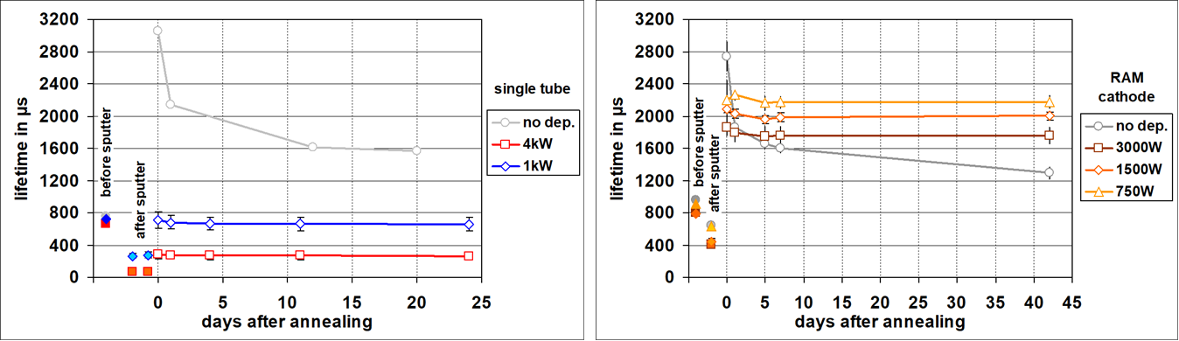
(a) Rotary Cathode (b) RAM Cathode
Fig4. Results of Carrier Lifetime measurement [2]

Table2. The comparison of Carrier Lifetime between Rotary Cathode and RAM Cathode
Carrier Lifetime | Rotary | RAM | Without ITO
Before deposition | 760µs | 800µs | 900µs
After deposition  / Before annealing | 300µs | 440µs | ---
After annealing | 750µs | 2080µs | 2800µs

Table3. The comparison of Electrical properties between Rotary Cathode and RAM Cathode
(as deposition)
Electrical Properties | Rotary | RAM
Resistivity | 7.75µΩm | 5.35µΩm
Hall Mobility | 18.6cm²･V⁻¹･s⁻¹ | 38.6 cm²･V⁻¹･s⁻¹
Carrier Density | 4.33×10²⁰ | 3.03×10²⁰

- Summary
It is thought that following results using RAM Cathode has a enough potential to increase the efficiency of HIT-PV.
- Higher iVoc : before ITO deposition 715mV after annealing 732mV
- Longer Carrier Lifetime : before ITO deposition 760µs after annealing 750µs
- Higher Hall Mobility : 38.6cm²･V⁻¹･s⁻¹ (as deposition)

- References
[1] S. D. Wolf, B. Demaurex, et. al., Phys. Rev. B 83, 23 (2011).
[2] V. Linss, M. Bivour, H. Iwata, et. al., SiliconPV 2019

- Acknowledgement
We wish to thank to Dr. Jun-ichi Nomoto with The National Institute of Advanced Industrial Science and Technology of Japan for electrical and XRD measurement.

