Media Energy Displays Based on Thin Film Solar Modules for BIPV and Power Plants

Volker Probst
SolCIS, Krampnitzer Weg 26H, 14089 Berlin, Germany

A new type of PV product is introduced: the Media Energy Display. The basic element is a slightly modified standard thin film solar module with an integrated display function. The thin film cell material can be any kind including CIGS, CdTe , Perovskite and thin film silicon.
The main modification is patterning a grid of optical apertures into the thin film cell stack. A custom designed LED array is mounted at the backside of the finalized module in that way that the LED’s are adjusted towards the aperture grid, see Fig.1

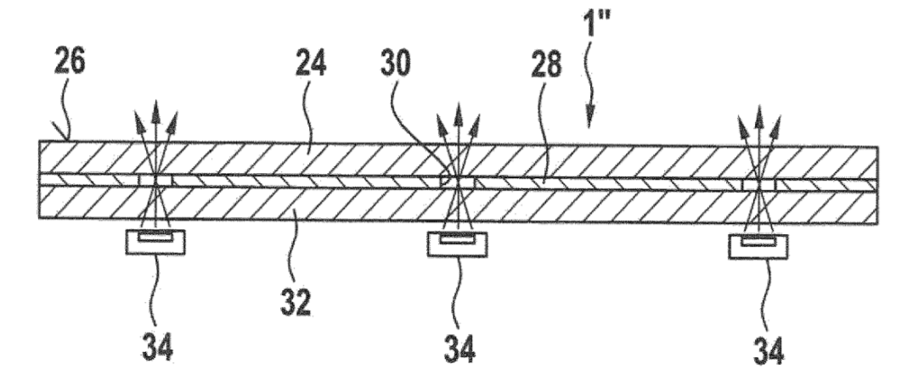

Fig. 1: Schematic cross section of the Media Energy Display :
24 - solar module glass-glass laminate
26 – display side of the unit
28 – opaque PV cell stack
30 – aperture
34 illuminant, e.g. RGB-LED

The light of the LEDs is emitted through the apertures of the thin film solar module and is clearly visible from the viewers side (26). An assembly of numerous of those basic module elements yields a large area high resolution display in combination with the generation of solar electricity -the Media Energy Display (MED).

This application is very beneficial for large area applications like BIPV or solar power plants. Here the loss in active PV display area resp. photovoltaic yield through aperture grids is only 2% to 5% even for high resolution display layouts. A schematic example is given in Fig.2

Fig. 2: Schematic top view section of a MED from the viewers side:
The blue squares show the apertures in the black solar cell layer with RGB-LEDs behind sending homogenously blue light in this case

In this example the aperture grid distance of 25mm in x- and y- direction is assumed with an aperture size of 4mm x 4mm which is suitable for the application of powerful RGB-LEDs. The loss in active photovoltaic area is less than 3%. With a total MED size of 9.0m x 15.6m and a thin film solar module size of 0.6m x 1.2m an array of 195 modules is applied. The recommended minimum viewing distance of such large displays would be 25m. A resolution of 360 x 640 RGB-pixels is obtained in this case, which is similar to the resolution of common smart phone displays.
Due to the strong light emission from LEDs even daylight use of the MEDs for advertising is possible. The architectural design of such a MED-façade is perfect, because all technical features of the display are not visible from the viewers side.
The display unit can be triggered such that media, advertising or information appear in the foreground as static or moving images. When the display function is switched off, only the architecture of the building appears in the foreground – e.g. in the appearance of a premium opaque glass facade. The MED can also be used as a design element of the building – it can change the architectural appearance of the buildings in many ways depending on the displayed graphics, figures or shapes which is very attractive for representative urban locations.
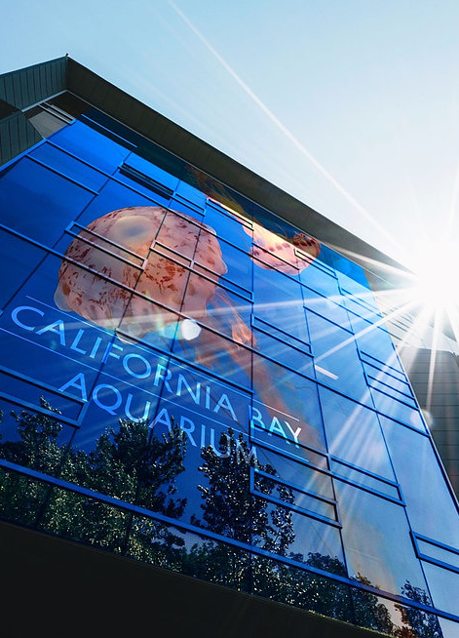

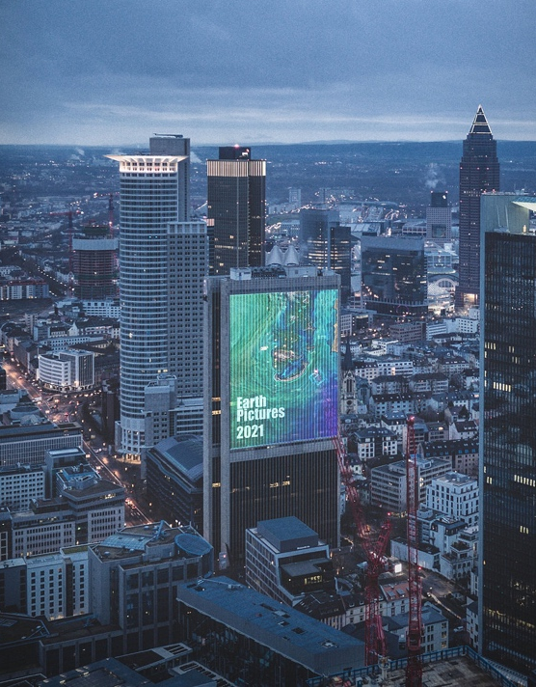

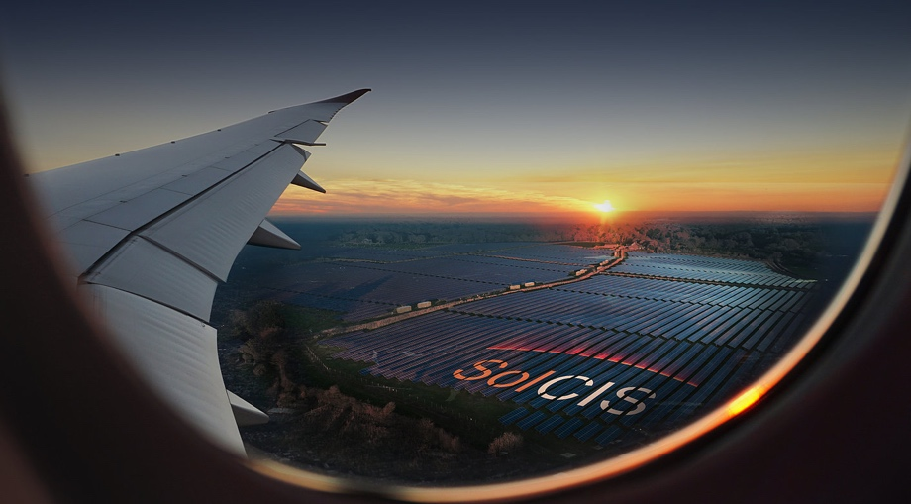

Fig.3 Examples for Media Energy Displays applied to BIPV

Fig.4 Example of a Media Energy Display applied to a large scale Power Plant.

Another application could be on Solar Power Plants, where a small part of the area, e.g. 25mx50m in size would be provided by MEDs in order to present the company logo of the manufacturer or operator into the sky or to expose any other advertising messages. This would for example be attractive on solar park sites close to main airway routes or airports.

The paper will describe the main technology and Balance of Energy of MEDs, it will show prototypes and give nice examples for future MED applications on facades and powerplants.

