Magnetron Sputtering Equipment with 10,000 wph Throughput enabling Cost-Competitive Mass Production of Next Generation Solar Technology
Sibo Chen, Zhenhao Zhang and Sebastian Gatz

Abstract
Given the continuously outbreak of the COVID-19 pandemic and the international trade friction the world economy is on course to plunge into its worst recession since the Second World War. The Chinese photovoltaic (PV) market, which takes the lion’s share of the global manufacturing had an export ratio over two third in 2020, is currently under a huge price pressure. However, the new carbon neutrality pledge from China’s 14th Five-Year Plan also spurring on further growth in wind and solar power with a higher target for the proportion of renewables in the energy mix. Driven both by economic competition and political guidance, new technologies such as heterojunction solar cells (HJT) and TOPCon with higher conversion efficiencies and lower levelized cost of electricity (LCoE) are meeting unprecedented opportunities.
In this contribution the new platform XEA|nova® L with a leading high throughput over 10,000 wph (Wafers per Hour) for PVD processes. The bifacial deposition of TCO (Transparent Conductive Oxide) materials in mass production of HJT solar cells is introduced. The impact of the scaling effect on the reduction of CapEx (Capital Expenditure) and TCoO (Total Cost of Ownership) of this process step is thoroughly analyzed. Measures and concepts proven in running production, for instance a fast but extremely low-damage coating process with application of house-made strong magnet bars with well controlled magnetic field distribution, the precise temperature control with high homogeneity, good process flexibility enabled by the plug-in design of the cathode units etc., are demonstrated in more detail. This paper will also discuss a straightforward PVD processing on the XEA|nova® L platform enabling very cost-effective passivated contacts in high volume production. The process sequence and its specifics is discussed more in detail in the paper. This paper reveals also that the XEA|nova® L platform is ready to support Cu-plating technology to pave the way for the development of silver-free HJT mass production.

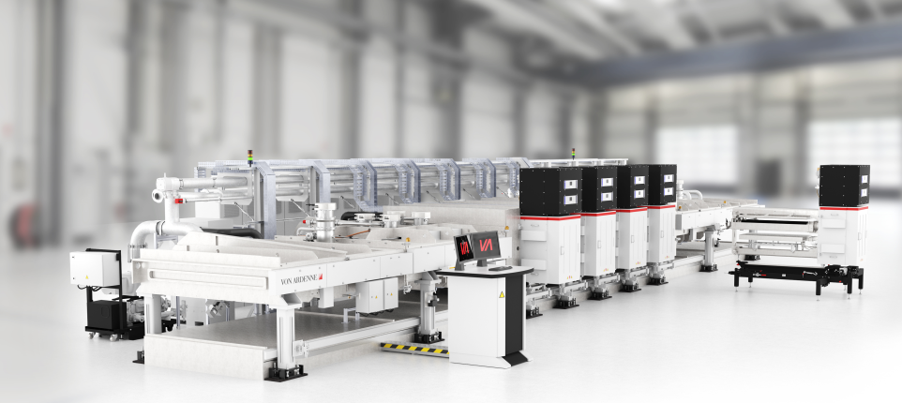
XEA│nova® L
Fig. 1: XEA│nova® L with a high throughput of 10,000 wph and very compact footprint

