Advanatges of Solder Paste in Shingling Interconnection
Abstract/Introduction
Shingling interconnection is beginning to make its impact in solar module manufacturing. The is because it allows an increase of module output power without introducing substantial modification in the cell, fabrication process and in the module bill of materials (BOM). The interconnection of the shingle pieces to a shingled string, so called supercell, is mostly realized by ECA (electrically conductive adhesive) gluing [1]. However, long term outdoor performance data proving their stability against environmental influences is not yet available. ECA joints can be easily attacked by moisture [2]. Their electrical performance during life has produced mixed results and many reports show that the joint may not pass harsh test conditions like 2000 hour damp heat as per IEC61215 [3]. Further, cost of ECA is another limiting factor in price sensitive PV market.
Solder paste, on the other hand, is composed of solder alloy particles dispersed in flux which primarily contains resin/rosin binder and activator package. Role of flux is to clean oxides from the solder metals and conductive pads being connected. Solder paste is proven material in semiconductor and assembly solutions [3]. Solder paste can alleviate some of the shortcomings of ECA and offer advantages such as: 1. Formation of reliable joints 2. Can be dispensed or printed 3. Stable viscosity and higher shelf life compared to ECA 4. Fraction of cost to that of ECA 5. Low voiding 6. Better thermal and electrical conductivity compared to ECA and 7. Resistant to moisture.
In this work, we investigated application of lead free, low temperature solder pastes in shingle cell interconnection. The aim is to identify solder paste as joining material and evaluate its bond strength and reliability by doing accelerated aging tests. We also aim to study the role of the solder paste on the electrical and mechanical properties of shingled modules and compare it with ECA. In particular, solder pastes based on different alloy platforms are presented with the aim to evaluate fast reflowing and snap curing properties of solder pasts for making it suitable for existing automated shingling machines or modified tabbing machines.

Approach
Two types of lead free solder pasts were used in this study. They are based on eutectic and non eutectic tin-bismuth pastes namely, OM535® and OM550® from MacdermidAlpha respectively (Table 1).
TABLE I. Solder paste properties.
Solder Paste | Alloy | Powder type | Liquidus  ºC | Yield Strength  MPa | Reflow Temp  ºC
OM535 | SbXO2 (Eutectic) | T4 | 138 | 60.1 | 165
OM550 | HRL1 (non eutectic) | T4 | 152 | 37.5 | 185
Typically, paste is printed on silver busbar on the front side of the cell and rear side of the other cell is placed over it. Five cell shingling was assembled and fast reflowed using 7 zone reflow oven (Heller). Based on melting temperature of the alloy, peak temperature for reflow was chosen and cells were exposed for 20 sec at peak temperature. After the assembly, bus ribbons were soldered, and lamination was done at 140ºC using ethyl vinyl acetate (EVA) as lamination material and polyester white back sheet. Sinton I-V curve tester was used to evaluate electrical performance of the minimodules. As a part of study, printing evaluation and transfer efficiency, profile optimization, X-ray analysis for voiding and FESEM (field emission scanning electron microscopy) was performed. Panels were also analyzed for contact resistivity and Electroluminescence (EL) test. Finally, damp heat and thermal cycling test conducted as per IEC61215. Similar tests were conducted on ECA which was based on acrylate based chemistry.

Results and Discussion
Both, ALPHA® OM535 and ALPHA® OM550 HRL1 have a melting point significantly lower than standard SAC305 (tin-silver-copper) alloy. A peak temperature of only 165 and 185°C respectively is also equivalent to most ECA curing temperature. This reduces energy consumption in the PV application process and stress build up on the cells. Pastes are lead free which mean no environment hazard and can be snap cured like ECAs. These two alloys are specifically designed to improve reliability of the solder joint.
As a first part, 3 mil stencil was fabricated for the experiments. This is through cut stencil made up with stainless steel. DEK03Xi printing machine was used to do automated printing. Just enough paste was printed on the busbar to avoid any cracking during shingling assembly. This amount was optimized by printing paste pads from 300 to 900 microns on the 1 mm wide busbars. We found optimized height to be 65 micron which reduces down to around 55 micron after fast reflow. Paste spreads completely to fill the width of the busbar (Fig. 1). The pad filling is not possible with ECA as it does not coalesce like solder paste.
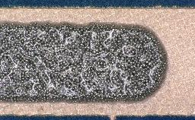 | 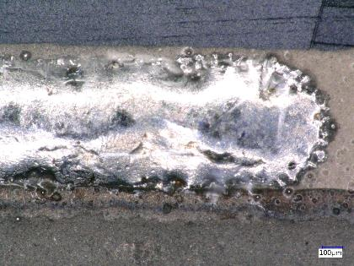
FIG 1. (left) As printed solder paste | (right) After fast reflow
Solder paste has excellent stability and metal content remain almost unchanged even after 12 h of continuous printing. The binder and solvent system are formulated in such a way that, viscosity buildup is restricted and paste can be printed for hours without cleaning the stencil. In addition, the high print definition and speed works in favor of paste. Generally, ECAs do not have stencil/screen life more than 4 hours. After that, the viscosity of ECA increases rapidly and often insufficient transfer and screen pore clogging is observed. Material waste is also a big problem with ECA. ECA additionally need higher pressure to print and through cut stencils do not work with ECA. Shear strength of the solder joint was found to be over 5Kg with proper cohesive failure of joints. This indicates the bond formation with both solder pastes is in acceptable range. Fast reflow profile was optimized using heller reflow oven. Pastes can be also be snap cured using IR (infra red) for 10 sec.
Five cell shingled assembly could be easily fabricated in standard oven or tabbing machine having IR source. Microscopic analysis revealed complete wetting, continuous IMC (intermetallic compounds) formation and no microcracking. The wetting angle found to be 13º. No silver leaching observed. The quality of the joints was also analyzed by X-ray. This determines voiding in the joints. As can be seen in below Fig.2, the solder paste spread well over the bus bar and no solder balls observed.
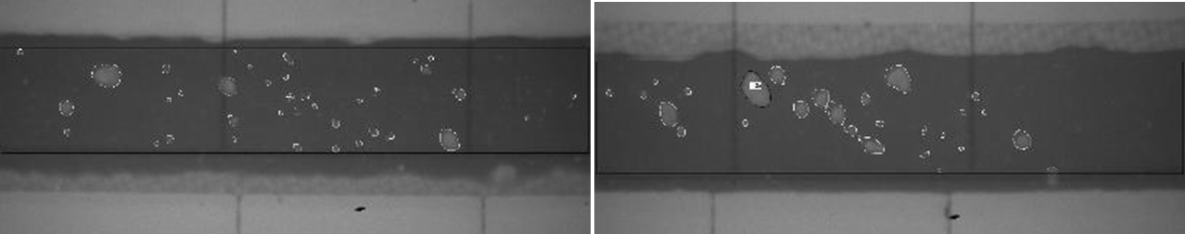
FIG. 2. X-ray analysis for void. 5.9 % with OM535 (left) and 4.2 % voiding with OM550 (right)
The voiding is less than 10 % which mean there is good thermal contact between the joining surfaces. A large number of voids reduce the solder joint reliability. Voids also reduce the thermal conductivity of the solder joints, can cause solder bridges and solder transfer between neighboring solder joints during the reflow soldering process. In small solder joints, voids can significantly reduce their current carrying capacity.
Minipanels were exposed to climatic testing, conforming to IEC 61215, at 2000 h of Damp Heat (DH) and 200 temperature cycles (200 TC). Power measurements and electroluminescence imaging (EL) were performed before and after the tests. No degradation in module performance or other functional properties was noted (Fig. 3). EL analysis also shows no evidence of cracking or other defects. The maximum power loss permissible according to IEC 61215 is ±5% after the test. None of the samples reached this value. The maximum change in P_{max} was less than 3 % for OM535 in both damp heat and thermal cycling test. For OM550, all factors including P_{max} were less than 1.5%. These results demonstrate that both OM535 and OM550 pastes are resistant to oxidation and are resistant to changing weathering conditions. These results further confirm that the lead free and low temperature alloy-pastes can be used for shingling application. Pastes can withstand the expansion and compression forces produced during thermal cycling.

FIG.3 Damp heat and thermal cycling results of OM535 and SP55 assembled shingled cell assembly. D: 2000 h damp heat test and T: 200 cycles thermal cycling test

Conclusion
We report new low temperature lead free solder pastes for shingling interconnection. Two tin-bismuth based solder pastes with one eutectic and other non eutectic alloy evaluated in the study. We found an acceptable wettability and printability of two pastes. These pastes show excellent stability, longer stencil life and consistent transfer efficiency (>90 %). Solder joints were strong with die shear value more than 5Kg, and voiding was less than 10 %, indicating bonds have better contacts and complete wetting has happened. Both pastes could be fast reflowed and laminated with EVA. The modules assembled using these pastes pass thermal-cycling and damp heat reliability testing according to IEC 61215. Based on these results we conclude that the new lead-free low temperature solder pastes can be used to make shingling and other advanced interconnection assemblies.
Reference
[1] M. Estruga, L. Theunissen, A. Ardizzone, B. Willems, and A. Henckens, “Electrical conductive adhesives for cell interconnection in shingled module technology: the impact of material properties on mini-module performance”, Proceedings of the 35th European Photovoltaic Solar Energy Conference and Exhibition, Brussels, Belgium, 2018, pp. 67–70.
[2] I. Ullmann, D. Rudolph, J. Rabanal-Arabach, A. Schneider, and A. Halm, “Investigation on the Quality of Adhesive Joints of Shingled Solar Cells by Accelerated Lifetime Testing”, Proceedings of the 35th European Photovoltaic Solar Energy Conference and Exhibition, Brussels, Belgium, 2018, pp. 1210–1213.
[3] J S. Hwang, “Solder Paste in Electronics Packaging: Technology and Applications in Surface Mount, Hybrid Circuits, and Component Assembly” (Springer Science & Business Media, 2012).

