智慧供应链-光伏支架产融结合之桥
Smart Supply Chain – the Bridge between Industry and Finance
【摘要】Abstract

智慧供应链体系架构：The architecture of smart supply chain.
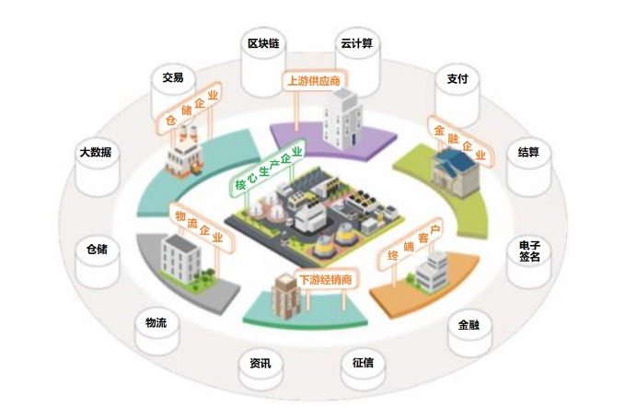
智慧供应链在传统光伏支架领域的应用分为三个步骤。The application of smart supply chain in the field of photovoltaic supports is divided into 3 steps.
首先，在现有产品的基础上，进行参数化产品创新，建立更全面的产品体系；
The 1st step, based on the current products, implement the parametric product innovation and build up more comprehensive product architecture.
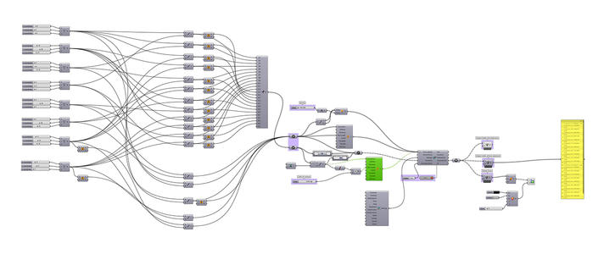
其次，融合大数据和互联网技术，实现供应链的智能化、网络化和自动化，形成技术与管理综合集成系统；
The 2nd step, integrate the big data and internet technology, make the supply chain intelligent, networking and automatical.
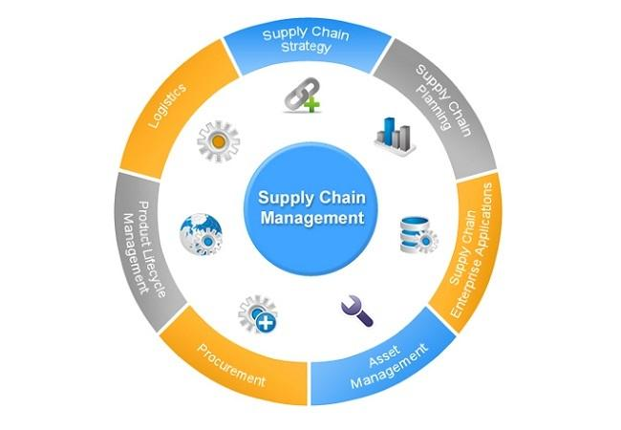

最后，聚焦跨境金融、钢材期货等创新趋势和客户化项目需求，定制最贴合行业特征的综合金融解决方案。
Finally, with the trend of cross border finance and steel futures, focus on the customization requirement, design a comprehensive supply chain financial solutions which well fit the industry characteristics.
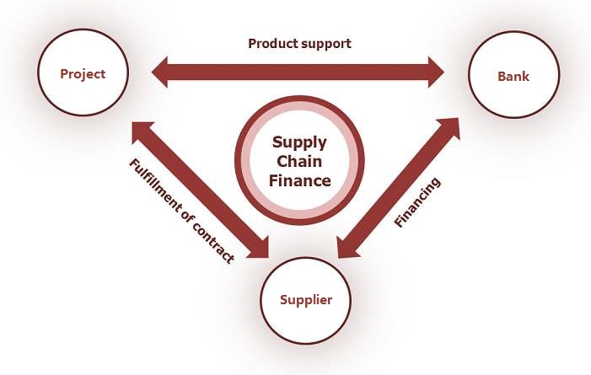
应用智慧供应链，有望大幅度缩减光伏支架供货周期、降低供货价格、规避钢材价格波动的不利影响，保持光伏发电项目开发建设全过程有序、可控。
As a result, the application of smart supply chain shorts the lead time, reduces the price and avoids the adverse impact of steel market price fluctuation. So that the overall process of the PV project could be orderly controlled.

