光伏支架参数化设计系统
PV Supports Parametric Design System
【摘要】Abstract

用传统方法开发光伏支架时，要在装配验证、性能分析和数控编程之后才能确定零件形状和尺寸。这就希望零件模型具有易于修改的柔性。With traditional method, the detail design of PV supports has to be determined after the assembly verification, performance analysis and NC programming. The flexibility of part models are required for easy modification.
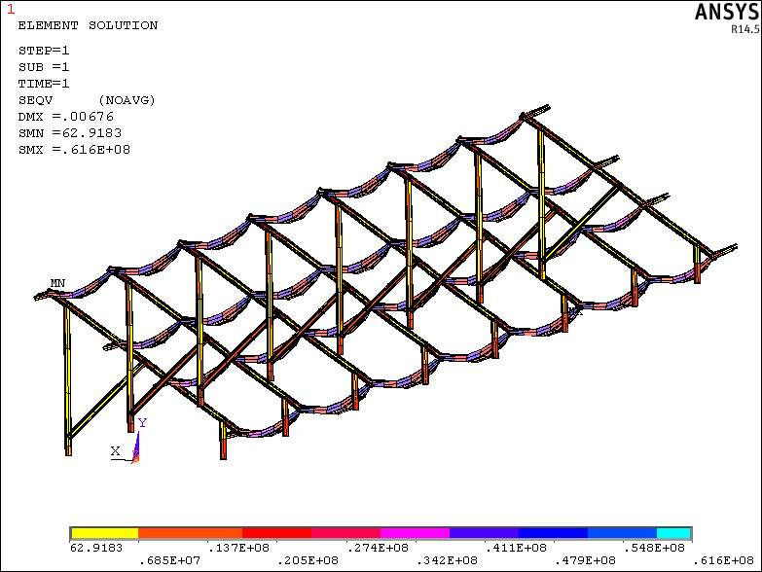
参数化设计方法将模型中的定量信息变量化，使之成为任意调整的参数；The method of parametric design defines the quantitative information as variable information for easy modification;
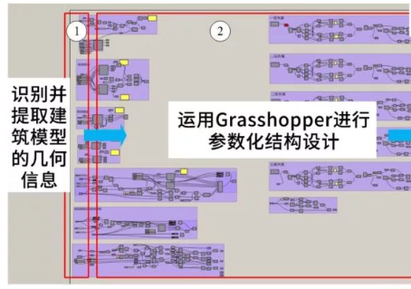
对于变量化参数赋予不同数值，得到不同大小和形状的零件模型；Assign different parameter to the variable information for different part model with different sizes and shapes;
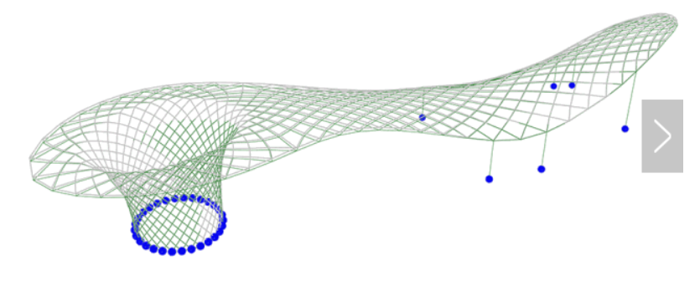
当光伏支架设计或文档部分作改动后，都可以自动的在其它相关联的部分反映出来；Modification in one part or document could be automatically connected to other relatives;
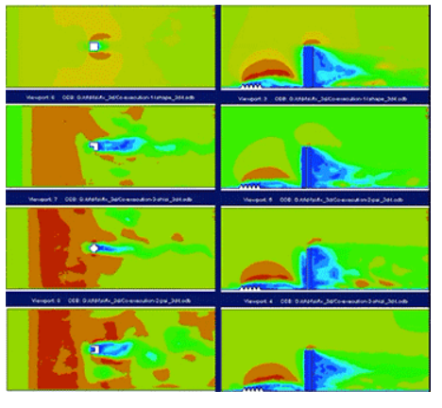
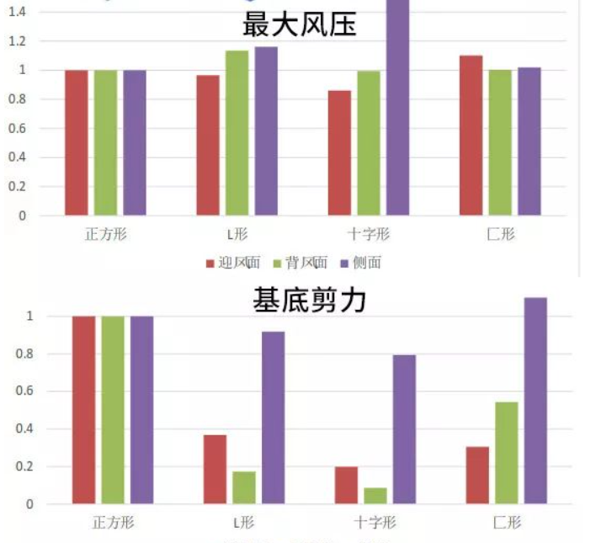
任一视图下所发生的变更都能参数化的、双向的传播到所有视图，以保证所有图纸的一致性，毋须逐一对所有视图进行修改。从而提高了工作效率和工作质量。Any change in any engineering view could be transferred to all views with parameterized and bidirectional way. This method keeps the consistency in all drawings without further modification and/or verification. The efficiency and quality are greatly improved.

