上海光伏展SNEC2020研讨会演讲1

演讲题目（中文）：新型材料助力组件边框与跟踪支架一体化设计
演讲题目（英文）：PV Module Frame and Tracker Integrated Design Powered by New Material

摘要（中文，描述论文性质、范围、内容、结构、重点以及意义）：
组件边框和光伏跟踪支架，是光伏系统组成中造价不降反升的大宗物料，已经成为进一步降低度电成本的主要障碍。应用新型镀铝镁锌钢板材料，是系统集成端降低成本的技术研究与产品开发方向之一。本文介绍了新型镀铝镁锌钢板的防腐机理和机械特性，以及该材料在组件边框以钢代铝、组件边框与跟踪支架支撑件一体化方面的标准适应性和经济技术可行性。最后，以实际应用案例为基础，计算了应用新型材料对于降低EPC造价和度电成本的实施效果。

摘要（英文）：
The module frame and tracker has become major obstacle of cost reduction in the PV system level due to its price increasing, rather than other price dropping materials. The application of Zinc Aluminum Magnesium alloy Coating Steel plate is an important way of cost reduction in the system level. This paper introduces the anticorrosion mechanism and mechanical properties. Also, PV module frame design with steel instead of aluminum, the PV module frame and tracker integrated design is also introduced. After discussion of the standards adaptability and economic and technical feasibility, this paper calculates the cost reduction level of EPC cost and LCOE.

摘要作者：韩利生^{1，2}，王云阁¹，宋志岗¹，梅淑文¹，陈铁军²，弓俊杰¹
作者公司：¹河钢集团光伏应用技术中心，²科海精工机电有限公司
议题范畴：光伏系统和智能并网技术
其他，（请详述）：系统设计和集成

演讲人信息：河钢集团光伏应用技术中心，首席工程师
Chief Engineer, PV Application Technical Center, HBIS GROUP.
演讲人简介（中文）：
科海精工机电有限公司创始人，河钢集团光伏应用技术中心首席工程师。中国科学技术大学博士生，光伏系统集成专家、丰田精益生产方式推广专家、摩托罗拉六西格玛黑带资格。曾主持开发建设全球最大高倍聚光光伏发电项目（位于中国青海省格尔木地区，装机容量153MW），作为主要项目成员完成两项863课题，37项专利发明人。
演讲人简介（英文）:
Founder of KEHI M&E, chief engineer of PV Application Technical Center of HBIS GROUP. A Ph.D. candidate. Expert of PV system integration, Toyota lean production and Motorola 6-sigma black belt. Dr. Han had led the development and construction of the world biggest HCPV project (153MW, in Golmud Qinghai China). A key member of two National High-tech R&D Program (863 Program), inventor of 37 national patents.

联系人：韩利生
职务：总经理
公司：科海精工机电有限公司
邮箱：rickhan@mail.ustc.edu.cn
电话：008613501667538

长摘要见下页。

新型材料助力组件边框与跟踪支架一体化设计
PV Module Frame and Tracker Integrated Design Powered by New Material
【摘要】Abstract
组件边框和光伏跟踪支架，是光伏系统组成中造价不降反升的大宗物料，已经成为进一步降低度电成本的主要障碍。
The module frame and tracker has become major obstacle of cost reduction in the PV system level due to its price increasing, rather than other price dropping materials.

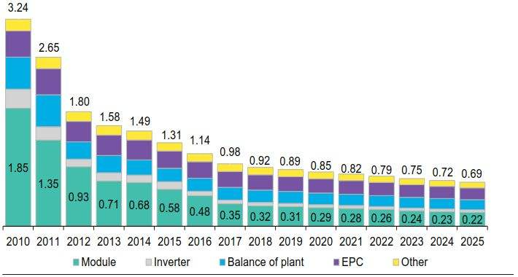

应用新型镀铝镁锌钢板材料，是系统集成端降低成本的技术研究与产品开发方向之一。
The application of Zinc Aluminum Magnesium alloy Coating Steel plate is an important way of cost reduction in the system level.
本文介绍了新型镀铝镁锌钢板的防腐机理和机械特性。
This paper introduces the anticorrosion mechanism and mechanical properties.
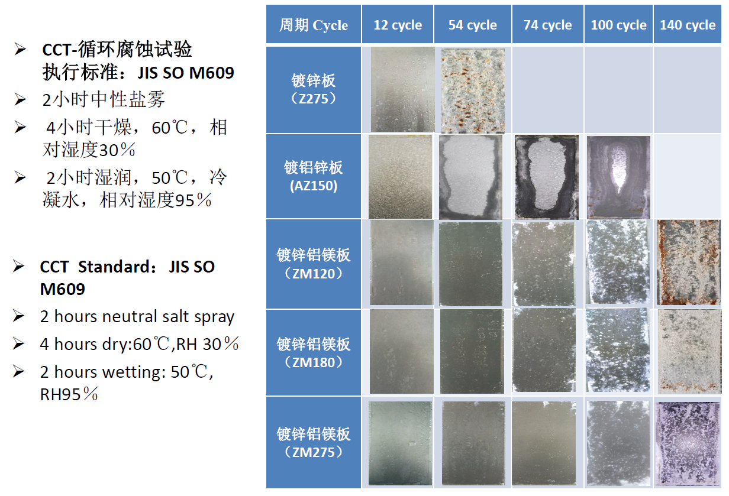
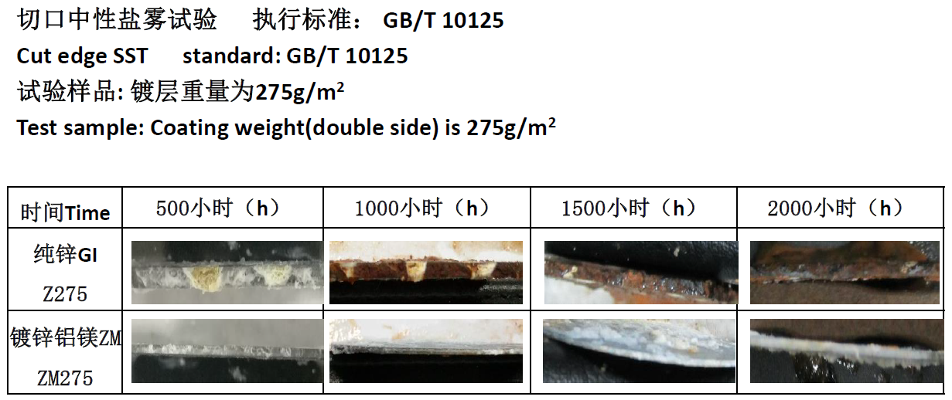
以及该材料在组件边框铝代钢、边框与跟踪支架支撑件一体化方面的标准适应性和经济技术可行性。
Also, module frame design with steel instead of AL, module frame and tracker integrated design is introduced.
组件边框3D建模、刚度分析、强度分析PV Module 3D modeling, stiffness analysis and strength analysis.
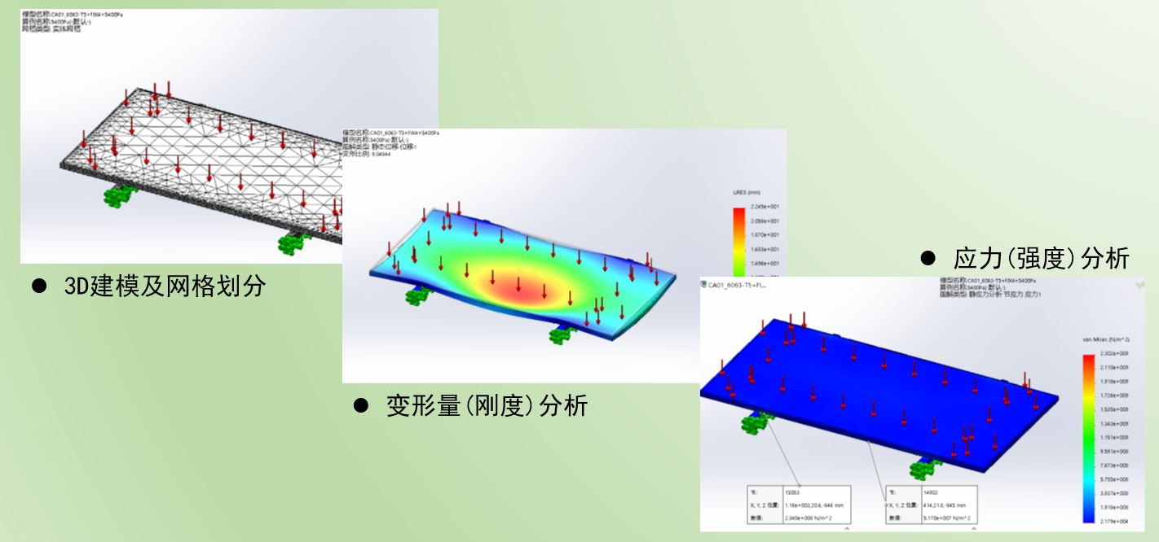
最后，以实际应用案例为基础，计算了应用新型材料对于降低EPC造价和度电成本的实施效果。
After discussion of the standards adaptability and economic and technical feasibility, this paper calculates the cost reduction level of EPC cost and LCOE.

