新型材料助力组件边框与跟踪支架一体化设计
PV Module Frame and Tracker Integrated Design Powered by New Material
【摘要】Abstract
组件边框和光伏跟踪支架，是光伏系统组成中造价不降反升的大宗物料，已经成为进一步降低度电成本的主要障碍。
The module frame and tracker has become major obstacle of cost reduction in the PV system level due to its price increasing, rather than other price dropping materials.

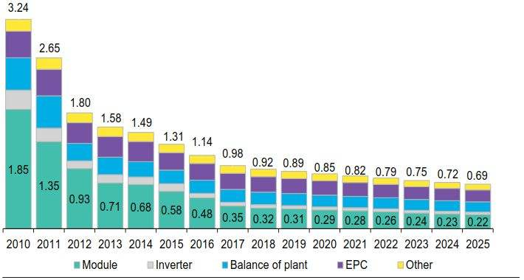

应用新型镀铝镁锌钢板材料，是系统集成端降低成本的技术研究与产品开发方向之一。
The application of Zinc Aluminum Magnesium alloy Coating Steel plate is an important way of cost reduction in the system level.
本文介绍了新型镀铝镁锌钢板的防腐机理和机械特性。
This paper introduces the anticorrosion mechanism and mechanical properties.
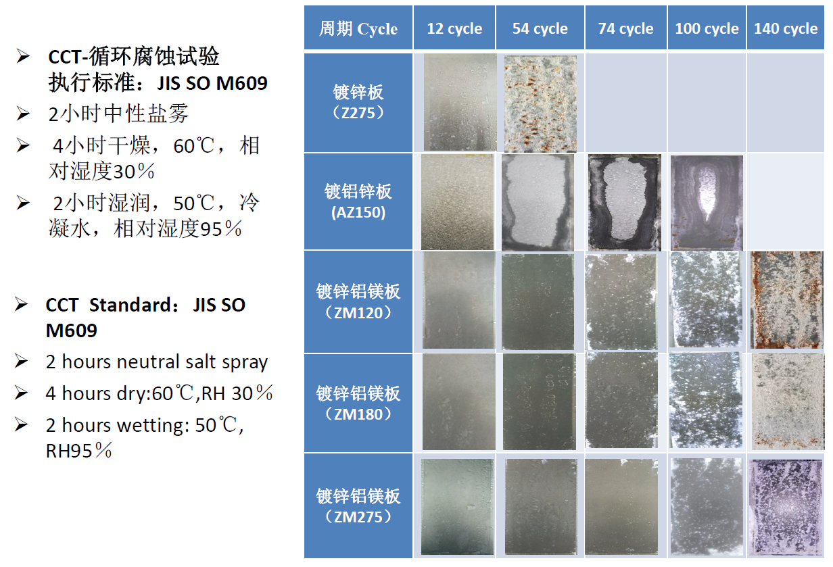
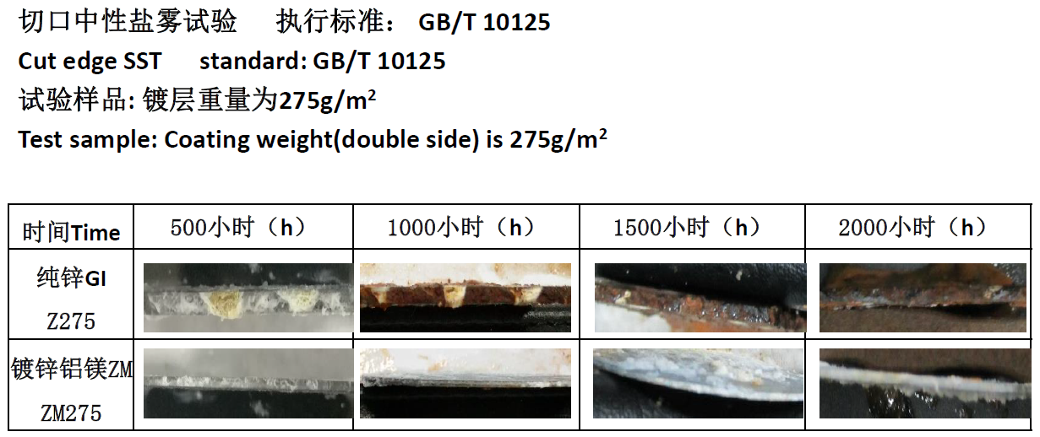
以及该材料在组件边框铝代钢、边框与跟踪支架支撑件一体化方面的标准适应性和经济技术可行性。
Also, module frame design with steel instead of AL, module frame and tracker integrated design is introduced.
组件边框3D建模、刚度分析、强度分析PV Module 3D modeling, stiffness analysis and strength analysis.
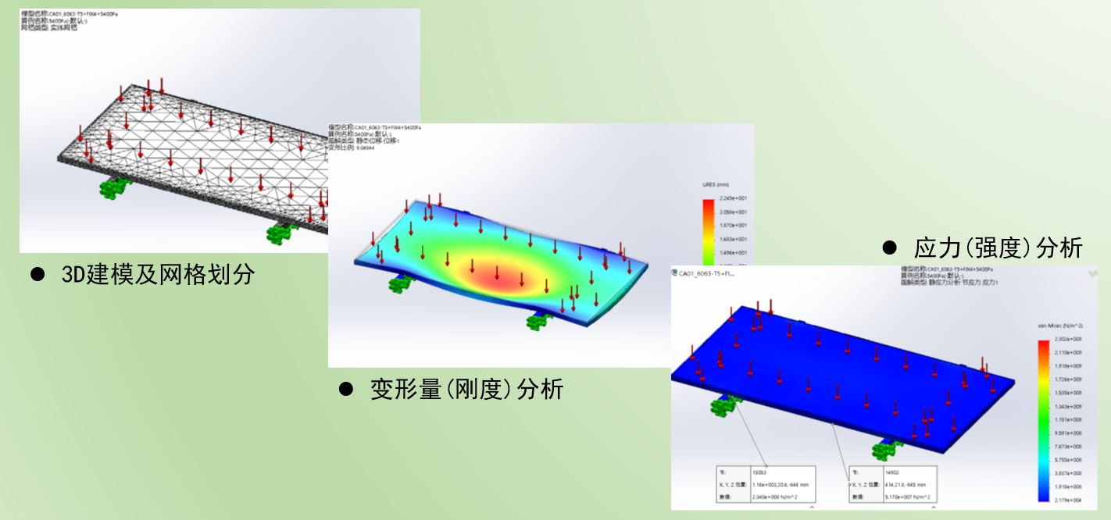
最后，以实际应用案例为基础，计算了应用新型材料对于降低EPC造价和度电成本的实施效果。
After discussion of the standards adaptability and economic and technical feasibility, this paper calculates the cost reduction level of EPC cost and LCOE.

