【SNEC2020】国际太阳能光伏与智慧能源大会申请资料

- 演讲题目:
多点驱动的应用及比较 Application and comparison of multipoint drive
- 演讲人简介（100字左右）及照片
姓名：李阳林 Robin Li
照片：

Brief introduction:
12 years experience in the solar tracking industry.
Staff Engineer in Solar Power Inc in US, responsible for wind tunnel testing and structural design.
System Architecture Director in Arctech Solar, responsible for wind tunnel testing and industry analysis. Writer of IEC standard in solar tracking system safety.
Overseas Technical Director in Runsol Solar, responsible for technical licensing and cooperation with oversea partners.

- 详细联络方式
Robin Li 李阳林
HuangShan RunSol New Energy Technology INC.,Ltd.
Add： Xiuning Economic Development Zone Huangshan City, Anhui Province, China
Mobile：0086-15889333910
Tel： 0086-0559-7716666
E-mail：robin.li@chrunsol.com
Web： www.chrunsol.com

- 议题范畴: 太阳能跟踪技术

Abstract of the topic

The key purpose of solar tracking system is to reduce the cost of electricity generation, which is LCOE, and therefore the reduction of cost of the tracking system itself per watt is one of the most critical factors to success.

The solution is simple: Expanding the size of every single system as much as possible in N/S direction and/or in E/W direction.

Increasing the size in E/W direction is called linked single axis tracker which cuts cost significantly and achieved great success in the first 10 years but not accepted by the market due to maintenance problems.
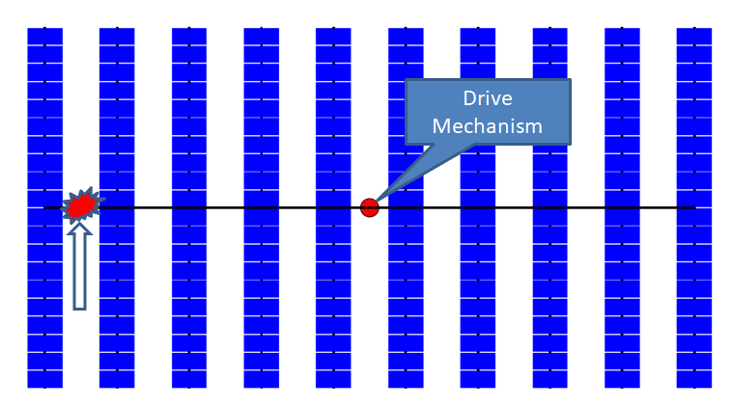
Increasing the size in N/S direction instead of implement linkages to drive multiple rows is another and only approaches left to reduce costs and avoid the blockage for maintenance as well. It was taking more and more market share in the past 3 years and seemed to be the mainstream of this industry until collapses happened repeatedly all over the world in the last 2 years. Tragedy!
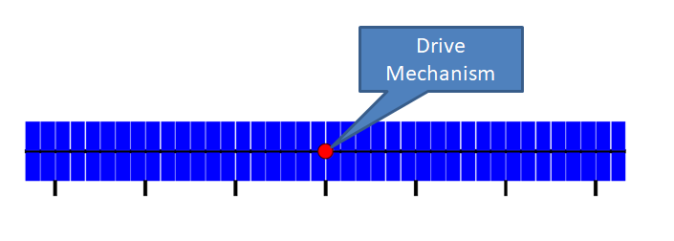
The reason is that with just a single drive drives the long structure, the longer the tracker means the more flexible the structure, the stronger vortex and greater inertia which work together to create resonant vibration under heavy wind. This phenomenon is named aeroelastic instability. The vibration energy is much worse for 4 meters wide (2P) systems.

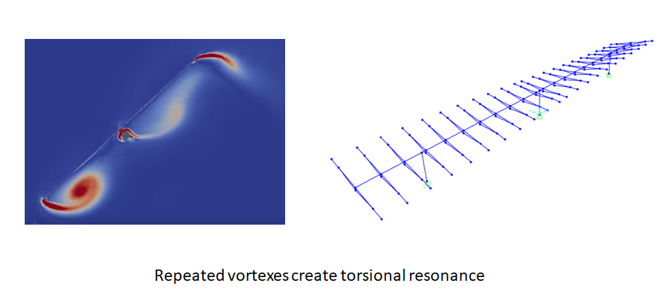

Therefore the solution is coming: equips more drive points and all the drive points are drive by one motor so that all the drive points move simultaneously. This is called multipoint drive. Multipoint drive makes the structure equivalently short enough and strong enough to avoid the forming of aeroelastic instability. More than 10 of the most important solar tracker manufacturers are working on the Multipoint Drive solutions now. It is not only the problem solver, but also highly likely the ultimate solution.

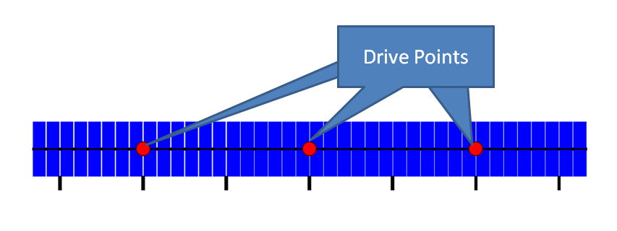
Among all the manufacturers, there are more than 10 kinds of drive mechanisms to fulfill the multipoint drive function idea which could be sorted into 2 categories as below:
A: Distributed Shaft Multipoint Drive
B: HALM multipoint Drive
Analyzing and sharing the pros and cons of all the typical mechanisms of the 2 categories are the contents of this speech.

