Progress in n-PERT rear emitter solar cells via cost-effective industrial pathways at SERIS

Donny LAI, James LAI, Jeffrey ISON, Balaji NAGARAJAN, Jammaal Kitz BUATIS, Rainer LEE, Rosalie GUERRA, Shuai JIN, Jidong LONG, Prabir BASU, Shubham DUTTAGUPTA, Armin G. ABERLE, Vinodh SHANMUGAM

Solar Energy Research Institute of Singapore (SERIS), National University of Singapore,
7 Engineering Drive 1, Block E3A, Singapore 117574, Singapore

To meet stable efficiencies above 22%, we present cost-effective industrial pathways of fully screen-printed, monofacial n-type passivated emitter, rear totally diffused (n-PERT) solar cells fabricated at SERIS, using industry-standard equipment, from 20.30% to 22.05%. These main process optimisations to be highlighted are namely – the introduction of laser-doped selective front surface field, the implementation of laser enhanced gettering, the boron diffusion optimization, busbar-less front metallisation, the synergistic optimization of nanosecond (ns) laser ablation and rear side dielectric passivation, and lastly the usage of better aluminium metallisation paste. It is noteworthy to mention that the ns laser source with 532 nm wavelength was used for both laser doping of the selective front surface field and laser ablation of the rear side dielectric, and the bulk lifetime of the n-type Czochralski (Cz)-grown silicon is 890 µs.

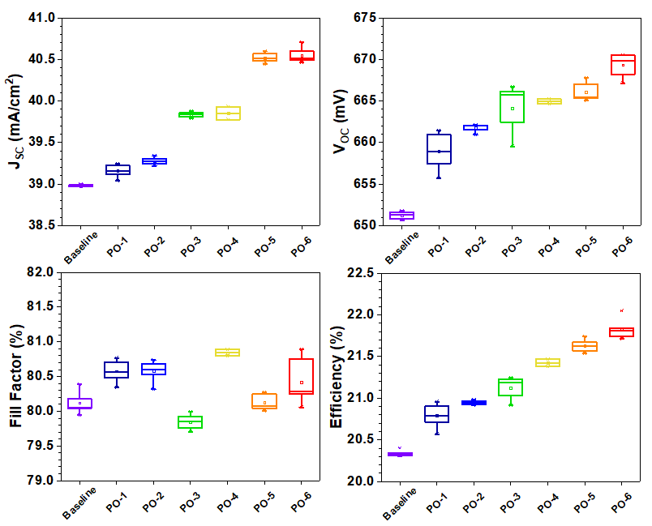
Fig 1. The measured electrical 1-Sun parameters of the n-PERT solar cells with rear emitters after various process optimisations.

