SNEC 2021: Abstract Submission
Session name: The 2021 PV Module Reliability Scorecard Release
Author: Tristan Erion-Lorico
Biography and photo:
Mr. Tristan Erion-Lorico has worked in the solar/electrical industry since 2006. He was previously the Product & Quality Manager at a PV module manufacturer, and more recently worked in equipment procurement and technical site operations at two different solar developers/Independent Power Producers assisting with projects in Canada, Japan, USA and Uruguay. In March 2018 Tristan joined PV Evolution Labs (PVEL) as Head of PV Module Business. His experience on both sides of the industry helped develop a strong sense of the value PVEL’s testing provides to the solar market.
Contact information:
Email: Tristan.erion-lorico@pvel.com
Mobile/WhatsApp: +1 (416) 576-3829
WeChat ID: terionlorico
Topic Category: Industry Standards and Testing Certification
Short description:
Tristan Erion-Lorico, Head of PV Module Business at PVEL, will present the 2021 PV Module Reliability Scorecard. The annual Scorecard is generated with results from PVEL’s Product Qualification Program (PQP), the most trusted and comprehensive PV module benchmarking report in the solar industry. With over a decade of experience and accumulated data, PVEL has tested over 400 unique bills of materials (BOMs) from 75 module manufacturers.
Now in its seventh edition, the 2021 Scorecard will report the Top Performers from six test sequences: Thermal Cycling 600, Damp Heat 2000, Mechanical Stress Sequence, Potential-induced Degradation (PID), and PAN Performance. PVEL’s PQP is regularly updated in response to feedback from downstream buyers, asset owners, financiers, independent engineers (IEs), manufacturers and independent research institutions.
Key points for the upcoming year will include a synthesis of our learnings from the lab to the field and back, as we aim to conduct testing that is increasingly representative of real world conditions and advise customers on deploying modules in the field. To that end, the 2021 Scorecard will include a deep dive into field performance, with validation against PAN files, as well as an analysis of modules that have been tested in comparable field conditions. Data from PVEL’s research and experiments guiding our Mechanical Stress Sequence and associated cell crack studies will also be shared.
Extended abstract
Every year, PVEL’s PV Module Reliability Scorecard is downloaded by thousands of solar industry professionals who use it to make data driven module purchasing and investment decisions. The report is accessed by users throughout the world, located in dozens of countries. Test results from the 2020 version of PVEL’s Product Qualification Program (shown below) are the basis for the 2021 Scorecard, which will be released just prior to SNEC. For the first time, Top Performers will be included for the Mechanical Stress Sequence, which was added in full in 2020. Other results presented will include Thermal Cycling 600, Damp Heat 2000, Potential Induced Degradation (PID) and PAN Performance.
PVEL’s Product Qualification Program test sequences:
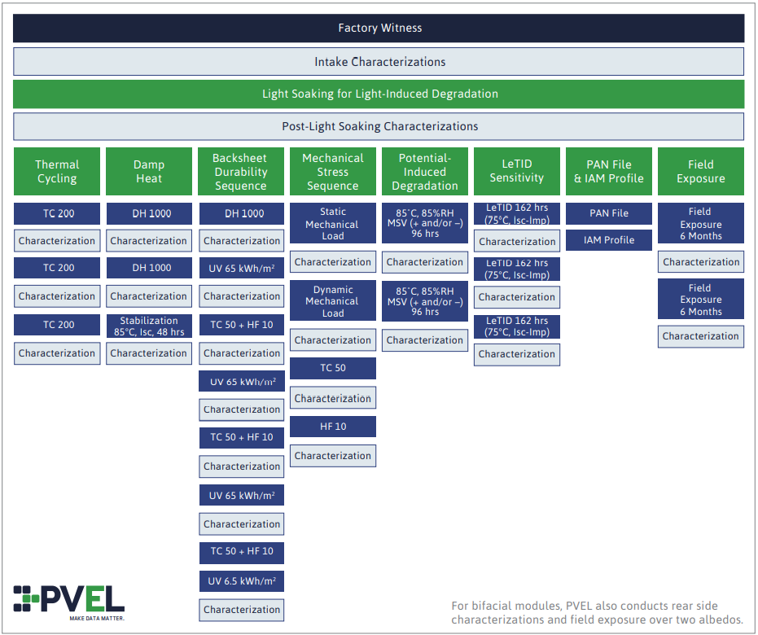

Another addition to the 2021 edition is a new analysis of field data comparing performance of like modules in an outdoor research test environment to analyze comparable conditions. Dozens of new BOMs have been tested since the 2020 Scorecard was released, including bifacial (glass-glass and transparent backsheet), heterojunction (HJT), “large” cells (158.75mm, 161.7mm, 166mm, 182 mm, 210 mm), half-cut cells, frameless, n-type PERT, interdigitated back contact (IBC), shingled, AC modules, TOPCon, SmartWire, multi-busbar and Ga-doped modules. Data on the reliability and performance of these various module types will be presented.
We anticipate showing slides similar to these (from the 2019 Scorecard presentation):
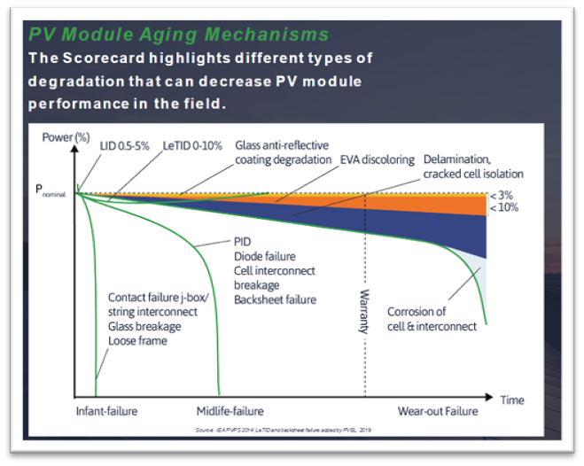
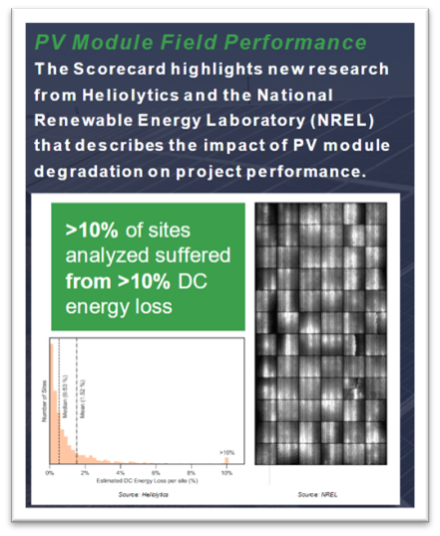
The 2021 PV Module Reliability Scorecard will also announce the 2021 version of the Product Qualification Program. Due to travel restrictions caused by COVID-19, PVEL has worked virtually, rather than in person, with the downstream module purchasing community to understand their needs, module manufacturers to understand their product development pipelines, and research institutes to understand the latest in technologies and module reliability testing. PVEL uses this market feedback to further research, develop, and distil into the 2021 Product Qualification Program.
Updates that are currently under consideration for our Product Qualification Program include:
- Standalone connector testing
- One run of PID for 192 hours (instead of two runs of PID at 96 hours each)
- Light stabilization after PID
- Faster LeTID testing
- Extended hail testing
- Backsheet sample FTIR
The presentation at SNEC will address these updates, and will also include an overview of the various research and experiments PVEL has conducted on the items listed above.

