High-Throughput, Low Damage Sputtering Machine For Transparent Conductive Oxides For Solar Cells
Xuemei Cheng, Simon Hübner, Beisenherz, Dirk, Peter Wohlfart
SINGULUS TECHNOLOGIES AG
E-Mail: Xuemei.Cheng@Singulus.de
Introduction
In the race for higher conversion efficiency and lower cost of silicon solar cells, Top-con and Heterojunction structure have been considered as the most promising candidates for the upcoming mass production technology in the market. [1] Especially the heterojunction solar cells (HJT), which are known for its good surface passivation, high open voltage, low temperature co-efficient, low thermal budget as well as simple process flow, have been implemented into the mass production line by several companies. We are highlighting the advanced features of a newly developed magnetron sputtering equipment, which can provide various functional materials (Transparent conductive oxides, AlOx, SiNx, a-Si, Ti, Ag, etc.) on large area with good uniformity, high throughput and low plasma damage for silicon solar cells applications. Especially the detailed studies of tin doped indium oxide (ITO) for heterojunction solar cells (HJT). We will present the influence of the employed magnetic confinement on different properties of the ITO as well as the final HJT solar cell. Furthermore, the influence of the main growth parameters of ITO (Indium Tin Oxide), e.g. gas phase composition (e.g. O₂ and H₂ content), target composition, and substrate temperature, are discussed in details. Our presentation will point out the aspects to be considered from the machine builder’s point of view to achieve highest possible cell efficiency with cost efficient large scale sputtering systems.
Results and conclusions
To minimize the sputter damage of the amorphous silicon layers by ion bombardment, the magnetics for sputter deposition of ITO have to be chosen very carefully. Degree of balance increasing from magnetics No.1 to magnetics No.3, shown in Figure 1. Due to missing the Lorentz force in case of unbalanced magnetics, ion flux density and energy is strongly enhanced. Optimized magnet bars with low electron losses can reduce discharge voltage to below 260 V.
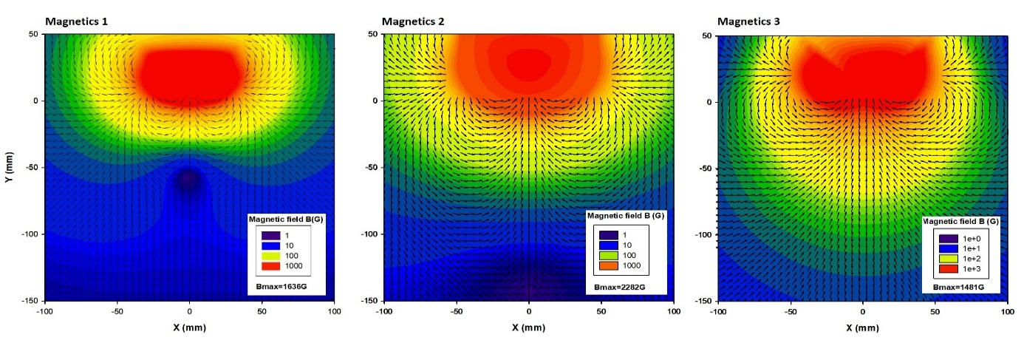
Figure 1: Degree of balance of three different magnetics
Besides the best choice of machine components, target material and gas phase composition are key elements to achieve highest transparency and lowest resistivity for deposited ITO layers. The influence of different magnetic systems in combination with different gas compositions (Ar, O₂, H₂) and plasma parameters on optical and electrical properties of the sputtered TCO films are discussed in detail. Figure 2 exhibits the specific resistance of the ITO layers in dependence on the oxygen and hydrogen content of the gas phase. ITO target composition is 95/5 In₂O₃/SnO₂, substrate temperature 180°C to 200°C, and the magnetics are as strong and balanced as possible. Varying the Oxygen content of the gas phase, the minimum of the specific resistivity of the ITO layers is reached at a value of round about 1.8%. Further increase in Oxygen content leads to increase in resistivity. As shown in figure 3, the transparency of this ITO layer with a thickness of 110nm is well above 85% for the whole spectral range between 350nm and 1100nm (green line). The specific resistivity of these layers can be slightly lowered by adding additional Hydrogen up to 4.9% (see figure 1). Coincidentally, the transparency of the layers increase for Hydrogen contents up to 2.5%. Another increase in Hydrogen content leads to large losses in transparency (yellow line, figure 2), which can be attributed to an increase in absorption due to an increase in Oxygen vacancies and the associated increase of free charge carriers. By raising the oxygen content to the same level as the hydrogen content, the losses can be overcompensated. The result is an ITO layer with a very low specific resistivity of 340µΩcm (green dot, figure 2) and the best transparency with values well above 88% over the full spectral range (dark blue line, figure 3).

Figure 2: Resistivity of several ITO-layers deposited with 95/5 target composition depending on oxygen and hydrogen contents of gas phase for magnetics No. 4.

Figure 3: Measurement of the transmission curves for wavelengths between 350nm and 1100nm for ITO grown with 1.8% of oxygen and varying hydrogen contents.
[1] Battaglia, Corsin, Andres Cuevas, and Stefaan De Wolf. "High-efficiency crystalline silicon solar cells: status and perspectives." Energy & Environmental Science 9.5 (2016): 1552-1576.

