Technologies for Profitable Recycling of Si Modules
C. S. Tao,1 W.-H. Huang,2 Z. Zhou,3 R. Lyu,3 L. Ricci,1 C. Tezak,2 J.-N. Jaubert,3 and M. Tao2
1 TG Companies LLC, Tucson, Arizona 85747, USA
2 Arizona State University, PO Box 875706, Tempe, Arizona 85287, USA
3 Canadian Solar, Inc. Changshu, Jiangsu, China 215562
Solar module recycling is unprofitable today. In this paper potential revenues from waste Si modules are analyzed. The biggest revenue potential comes from the Si cells, extracted intact or broken. The second revenue source is the bulky materials in the modules including Al frame, Cu wiring and glass. The total revenue is estimated between US$11–30/module depending on the percentage of cells extracted intact. This revenue is 4–10 times better than today’s recycling process that recovers only the bulky materials. Experimentally a special furnace has been demonstrated to successfully separate thin commercial Si cells of 160 μm from glass unbroken. From damaged cells a new chemistry has been developed to recover solar-grade Si and Ag. It requires fewer steps than today’s recycling process, with Ag recovery of 97% and Si recovery of 90%. A prototype recycling line is needed to assess the cost of the new process.
C. S. Tao is the Principal Engineer at TG Companies, leading the development and commercialization of process and equipment for silicon solar cell and module recycling. cobytao@tg-companies.com.

Key Words: Recycling, Solar Modules, Solar Cells, Silicon
Introduction – As the deployment of solar modules expands rapidly, so will their wastes. By 2050, waste modules are projected to total 78 million tonnes or 4.2 billion modules cumulative [1]. Although the need to recycle waste modules is widely recognized, it is rarely practiced as it is unprofitable today. The EU imposes an upfront fee on module manufacturers to cover the cost of recycling, but that fee is far below the actual cost to collect and process waste modules. In the US, the Solar Energy Industries Association initiated a voluntary recycling program in 2016. However, module owners must pay a high price for that service, which significantly curtails potential interests in module recycling.
Today’s recycling processes for Si modules generate a small revenue of ~US$3/module, as it recovers only the bulky materials including Al frame, Cu wiring and glass. All the Si cells along with the polymer sheets are shredded with the glass. Although the glass itself is highly-transparent solar glass, the recycled glass is contaminated and can not be used as solar glass without additional purification. Therefore, an important question for Si module recycling is whether there is more revenue from waste Si modules.

Potential Revenues – There are several possible ways to increase the revenue from waste Si modules:
- Reuse of decommissioned modules in secondary markets: The question is will these markets be large enough and sustained to absorb hundreds of GWp/year?
- Reuse of extracted cells for new modules: Si cells typically retain their good efficiencies far longer than the modules. Table 1 shows the best scenario revenue if all the Al BSF cells can be extracted intact, ~$31/module as of 4/29/2019. One concern is that 25-year old cells have lower efficiencies and can not sold at the current cell prices. This issue is expected to be short-term. The pace at which cell
Table 1. Best-scenario revenue from Al BSF modules as of 4/29/2019, $31.12/module.
Material Recovery % Value % Total Glass 100% $0.95 3.1
Al | 100% | $2.09 | 6.7
Polymers | 67% | n/a | 0

BSF cells 100% $28.08 90.2
Table 2. Worst-scenario revenue from Al BSF modules as of 4/29/2019, $11.41/module [2].
Material Recovery % Value % Total Glass 100% $0.95 8.3
Al 100% $2.09 18.3
Polymers 67% n/a 0
efficiency improves and cell cost drops will slow down as | Si | 90% | $4.62 | 40.5
the technology matures, and eventually level out. | Pb | 100% | n/a | 0
- Reuse of raw materials from modules: There are | Cu | 100% | $0.58 | 5.1

bulky, valuable and toxic materials in Si modules including
Ag 100% $3.17 27.8

solar-grade Si, Ag, Al, glass, Cu, as well as Sn and Pb, for ~$11/module as of 4/29/2019 (Table 2).

Experimental Results – Today’s recycling process for Si modules involves Cu and Al recovery, the first two blue boxes in Fig. 1. The remaining modules are shredded for glass. In our proposed process, a thermal step replaces module shredding, which can increase the recycling revenue from ~US$3/module up to ~US$30/module (Table 1). If the cells come in damaged or break during the thermal process, additional steps (the green boxes in Fig. 1) are needed to recover solar-grade Si, Ag, Cu, Sn and Pb for ~US$11/module. Therefore, the recycling process for material extraction is more complicated but generates less revenue than cell extraction. Our priority is thus cell extraction.
We have developed a furnace for cell extraction. It has a proprietary chamber to prevent Cu or Fe contamination of the Si cells during the thermal process. It allows various process gases including dry or steamed air or O₂. Fig. 2(a) is a photo of the furnace with a water vaporizer for steamed-air processing, and Fig. 2(b) is a half-cut mono PERC cell of 160 μm thick extracted unbroken from a cutout module. Whole 156×156 mm² multi Al BSF cells have also been extracted unbroken. With

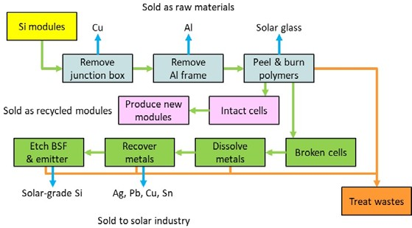
Fig 1. Our proposed recycling process for waste Si modules [3].

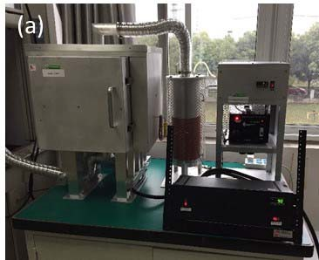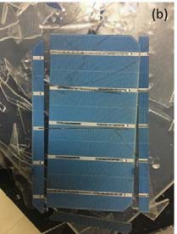
Fig 2. (a) A special furnace for cell extraction and (b) an extracted half-cut PERC cell from a cutout module.
Table 3. Ag recovery by new chemistry and by HNO₃.
Chemistry | Ag Initial | Ag Recovered | Recovery Rate
New chemistry | 1.1440 g | 1.1067 g | 96.7%
HNO₃ | 4.0323 g | 2.7812 g | 69.0%

the cells and polymer sheets cleanly removed, the glass can be recycled as high-value solar glass.
For material extraction, several reports describe a process based on HF, HNO₃ and NaOH to remove unwanted layers in Si cells for recovery of valuable and toxic materials [3,4]. The best Ag recovery rate to date is ~75% [3]. This is because they use HNO₃ to leach Ag, but electrowon Ag redissolves in HNO₃ [3]. We have developed a new chemistry that takes fewer steps than the reported process. The new chemistry offers a far better Ag recovery rate, ~97% now (Table 3) but expected to exceed 99%. The recovery rate of solar-grade Si is 90%, as the emitter and BSF are not solar-grade Si [3]. We are now developing a Si cell recycling system based on the new chemistry, which will be launched in a few months.
Conclusions – Significantly more revenues can be generated from waste Si modules if the Si cells are recovered instead of shredded. The potential revenue is estimated between US$11–30/module. Several technologies have been demonstrated to enable cell extraction from modules including a thermal process to separate thin Si cells from the glass unbroken and a new chemistry that recover 97% of the Ag and requires fewer steps than today’s process. These technologies could lead to a new industry worth ~$100 billion cumulative by 2050, but the cost of the new recycling process requires a prototype line to assess.
Acknowledgements – This work is supported by US NSF grant no. 1831148 and 1904544.
- International Renewable Energy Agency. 2016, End-of-Life Management: Solar Photovoltaic Panels.
- Tao M, Huang W H, Schichtel J. 2017, 33rd EUPVSEC (Amsterdam) p. 1878.
- Huang W H, Tao M. 2017, Solar Energy, 144, 22.
- Frisson L, Lieten K, Bruton T, Declercq K, Szlufcik J, Goris M, Benali A, Aceves O. 2000, 16th EUPVSEC (Glasgow).

