Title: Enhancing PV module thermomechanical performance and reliability through mounting technique.

Authors: Alex Masolin1, Andreas J. Beinert2

Affiliation: 1Coolback Company, Amstelveenseweg 500, 1081 KL Amsterdam, The Netherlands;

2Fraunhofer Institute for Solar Energy Systems ISE, Heidenhofstraße 2, 79110 Freiburg, Germany

Corresponding author: Alex Masolin | Phone: +31 (0)20 820 1872 | e-mail: alex.masolin@coolback.com

## FEM simulation of mechanical load

## In the Coolback® approach cooling fins replace a conventional frame as well as the backsheet (Fig. 1). We investigate the mechanical performance of a PV module using such cooling fins by FEM simulations of mechanical push and pull load according to the IEC 61215 [1].

The FEM model used is based on a FEM model published previously [2,3]. The solar cells are implemented as full-square mono-crystalline silicon wafer, without metallization and ribbons. We use hexahedral mesh elements with 2,700 mesh elements per solar cell and a quadratic serendipity basis function. Exploiting the two-fold axial symmetry, we model a quarter laminate.

Fig. 1: Coolback® cooling fins on the rear side of a PV module.

The FEM model covers lamination and mechanical load (ML) in push and pull direction. For ML, either a conventional frame or the Coolback® cooling fins are attached to the laminate. We simulate the mounting of the framed module on a rack by a fixed constraint on the long side of the module with a distance of 22% of the long side to its edge. As for cooling fins, the PV module is mounted by four specially designed clamps from the bottom, as shown in Fig. 2. We simulate the lamination process by applying a cooling from 150 °C to 25 °C. The residual stress from lamination is considered in the ML simulation. Here, we simulate a homogeneous push load of 2400 Pa and 5400 Pa as well as pull load of 2400 Pa. The used material models are shown in Table 1.

**Table 1:** Specifications and material properties of the reference PV module. *: provided by manufacturer, †: measured.

| Layer | Material | Dimension | Density [g/cm³] | Young’s modulus  [GPa] | Poisson’s ratio  [-] | CTE [10-6K-1] |
| --- | --- | --- | --- | --- | --- | --- |
| Front glass | soda-lime | 3.2 mm | 2.5* | 70* | 0.2* | 9* |
| Encapsulant | EVA | 460 µm | 0.96 [6] | T-dep.† | 0.4 [6] | 270 [6] |
| Solar Cell | Cz-Silicon | 156.75 × 156.75 × 0.180 mm³ | 2.329 [6] | Elasticity matrix [6] | | T-dep. [4,5] |
| Backsheet | TPT | 295 µm | 2.52 [6] | 3.5 [6] | 0.29 [6] | 50.4 [6] |
| Frame | aluminium |  | 2.7 [7] | 70 [7] | 0.33 [7] | 23 [7] |
| Frame-inlay | rubber | 8.85 × 1.15 mm² | 0.067* | 0.0074* | 0.3* | 769* |

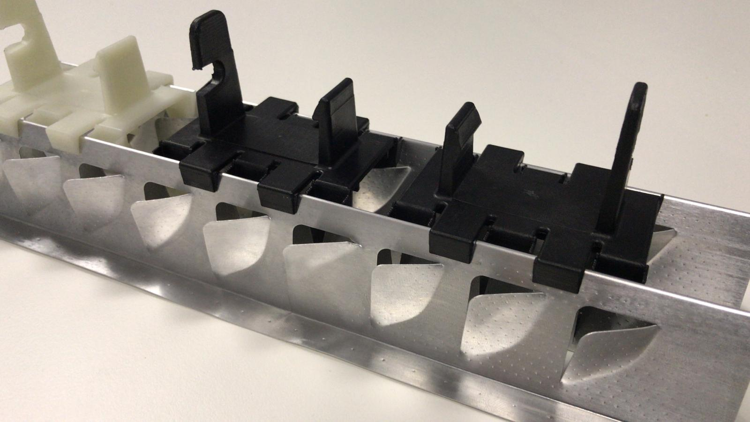To assess the impact of the novel mounting system, we evaluate the FEM simulation results using the maximum deflection of the PV module and the principal stresses in the solar cells. As a brittle material, silicon solar cells fail under tensile stress, therefore, we evaluate the maximum of the first principal stress $σ_{I}$  within the solar cells. We convert the obtained maximum first principal stress $σ_{I}$  values from the front and back side of the solar cells into a probability of solar cell fracture $P_{f}$  using the Weibull distribution [8] considering the size effect [9]:

|  |  |  |
| --- | --- | --- |
|  | $$P_{f}=1-\exp\left(\sum_{i}{{A_{eff,i}\left(\frac{σ_{I,max}}{σ_{0,i}}\right)}^{m_{i}}}\right) ,$$ |  |

with the effective area $A_{eff}$ , the maximum first principal stress $σ_{I,max}$ , the Weibull scale factor $σ_{0}$  and the Weibull modulus $m$ . The sum is over the values of the front (sunny) and back side, respectively. The effective area $A_{eff}$  can be interpreted as the area of significant stress values and is calculated for the front and back side separately by:

Fig. 2: Detailed view of one cooling fin with the specially designed clamps.

|  |  |  |
| --- | --- | --- |
|  | $$A_{eff,i}=\int{{\left(\frac{σ_{I,i}\left(x,y\right)}{σ_{I, max}}\right)}^{m_{i}} dA_{i} }.$$ |  |

The probability of solar cell fracture $P_{f}$  expresses the likelihood that within one module at least one crack in at least one solar cell occurs. For the Weibull scale factor $σ_{0}$  and modulus $m$  we use values from Kaule *et al*. [10] for Al-BSF solar cells. Mono- and bifacial PERC solar cells have a very similar behavior [11]. However, there are significant differences between different solar cell production processes. Therefore, the presented cell fracture probabilities are just exemplarily and the evaluation has to be performed for a specific cell type individually.

## Mechanical load

Fig. 3 shows the deflection of a laminate with a conventional frame as well as with the cooling fins at 5400 Pa push load and 2400 Pa pull load. The maximum deflection $d$  is depicted in Fig. 4 (a). For all investigated load cases, the PV module with cooling fins has a significantly lower maximum deflection. The cooling fins also lead to a different deflection shape. Instead of the parabolic deflection of a conventionally framed PV module, the PV module with cooling fins shows a rather U-shaped deflection and thus a smaller curvature.



Fig. 3: Deflection of the symmetry element (quarter PV module) of the framed (a+b) and cooling fins (c+d) PV module at 5400 Pa push load (a+c) and 2400 Pa pull load (b+d). Please note that the deflection values are represented as absolute values.

Fig. 4 (b) depicts the maximum first principal stress $σ_{I}$  along with the corresponding probability of solar cell fracture $P_{f}$ . At 2400 Pa pull load, the PV module with cooling fins has a higher maximum first principal stress of 42 MPa than the framed PV module with 7 MPa. This originates from the mounting on the rear side, around which very local tensile stress is induced due to the bending. However, since this is only a very small area, the solar cell fracture probability is still negligible. At 2400 Pa push load, the cooling fins PV module shows a lower tensile stress of 8 MPa compared to 24 MPa in the framed PV module. Both values correspond to negligible solar cell fracture probabilities. When going to 5400 Pa push load, the difference in tensile stress increases with the cooling fins PV module having 30 MPa and the framed PV module having 128 MPa. This corresponds to a solar cell fracture probability of 48% for the framed PV module while the cooling fins PV module still shows a negligible value.



Fig. 4: Maximum Deflection (a) and maximum first principal stress $σ_{I}$  (left axis of b) with the corresponding probability of cell fracture $P_{f}$  (right axis of b) for the framed (green) and cooling fins (orange) PV module at pull and push loads. Please note that the deflection values are represented as absolute values and the deflection at -2400 Pa pull load is in the opposite direction than the push values.

## References

[1] IEC IEC 61215-2:2016, Terrestrial photovoltaic (PV) modules – Design qualification and type approval – Part 2: Test procedures (2016).

[2] A.J. Beinert, P. Romer, M. Heinrich, M. Mittag, J. Aktaa, H. Neuhaus, Proceedings of the 36th European Photovoltaic Solar Energy Conference and Exhibition (EU PVSEC) (2019), 783–788.

[3] A.J. Beinert, P. Romer, M. Heinrich, M. Mittag, J. Aktaa, H. Neuhaus, IEEE J. Photovoltaics (2019).

[4] R.B. Roberts, Journal of Physics D: Applied Physics 14 (1981), L163-163.

[5] R.B. Roberts, Journal of Physics D: Applied Physics 15 (1982), L119-120.

[6] U. Eitner, S. Kajari-Schroeder, M. Köntges, H. Altenbach, in: H. Altenbach, V.A. Eremeyev (Eds.), Shell-like Structures: Non-classical Theories and Applications, Springer, Berlin/Heidelberg, 2011.

[7] W.M. Haynes (Ed.) CRC handbook of chemistry and physics, CRC Press, 2014.

[8] W. Weibull A Statistical Theory of the Strength of Materials, Generalstabens Litografiska Anstalts Förlag, Stockholm (1939).

[9] D. Munz, T. Fett Ceramics: Mechanical properties, failure behaviour, materials selection, 1st ed., Springer, Berlin | Heidelberg (2001).

[10] F. Kaule, M. Pander, M. Turek, M. Grimm, E. Hofmueller, S. Schönfelder, AIP Conference Proceedings 1999 (2018), pp. 020013-1–020013-9.