English:

Title of Presentation：
P+F Multilink IIoT Concept
-- IT/OT Fusion create multiple data value chain and infinite possibilities align with Smart Manufacture

Abstract:
The P+F Comtrol IO-Link Masters provide simultaneous access to the PLC via Industrial Ethernet and connect SCADA system or enterprise cloud solution via OPC-UA. In addition, the MQTT to be launched by the master station provides you with a flexible message mode: publish / subscribe, which is why we call this IO-Link module the IoT Master. OPC-UA technology combined with IO-Link communication method, in a real sense, realizes the interconnection and interconnection of all levels of the automation network (CloudPLCSensor). Intelligent sensor with IO link interface provides big data (process data, service data, event data) for industrial automation, and realizes remote setting, predictive maintenance, rapid replacement, online diagnosis and other functions. The production process of photovoltaic silicon wafers and battery wafers is complex, and the individual device buses are diversified. The P+F Comtrol IO-Link Masters are the optimal solution for stand-alone cloud-based application as they provide seamless configuration down to the sensor level and a multi access concept supporting OPC UA.

System diagram:
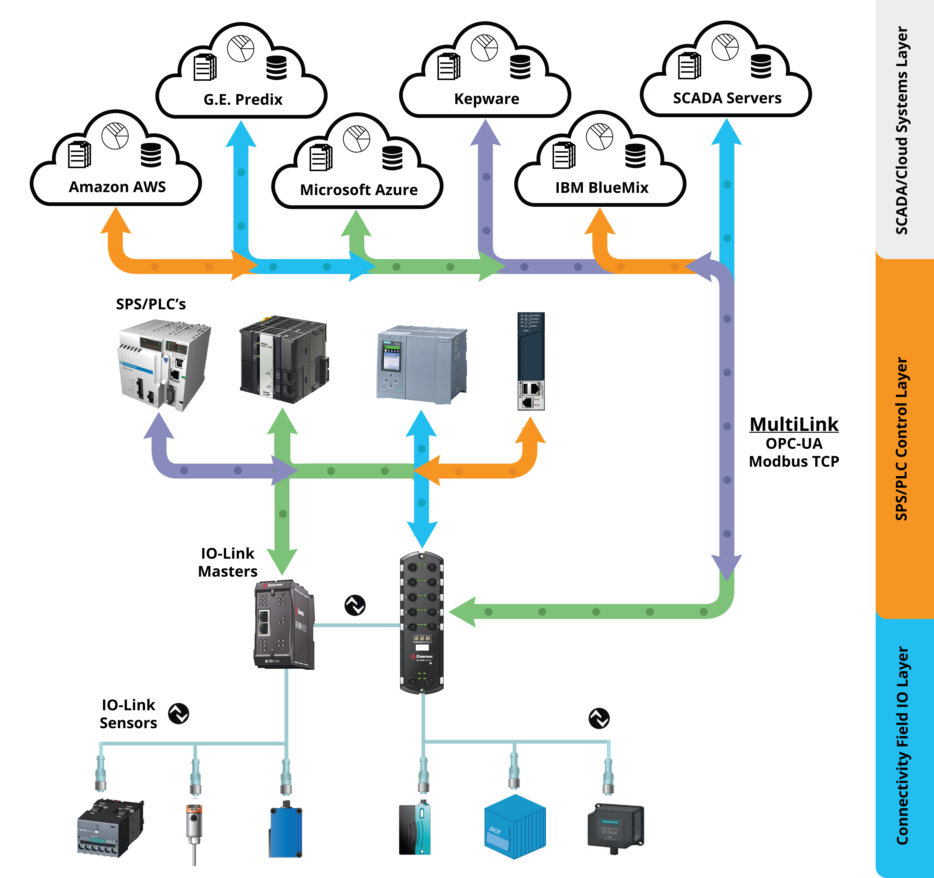

中文：

演讲题目:
倍加福基于IIOT概念的多链路技术
-- IT/OT融合创造多个数据价值链，与智能制造接轨提供无限可能
摘要：
P + F Comtrol IO-Link主站通过工业以太网访问PLC的同时，可通过OPC-UA连接SCADA系统或企业云解决方案。除此之外，该主站即将开通的MQTT为您提供灵活的消息模式：发布/订阅，这也是为什么称IO-Link模块为 IoT Master。OPC-UA技术结合IO-Link通讯方式，从真正意义上实现了自动化网络所有级别的互连互通（云PLC传感器）。带IO-Link接口的智能传感器，为工业自动化提供了大数据（过程数据、服务数据、事件数据），实现了远程设定、预见性维护、快速替换、在线诊断等功能。光伏硅片、电池片生产工艺复杂、单体设备总线多样化。IO-Link Master是基于云应用的最佳解决方案，因为它们提供了传感器级别的无缝配置以及支持OPC UA的多址概念。

系统示意图：

