Screen Printing of Copper Pastes for Metallisation of Silicon Passivated Contact Solar Cells
^{1,2}Boon Heng TEO, ²Ankit KHANNA, ²Vinodh SHANMUGAM, ²Ma Luisa Ortega AGUILAR, ²Maryknol Estrada DELOS SANTOS, ³Wei-Chen CHANG, ²Thomas MUELLER
¹ Graduate School for Integrative Sciences and Engineering, University Hall, Tan Chin Tuan Wing, #04-
02, 21 Lower Kent Ridge, National University of Singapore, Singapore 119077
² Solar Energy Research Institute of Singapore (SERIS), Block E3A, #06-01, 7 Engineering Drive
1, Singapore 117574
³ Geckos Technology Corp, 6F-11, No 38, Taiyuan St, Zhubei City, Hsinchu County, Taiwan 30265

Abstract
The work in this paper aims to investigate the potential of screen-printed Cu as a potential replacement for conventional Ag contacts in silicon passivated contact solar cells. A curing-type novel Cu paste formulation was synthesized via wet-chemical reduction. The pastes comprise of Cu nanoparticles with average diameters of 400 nm ± 100 nm with a thin (~5 nm) encapsulating layer of polyvinylpyrrolidone to prevent Cu oxidation during annealing. The Cu pastes were then screen-printed and cured under vacuum conditions (< 300 ppm O₂) at temperatures between 200 °C to 400 °C for 30 min. The screen-printed Cu fingers were investigated based on their printability, line and contact resistance to Indium-Tin oxide, a common transparent conductive layer for passivated contact solar cells. Scanning electron microscopy was used to analyse the morphology of the cured Cu fingers and the nanoparticles at the contacting interface. Consistent finger widths between 53 - 60 μm and finger heights above 20 μm were achieved. The average specific contact resistivity of the Cu-ITO contact for the best-performing paste formulation under optimal curing conditions was 0.4 mΩ.cm². The resistivity of printed Cu lines after curing at 400 °C for 30 min was 27 μΩ.cm. Subsequent work involves further paste development, improving screen printed finger aspect ratios, and optimising curing conditions.
Boon Heng TEO is a researcher at the Silicon Materials and Cells Cluster in the Solar Energy Research Institute of Singapore. SERIS is sponsored by the National University of Singapore (NUS) and Singapore’s National Research Foundation (NRF) through the Singapore Economic Development Board (EDB). This research was supported by the National Research Foundation, Prime Minister’s Office, Singapore under its Clean Energy Research Programme project grant (NRF2014EWT-EIRP001-016). The corresponding author can be contacted at boonheng.teo@u.nus.edu.

Keywords: Screen printing, Copper nanoparticles, curing-type pastes, passivated contact

High efficiency passivated contact silicon wafer solar cells can achieve high open-circuit voltages (> 735 mV) due to excellent surface passivation achieved with the insertion of thin hydrogenated amorphous silicon layers. High photoconversion efficiencies above 24% have been obtained [1-4], with a record reported efficiency of 26.7% achieved with an interdigitated back-contact structure (IBC-HJ) [1]. Although HJ cells have evolved from R&D to industry, the manufacturing cost must be reduced in order to increase the feasibility of production. Conventional Ag contacts account for over 20% of the total cost for in HJ cells [5], and there is a need to explore alternative cost-effective metal contacts.

Screen printing of Cu contacts is a potentially low-cost solution for HJ cell metallization because Cu not only exhibits similar electrical resistivity to Ag (resistivity of pure Ag, ρ_{Ag} = 1.6 μΩ.cm; resistivity of pure Cu ρ_{Cu} = 1.7 μΩ.cm), but it is also a hundred times cheaper (Ag costs USD 500/kg and Cu costs USD 5/kg as of Feb 2019) in raw cost [6, 7]. Screen printing is also the dominant metallization technology in the PV industry as it is cost-effective and has high-throughput. Screen printing for HJ cells in R&D and industry has been established for low-temperature Ag-based polymer pastes [8-12]. Therefore, if suitable Cu pastes are developed, Cu paste screen printing can be easily integrated into existing industrial HJ cell production lines. Therefore, this study investigates the development and application of Cu pastes.

Copper nanoparticles were synthesized via wet-chemical reduction. Copper hydroxide and polyvinylpyrrolidone (PVP) were dissolved in ethylene glycol solution and stirred until complete dissolution in a flask. An ascorbic acid polyol solution was added to the flask and stirred. A color change from blue to brown indicates the formation of Cu nanoparticles. The final dispersion was washed with ethanol at 5000 rpm for five minutes using centrifugation. Ethyl cellulose (EC) powder was dissolved in anhydrous ethanol to form 10 wt% EC, which is added to the flask containing Cu nanoparticles, anhydrous terpineol and dilute anhydrous ethanol. The solution was then sonicated using an ultrasonic horn (Qsonica Q700 Sonicator) and stirred with a hand-mixer (Ultraturrax, IKA). The Cu pastes were screen-printed on full-area textured mono-crystalline Czochralski (Cz) wafers with 80 nm front ITO using a commercially available screen-printing line. A standard screen specification of 4 busbars with 0.9 mm busbar opening and 120 fingers with 55 μm finger opening, mesh count 400 (wires/inch) and wire diameter of 18 μm was used. The Cu pastes were screen printed with optimized print speed (100 mm/s) and pressure (12 kg). A vacuum oven with < 300 ppm O₂ was used to cure the screen-printed samples.

The specific contact resistivity, ρ_{c} between the screen-printed Cu fingers and the textured ITO interface was determined via the Transmission Line Model (TLM) method [13]. All samples were cured in vacuum oven conditions for 30 min. Cu fingers cured at 300 °C obtained ρ_{c} average of 0.9 mΩ.cm². As curing temperature increases from 350 °C to 400 °C, ρ_{c} improves from 0.5 mΩ.cm² to 0.4 mΩ.cm². Fig. 1 shows TLM specific contact resistivity for fingers screen-printed with Cu paste cured between 300°C and 400 °C under vacuum conditions for 30 min.

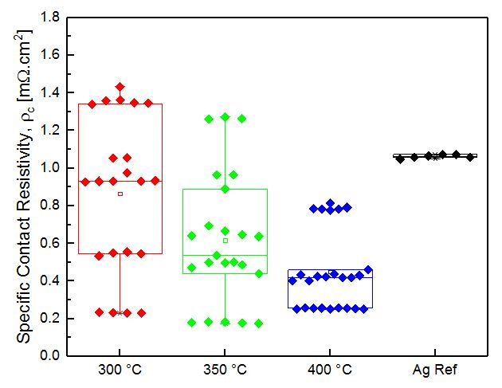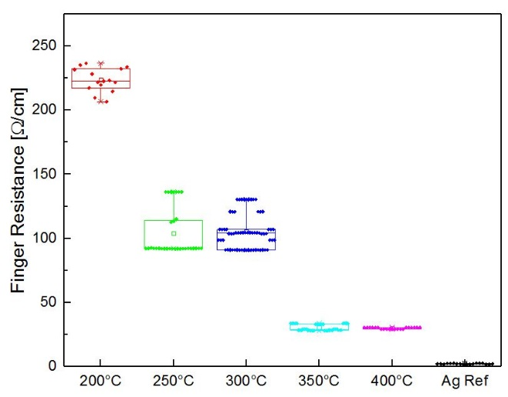
Fig. 1: (Left) Boxplot of specific contact resistivity, ρ_{c} [mΩ.cm²] for Paste LA1SR1 with varying curing temperatures, cured in a vacuum oven (< 300ppm O₂) for 30 min and (Right) boxplot of finger resistance [Ω/cm] for Paste LA1SR1 with varying curing temperatures, cured in a vacuum oven (< 300ppm O₂) for 30 min.

The contact resistance values obtained by fingers screen-printed with Cu pastes are comparable, if not marginally better than the contact resistance between the Ag reference paste (a state-of-the-art commercially-available paste for HJ cells) and the ITO interface. The contact resistances obtained by the Cu screen printed fingers are excellent and can potentially contribute to high-efficiency HJ cell structures. However, it is also important to note that curing temperatures above 350° may likely degrade a-Si:H layers in HJ cells. Further work is needed to improve annealing processes at lower temperatures while maintaining the integrity of a-Si:H layers in the HJ cell.

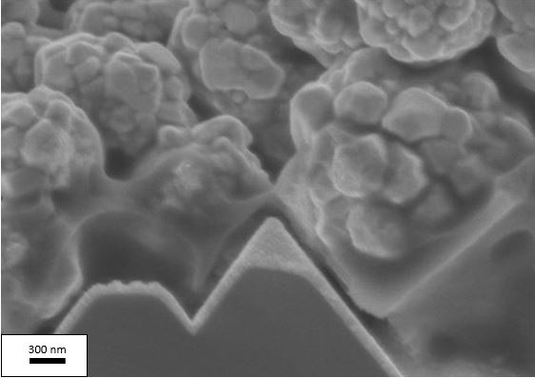
Fig. 2: Scanning electron microscope (SEM) image of fully cured Cu nanoparticles sintered and in contact with the ITO surface.

Busbar-to-busbar resistance measurements were used to determine the average finger resistances of Cu paste screen-printed finger samples cured at different temperatures for 30 min. Samples cured between 250 °C to 300 °C exhibit finger resistances between 90 Ω/cm to 110 Ω/cm. The improved finger resistances are attributed to the increased contact between Cu nanoparticles. The Cu paste screen-printed samples cured between 350 °C to 400 °C obtained the best finger resistances down to 25 Ω/cm, a large improvement in resistance and moving closer towards Ag reference finger resistance values of 1.7 Ω/cm. Importantly, curing at this temperature range results in improved sintering of the Cu paste.

The Cu pastes developed in this work exhibit great potential in replacing Ag metal contacts in passivated contact solar cells. Subsequent work in the pipeline involves further paste development, improving screen printed finger aspect ratios, and optimising curing conditions. To improve contact resistance, Cu nanoparticle size can be reduced to reduce void formation at the ITO-metal interface. Optimising paste viscosity, printing speed and pressure and employing dual-printing techniques to improve Cu finger aspect ratios will reduce optical shading loss and increase the short circuit current density in the passivated contact solar cell. In order to maintain the minority carrier lifetime of the amorphous Si layers in passivated contact solar cells, curing at lower temperatures below the temperature range investigated and increasing curing durations must be explored.

[1] K. Yoshikawa, W. Yoshida, T. Irie, H. Kawasaki, K. Konishi, H. Ishibashi, T. Asatani, D. Adachi, M. Kanematsu, H. Uzu, K. Yamamoto, Exceeding conversion efficiency of 26% by heterojunction interdigitated back contact solar cell with thin film Si technology, Solar Energy Materials and Solar Cells, Vol 173 (2017) pp 37-42.
[2] D. Adachi, J.L. Hernandez, K. Yamamoto, Impact of carrier recombination on fill factor for large area heterojunction crystalline silicon solar cell with 25.1% efficiency, Applied Physics Letters, Vol 107 (2015) pp 233506.
[3] M. Taguchi, A. Yano, S. Tohoda, K. Matsuyama, Y. Nakamura, T. Nishiwaki, K. Fujita, E. Maruyama, 24.7% Record Efficiency HIT Solar Cell on Thin Silicon Wafer, IEEE Journal of Photovoltaics, Vol 4 (2014) pp 96-99.
[4] K. Masuko, M. Shigematsu, T. Hashiguchi, D. Fujishima, M. Kai, N. Yoshimura, T. Yamaguchi, Y. Ichihashi, T. Mishima, N. Matsubara, T. Yamanishi, T. Takahama, M. Taguchi, E. Maruyama, S. Okamoto, Achievement of More Than 25% Conversion Efficiency With Crystalline Silicon Heterojunction Solar Cell, IEEE Journal of Photovoltaics, Vol 4 (2014) pp 1433-1435.
[5] W.C. Chang, L.W. Weng, C.K. Chuang, J.X. Liang, T.N. Yang, W.Y. Ma, The Preparation of Antioxidant Copper Paste and Its Application to Silicon Solar Cells, Journal of Nanoscience and Nanotechnology, Vol 16 (2016) pp 9125-9131.
[6] Westmetall, Metal Prices Trend and Analysis https://www.westmetall.com/en/markdaten.php, in.
[7] KITCO, Metal Prices Trends and Analysis https://www.kitco.com/market/, in.
[8] A. Faes, M. Despeisse, H.-Y. Li, J. Geissbühler, C. Ballif, A. Lachowicz, A. Bettinelli, P.-J. Ribeyron, D. Munoz, J.-F. Lerat, Metallization and interconnection for high-efficiency bifacial silicon heterojunction solar cells and modules, Photovoltaics Bulletin, 41 (2018) pp 1 - 5.
[9] A. Descoeudres, C. Allebé, N. Badel, L. Barraud, J. Champliaud, G. Christmann, F. Debrot, A. Faes, J. Geissbühler, J. Horzel, A. Lachowicz, J. Levrat, S. Martin de Nicolas, S. Nicolay, B. Paviet-Salomon, L.L. Senaud, C. Ballif, M. Despeisse, Low-temperature processes for passivation and metallization of high-efficiency crystalline silicon solar cells, Solar Energy, 175 (2018) pp 54-59.
[10] J.D. Fields, M.I. Ahmad, V.L. Pool, J. Yu, D.G. Van Campen, P.A. Parilla, M.F. Toney, M.F.A.M. van Hest, The formation mechanism for printed silver-contacts for silicon solar cells, Nature Communications, Vol 7 (2016) pp 11143.
[11] C. P. Hsu, R.-H. Guo, C. C. Hua, C.-L. Shih, W.-T. Chen, T.-I. Chang, Effect of polymer binders in screen printing technique of silver pastes, Journal of Polymer Research, Vol 20 (2013).
[12] A. Khanna, Z.P. Ling, V. Shanmugam, M. Boreland, I. Hayashi, D. Kirk, H. Akimoto, A. Aberle, T. Mueller, Screen printed metallisation for silicon heterojunction solar cells, in: 28th European PV Solar Energy Conference and Exhibition, Paris, 2013, pp. 1336 - 1339.
[13] D.L. Meier, D.K. Schroder, Contact resistance: Its measurement and relative importance to power loss in a solar cell, IEEE Transactions on Electron Devices, 31 (1984) 647-653.

