Floating solar photovoltaic farms: A state of the art of the numerical modelling solutions.
Benjamin Gendron^{#1}, Félix Gorintin^{#2}, Maria Ikhennicheu ^{#3}, Mattias Lynch ^{#4}
* INNOSEA France
1 rue de la Noë, 44 321, Nantes CEDEX 03, France
¹benjamin.gendron@innosea.fr
²felix.gorintin@innosea.fr
³maria.ikhnennicheu@innosea.fr
⁴mattias.lynch@innosea.fr

- Keywords
State of the art, Photovoltaïcs, Floating PV, Moorings.
- Abstract
This study is intended to present a state of the art of the different methods used for the numerical simulation of floating solar farms and its mooring lines.

The market of floating solar farms is recent and enables the use of land that would otherwise be un-exploited such as lakes, flooded carriers, damn lakes or swamp areas. When looking at the perspective of the available surface area around the world, floating solar has a real potential.

The question of the loads acting on a solar farm and the resulting displacements is important as it determines the size of the moorings and the costs of the farm. Having a model that is able to estimate the loads on the farm, wind and wave, able to predict the global displacements and rotations of the floaters is an important part for the design of floating solar farms.

The generic solution currently being used for floating solar mooring design is based on analytical calculations, based on standards such as [1], [2] and [3]. General recommendations for mooring design, construction and maintenance are made in [4]. Nevertheless, recent events such as the Yamakura dam incident – hit by typhoon Faxai in September 2019 – have severely impacted the image of the whole sector. Therefore, a major focus has recently been made on the reliability and on our capability to more accurately model the behaviour of large floating solar farms.

In the state-of-the-art, two different kinds of numerical methods have been identified. The first technique is based on the multi-body approach which implies modelling each floater individually and the connections between them. This approach is time consuming as it requires handling multiple elements but appears to be the most realistic for small scale arrays. The other method implies modelling the entire farm as an equivalent flexible plate. This enables faster calculations due to the reduced number of elements but requires finding the correct material coefficients that will properly represent the set of floaters. In both cases, the loads on the floater array may be estimated and the displacements deduced.

The aim of this state-of-the-art is to compare both approaches in order to more accurately model the behaviour of floating solar PV farm, within a realistic and achievable computing time.

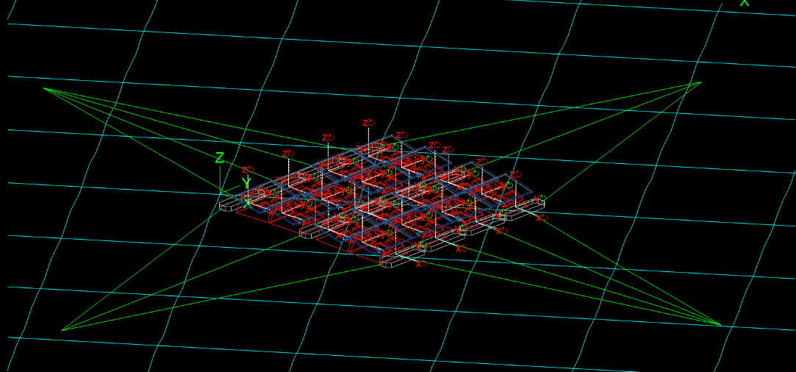
Figure 1 Example of a multi-body approach for floating solar PV modelling

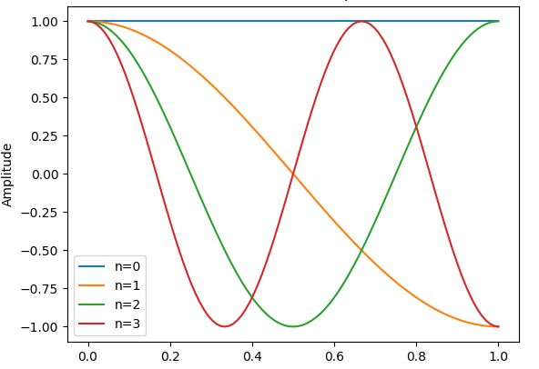
Figure 2 Example of flexible plate vibration modes

References
- Offshore Standard DNV-OS-C205, Environmental conditions and environmental loads, DET NORSKE VERITAS. 2010.
- EN 1991-1.4. Eurocode 1: Actions on structures, general actions. Part 1-4 Wind actions. EUROCODE. 2010.
- ASCE. 2010. Minimum Design Loads for Buildings and Other Structures. ASCE/SEI Standard 7-10.
- Energy Sector Management Assistance Program; Solar Energy Research Institute of Singapore. 2019. Where Sun Meets Water : Floating Solar Handbook for Practitioners. World Bank, Washington, DC. © World Bank. https://openknowledge.worldbank.org/handle/10986/32804 License: CC BY 3.0 IGO.

