SNEC 2020 Shanghai

PV System Monitoring Concept and First Evaluation based on 100MW Test Filed Plant, Gonghe Qinghai, China

Boris Farnung, Jefferson Bor
Fraunhofer Institute for Solar Energy Systems ISE, Heidenhofstrasse 2,
79110 Freiburg, Germany
Phone +49 761 4588 5471
boris.farnung@ise.fraunhofer.de
jefferson.bor@ise.fraunhofer.de

Xiaoping Xie, Pang Xiulan
SPIC Qinghai Photovoltaic Industry Innovation Center
Huanghe Hydropower Development Company
pang_pxl@126.com

In times when unit for large scale photovoltaic power plants changes from multi-megawatt (MW) to gigawatt (GW) and in the same time PV industry introduce new cell and module concepts, power electronics and design concepts constantly, the project developers are facing to a difficult question: “What is the best selection of components and the most innovative design to achieve high performance and high reliability with minimum costs”
For that purpose, Huanghe Hydropower Development Company (HHDC) initiated the 100MW Test field project in 2016. It is the world largest PV test field for component and design validation. The test field contains five zones to compare different concept of technologies and design of PV power plants. Each concept was realized with a PV array of around 1 MW capacity.
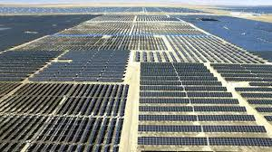
Figure 1: 100MW PV Test filed from HHDC, Gonghe, Qinghai, China
In 2018 a comprehensive monitoring and data acquisition system was accomplished to support evaluation and research for the long-term. The approach goes far beyond monitoring solutions used in other utility scale projects. Additional, high accurate sensors and meters were distributed within each array and installed on string and sub-array level. To ensure a high standard irradiance data, six metrological stations equipped with tracker, and ventilated horizontal and tilt sensors were included.
In this paper, data and results of 2019 are presented, comparing different technologies through the collected data from the different zones. For this purpose, the methodology of data handling, processing, and filtering before the analysis is described as evaluation results are highly depending on this methods.
The results for the different technologies, such as mounting structures, design configurations, module technologies and inverter types are shared.

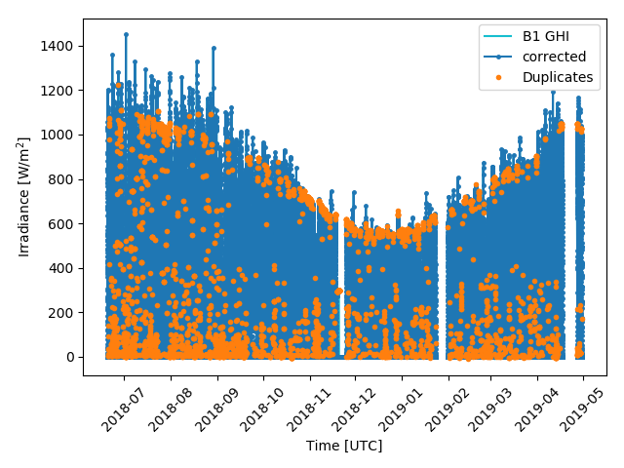
Figure 2: GHI data quality control with quality “flag”

