Title: Determination of temperature coefficients for bifacial solar cells under different illumination conditions
C. Müller, K. Ramspeck, S. Dauwe and M. Meixner
h.a.l.m. elektronik GmbH
c.mueller@halm.de

IV measurements of solar cells or solar module in high volume production are typically done somewhat off from standard test conditions (1000 W/m² and 25 °C). In order to achieve comparable results, the IV curves are corrected to standard test conditions using correction procedures described in standards and temperature coefficients determined at similar devices. In this work, these temperature coefficients are determined for bifacial solar cells.
We present IV measurements for bifacial solar cells under different illumination conditions. Therefore, we bring the solar cell to defined temperatures within the dark chamber of our bifacial solar cell test system. We monitor the temperature to make sure the solar cell is at a steady temperature which is homogenous across the whole device. To meet the requirements of the standard (IEC 60891) we measure the device temperature at four different positions (Figure 1) simultaneously.
Figure 1: Positions of the temperature measurement after IEC 60891
A general problem with temperature measurements of bifacial solar cells is shading due to temperature sensors. Nevertheless, a permanent temperature control is necessary for obtaining exact measurement results. Therefore, we use temperature sensors which keep the shading of the solar cell at the level of the contacting and thereby don’t affect the IV measurement results.
We are performing IV measurements at different defined temperatures in the range of 15°C up to 60°C. For every temperature we make monofacial front and rear measurements and additionally under bifacial conditions, what implies illumination of both sides of the device from two separated light sources. Due to those measurements, we get a set of measurements for every illumination condition in respect to the cells temperature. Every measurement is only corrected in terms of insolation. Figure 2a shows IV curves measured at different temperatures taken under monofacial front illumination. The different shape of the curve for the corresponding temperature can be identified as well as the different results for the open circuit voltage (V_{OC}) and short cut current (I_{SC}). By linear fitting the measured values for I_{SC} and V_{OC} against the temperature the temperature coefficient for current (α,α_{rel}) and voltage (β,β_{rel}) can be determined respectively. With those temperature coefficients we correct the measured IV curves. The result can be seen in figure 2 b. In the detailed diagram of figure 2 b a split-off at the maximum power point can still be seen. Therefore we derive the curve correction factor (κ) by minimizing the difference of the maximum power of all measurements. Figure 2c shows the corrected IV measurements using κ additionally.
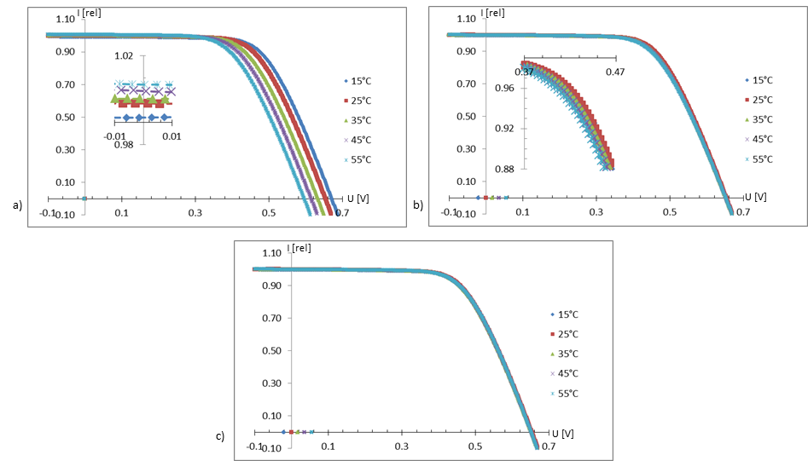
Figure 2: a) IV curves measured at different temperatures@ 1000 W/m². The small diagram shows a zoom at 0V. b) Same IV curves corrected to 25 °C using temperature coefficients for current and voltage. The small diagram shows a zoom to the maximum power point. As can be seen, the evaluated temperature coefficients result in a good match at Isc and Voc conditions. c) Same IV curves with the curve correction applied in order to correct the FF of the IV curve. A perfect match of all IV curves is achieved.
This method was done for all three illumination conditions (front, rear, bifacial) and the corresponding temperature coefficients were determined. To the best of our knowledge this is the first time this was done for the three different illumination conditions.

