Preparation and characterization of poly-SiC_{x} and its application for tunnel-SiO_{x}/poly-SiC_{x} passivated contact
Summary
In this work, we investigated the phosphorus-doped poly-SiC_{x} thin film and its application on passivated contact solar cells. The poly-SiC_{x} with different carbon concentrations was prepared. Our preliminary work shows poly-SiC_{x} passivated contact possesses robust surface passivation quality with typically J₀ of 3-20 fA/cm² depending on the annealing temperature. The sheet resistance of the poly-SiC_{x} thin film is under investigation. Also, we used this materials to polysilicon passivated contact solar cells. Our preliminary shows that the newly developed solar cells showed the overall better performances (including V_{oc}, J_{sc}, and FF) than the control ones. Finally, we developed the new passivated-contact solar cells with the champion efficiency of 24.27%.

Introduction
Polysilicon (poly-Si) passivated contact is considered as one of the most promising next-generation c-Si solar-cell technique because of the excellent full surface passivation and the compatibility with the manufacturing line [1, 2]. However, the shortcoming of the present polysilicon passivated-contact technology is the preservation of front-sided metal contact that induces significant recombination. One solution is to apply polysilicon passivated contact to the front surface.
Aim to solve the problems mentioned above, an ideal solution is to use silicon alloys with broaden optical-bandgap, which has the potential to reduce parasitic absorption. The new poly-silicon- alloy passivated contact serves both as the window layer and the carrier transverse-transportation layer, which leads to the double-sided passivated solar cell without metal contact. If this idea works, the industry has the chance to develop the industrial used double-sided passivated silicon solar cells with open-circuit voltage (V_{oc}) of >720 mV and the efficiency of >23.5%. Thus, it is worthy of investigating the new materials and new-structured solar cells.
In this work, we focus on the investigation of the phosphorus-doped poly-SiC_{x} thin film and its application on passivated contact. The plasma-enhanced chemical deposition (PECVD) technique is used to fabricate the amorphous SiC_{x} precursor. Optical properties, electronic properties of the poly-SiC_{x}, and the integration in solar cells are under investigation.
- Experiments
The 6-inch, 1-3 Ω-cm, 180-μm, n-type CZ c-Si wafer polished by KOH solution was used as the substrates of lifetime samples. One-sided mirror-polished 4-inch, 1-2 Ω-cm, 260-μm, n-type Czochralski (CZ) c-Si wafer was used as the substrates for ellipsometer measurement. Quartz wafer was used as the substrate for UV/Vis/NIR and Hall measurement. The ultra-thin SiO_{x} on the wafer surface was grown by the HNO₃ solution. Following the growth of SiO_{x}, the in-situ phosphorus-doped amorphous Si and SiC_{x} thin films were deposited using PECVD with silane (SiH₄), phosphine (PH₃), hydrogen (H₂), and methane (CH₄) as the reaction gases. The composition of SiC_{x} was modified by adjusting the flowing rate of SiH₄ and CH₄. After deposition, the samples were subjected to the high-temperature annealing at 820ºC to 920ºC to form the poly-Si and poly-SiC_{x}, followed by N₂+H₂O post hydrogenation annealing.
The minority carrier lifetime was characterized using quasi-steady-state photoconductance (QSSPC) (Sinton WCT-120) measurements. The electronic properties of the poly-Si and poly-SiC_{x} were measured using Hall (Nanometrics, HP-5500C) and four-point probe (NAPSON, CRESBOX). The active phosphorus profile of the poly-Si passivated contact was measured using an electrochemical capacitance-voltage (ECV) system (Buchanan, CVP21). The crystalline structure of the poly-Si layer was characterized by Raman measurement with a 325-nm excitation laser (Renishaw, inVia-reflex). The optical properties, including absorption coefficient (α), refraction index (n), and extinction coefficient (k) of the poly-Si and poly-SiC_{x} were measured using UV/Vis/NIR (Perkin Elmer, Lambda 950) and ellipsometry spectroscopy (J.A. Woollam, M-2000DI).
- Results and discussion
The SiO_{x}/poly-SiC_{x} (R1, R2, and R3) passivated contact display excellent surface passivation, i.e., the single-sided saturated dark current (J_{0,s}) of 3-5 fA/cm², if the crystalline annealing temperatures in the range of 840ºC to 880ºC, as shown in Fig. 1(a). The flowing rate of CH₄ to SiH₄ is defined as R. Surface passivation of R1 and R2 lifetime samples is weakened if the temperature raising to 920ºC, i.e., the J_{0,s} raises to >10 fA/cm². In contrast, the surface passivation of R3 lifetime sample still keeps at an excellent level, i.e., J_{0,s} is 4.4 fA/cm². The poly-SiC_{x} with higher carbon concentration seems more stable than the one with low carbon concentration in the higher-temperature annealing.
The sheet resistance (R_{sh}) of c-Si/SiO_{x}/poly-SiC_{x} (40 nm) passivated contact measured using four probes, and the R_{sh} of poly-SiC_{x} (40 nm) measured using Hall are given in Fig. 1(b). We can observe the following phenomena. 1) Although a single poly-SiC_{x} thin film has high R_{sh} of 2000-20000 Ω/sq, the c-Si/SiO_{x}/poly-SiC_{x} passivated contact possesses acceptable R_{sh} of 40-120 Ω/sq. The R_{sh} can be reduced by 20 to 200 times by using c-Si/SiO_{x}/poly-SiC_{x} to replace poly-SiC_{x}; and the higher annealing temperature, the more reduction of R_{sh} is obtained. The significant reduction of R_{sh} can be attributed to the in-diffusion of phosphorus into silicon wafer and to that the carrier in crystalline silicon has much higher mobility than that in poly-SiC_{x}. 2) The R_{sh} of both c-Si/SiO_{x}/poly-SiC_{x} and poly-SiC_{x} reduces with the increment of annealing temperature. Rasing annealing temperature enhances the crystallization rate of poly-SiC_{x}, leading to higher active doping concentration and higher carrier mobility in poly-SiC_{x}. Also, Rasing the annealing temperature enhances the in-diffusion of phosphorus, which improves carrier transportation in the surface layer of Si wafer. Thus, it is understandable that raising temperature benefits the transportation. 3) The R_{sh} of poly-SiC_{x} increases with the increment of R. Increasing R means that more carbon atom is incorporated into poly-SiC_{x}, which perhaps broadens the bandgap and suppresses the activation of impurity.
Finally, the solar cells with poly-SiC_{x} and poly-Si are developed. The devices with poly-SiC_{x} thin film show an higher average efficiency than the controlled one. The champion efficiency of the passivated contact solar cells with poly-SiC_{x} reaches 24.27%, which is measued indenpently by Nankai University, as shown in Fig 1(c). Finally, we would like to give a new name to the solar cell with newly developed heavily-doped silicon dielectric, PERTOP solar cell.
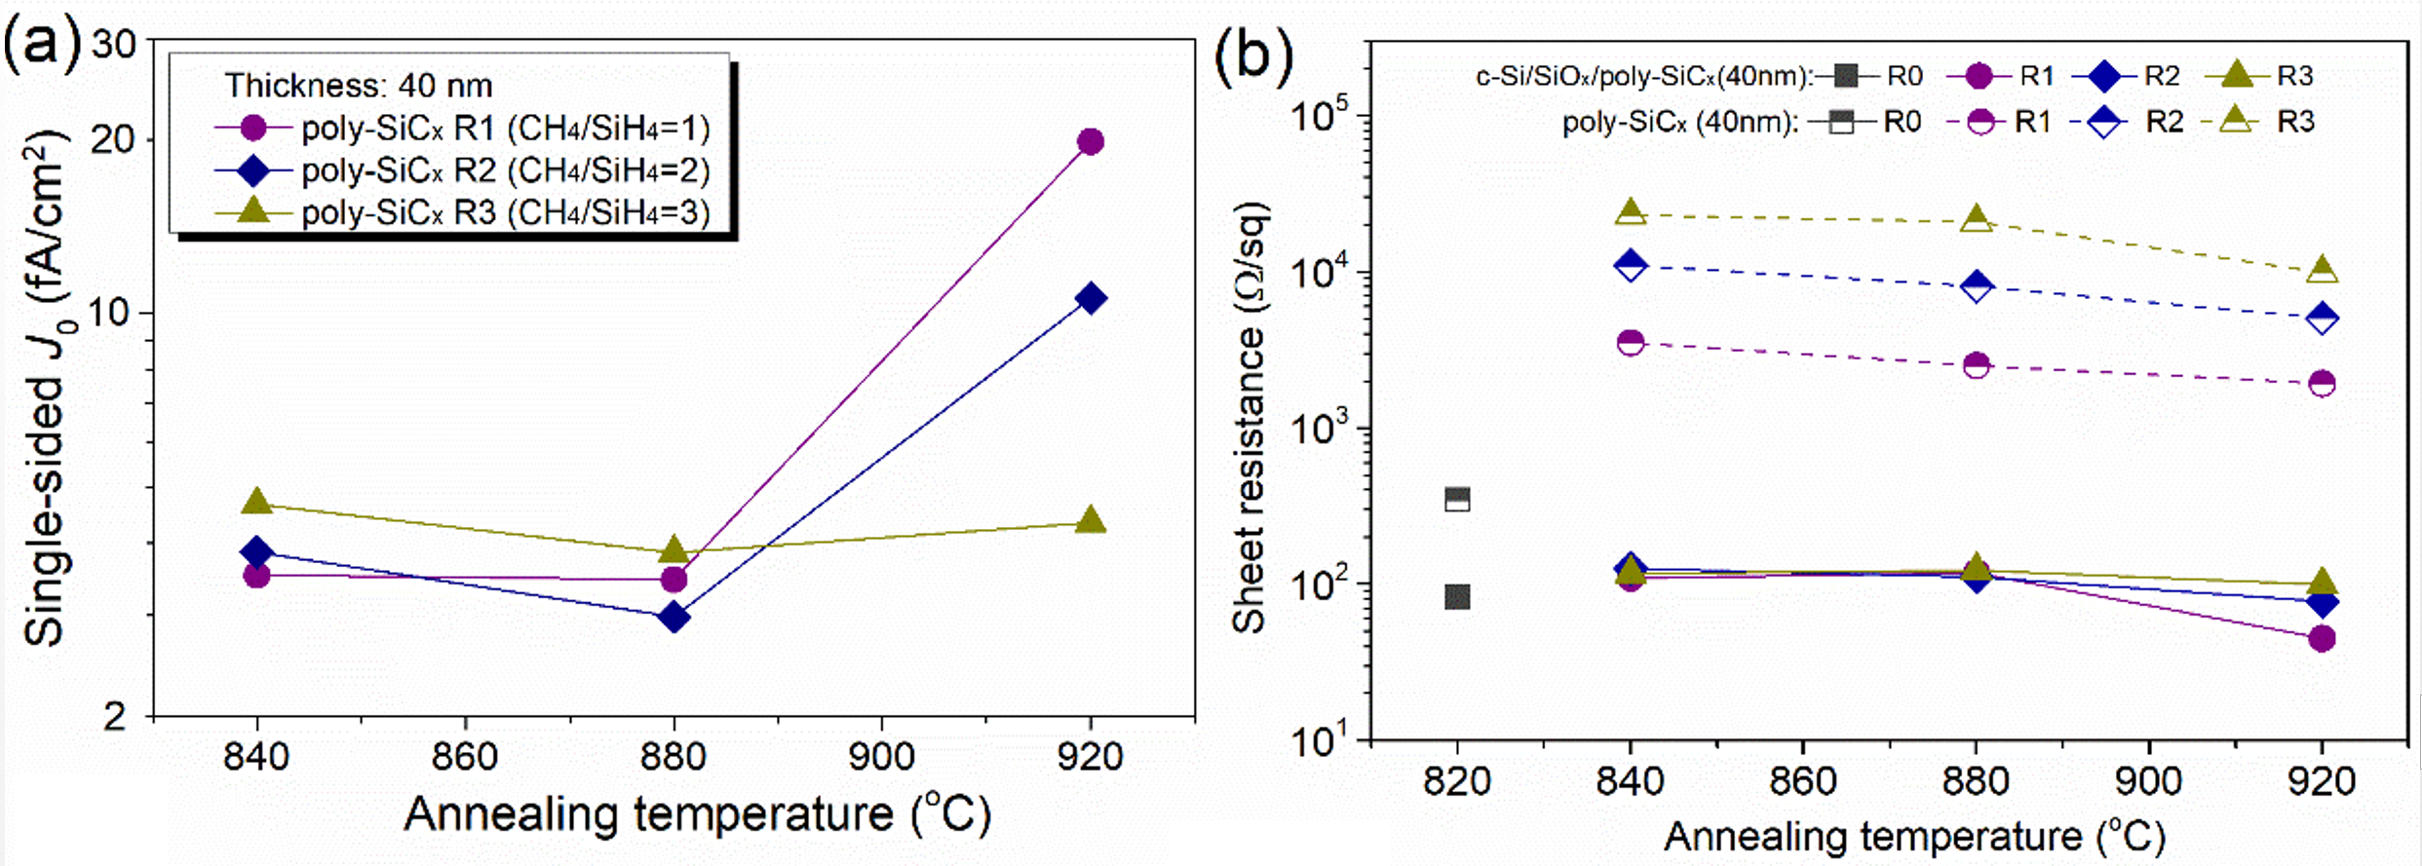
Figures 1 (a) Single-sided J₀ of the SiO_{x}/poly-SiC_{x} (R1, R2, R3) with different annealing temperatures (840-920ºC). (b) R_{sh} of the poly-SiC_{x} and SiO_{x}/poly-SiC_{x} with different annealing temperatures (840-920ºC). (c) Champion efficiency of the new solar cell and the controlled one.

Reference
[1] F. Feldmann, M. Bivour, C. Reichel, M. Hermle, S.W. Glunz, A passivated rear contact for high-efficiency n-type silicon solar cells enabling high Vocs and FF 82%, in: 28th European PV Solar Energy Conference and Exhibition, Paris, France, 2013.
[2] Y. Chen, D. Chen, C. Liu, W. Zigang, Y. Zou, Y. He, Y. Wang, L. Yuan, J. Gong, W. Lin, X. Zhang, Y. Yang, H. Shen, Z. Feng, P. P. Altermatt, P. J. Verlinden, Mass production of industrial tunnel oxide passivated contacts (i‐TOPCon) silicon solar cells with average efficiency over 23% and modules over 345 W, Prog. Photovoltaics, (2019).

