Extended Abstract for “A tropical case study quantifying solar irradiance collected on a car roof for vehicle integrated photovoltaics (VIPV) towards low-carbon cities”

1. Brief experimental background
The experiment methodology was an adaptation of Ota et al. that involved the installation of a pyranometer on the car roof.¹ The vehicle travelled a pre-determined route in a residential estate in Singapore over a period of six days over three timeslots: 0800 – 0900, 1230 – 1330, and 1800 – 1900. Each run of the experiment varied between 13 minutes to 18 minutes due to traffic lights, stopping for cars to pass, and waiting in line to enter the carpark. Sky camera images were taken at six pre-determined locations, three in route A where buildings are located North and South of the vehicle, and another three in route B where buildings are located East and West of the vehicle as seen in Figure 1.
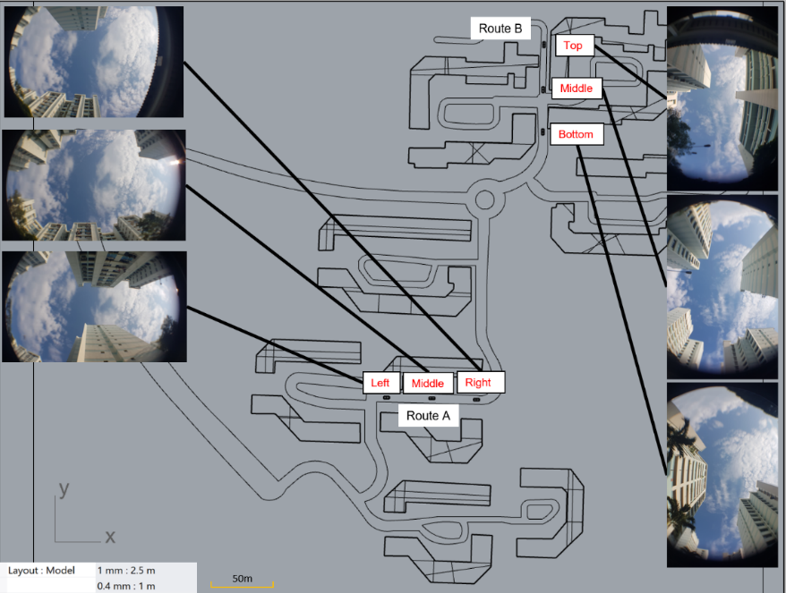
Figure 1: Visual schematic of the six locations where sky camera images were taken. Representative images were taken from the 0800 – 0900 timeslot on 1st November 2019.

2. Results and discussion on irradiance received at various times of the day
a) Comparing between time periods
Figure 2 presents the irradiance distribution for the three time periods comparing both routes A and B for all six days. For both routes, the range in solar irradiance received is the largest for the 1230-1330 period as compared to the other two. We attribute this to varying levels of shading as the car roof moves from a blocked to unblocked position. In the 0800-0900 period, the variation is smaller as the maximum irradiance value is smaller when compared to the 1230-1330 period, which is attributed to the higher proportion of diffuse irradiance. In the 1800-1900 period, the range of irradiance received is within the range or less than the minimum of the other two periods, potentially due to the reduced irradiance as the sun sets.

Figure 2: Comparison of irradiance collected over routes A and B over the 3 time periods.
b) Comparing between routes

Comparing the two routes, the effect of building orientation has a definitive impact on the irradiance readings in the 1230 – 1330 period whereby the median value is higher in route A than route B. East-West oriented street canyons were also reported to receive higher solar radiation than North-South orientation by Gong et al.,² which coincides with our experimental results. However, the median values between the two routes for the 0800 – 0900 and 1800 – 1900 period do not differ significantly. This is attributed to the higher proportion of direct irradiation received by the car roof in the 1230 – 1330 period as compared to the other two. Note that due to the high variability of irradiance received, the median value was used as a comparison rather than the average, which is affected by extreme values in solar irradiance in a dynamic environment.

3. Additional analysis in the main paper
In addition to the above results, the main paper investigated the effect of weather on solar irradiation received. Subsequently, we analysed the sky view factor (SVF) of the six locations identified in Figure 1. Due to the page limit of the extended abstract, these results are not presented in this document.

Nevertheless, we believe that the methodology developed and findings obtained from this study would be of significant interest to the photovoltaic community in the conference for sustainable urban environments.

References
¹ Ota, Y., Masuda, T., Araki, K., & Yamaguchi, M., Curve-Correction Factor for Characterization of the Output of a Three-Dimensional Curved Photovoltaic Module on a Car Roof, Coatings, 8(12), 432, 2018.

² Gong, F.-Y., Zeng, Z.-C., Ng, E., & Norford, L. K., Spatiotemporal patterns of street-level solar radiation estimated using Google Street View in a high-density urban environment, Building and Environment, 148, 547-566, 2019.

