Title: | Highly Productive Vacuum Deposition Equipment For High Efficient Crystalline Silicon Solar Cells
Authors: | Xuemei Cheng, Simon Hübner, Dirk Beisenherz, Frank May, Torsten Dippell, Peter Wohlfart
Address: | SINGULUS TECHNOLOGIES AG, Hanauer Landstr. 103, 63796, Kahl am Main, Germany
Corresponding author:  Phone:  E-mail: | Dr. Xuemei Cheng  +49 6188-440 142 / +86 13122006090  Xuemei.Cheng@Singulus.de
Abstract
In the race for higher conversion efficiency and lower cost of silicon solar cells, TOPCon (tunnel oxide passivated contact) and Heterojunction structures are regarded as the most promising candidates for mass production technology in the market [1]. As a consecutive upgrading technology of PERC solar cell, TOPCon structures incorporate an ultra-thin tunnel oxide and a thin doped poly silicon layer to ensure great passivation and excellent charge carrier selectivity at the same time, with at least two extra processing machines compared to the PERC process. A record efficiency of 24.9 % has already been achieved on n-type TOPCon monocrystalline solar cell [2]. One of the main challenges of mass production of TOPCon solar cells is that poly-silicon layers deposited by LPCVD show a rather low growth rate and exhibit certain inhomogeneity and strong wrap-around, which requires an additional etching step to clean the front side of the cell (fig1) [3]. SINGULUS has developed a high-throughput in-line PECVD production system based on the well-established GENERIS platform, designed for strictly single-sided deposition of oxide and doped silicon layers without wrap-around, which effectively reduces the complexity of the production process for TOPCon cells by using linear inductive coupled (ICP) and capacitive coupled (CCP) plasma sources.
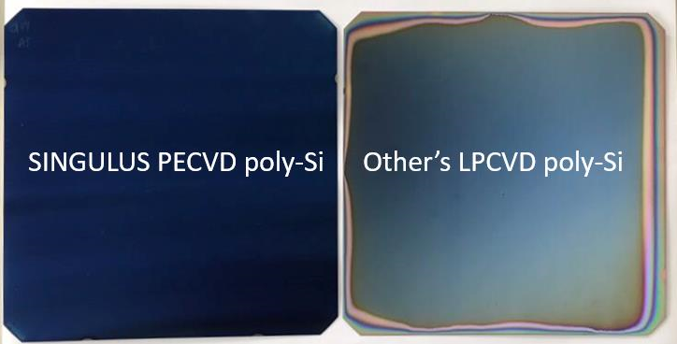
Figure 1: Wrap-around during poly-Si deposition, view of the rear side of the solar cell.
Left: No visual detectable wrap-around of poly-Si deposited by GENERIS PECVD;
right: high wrap-around detectable on the rear side of a solar cell coated with poly-Si by LPCVD
As for heterojunction (SHJ) solar cells, dozens of companies have already installed pilot lines to develop and are testing new technologies and process steps for mass production. We have been successfully supplied our low plasma damage, high-target utilization GENERIS PVD for ITO deposition to an industrial SHJ cell pilot line and achieved 24.1% in mass production [4]. In order to further enhance the SHJ cell efficiency, multi-layer structures of TCOs are considered to further decrease the contact resistivity at the interfaces between doped amorphous silicon TCO and metal contact layers in mass production [5]. Beyond that, SINGULUS is working on an upgrade of GENRIS PVD targeting on higher throughput (~10000 wafers/h), compatibility with larger wafer formats and a flexible modular design for multi-layer structures. Moreover, we are developing silicon oxide and doped silicon layers deposited directly in-line with the sputtering machine GENERIS PVD, which shows great potential to simplify the process flow of TOPCon cell production even more. Preliminary tests of in-line in-situ doped, sputtered n-type poly-Si on top of a wet chemical tunnel-oxide layer show very promising iVoc and recombination current values (fig2).
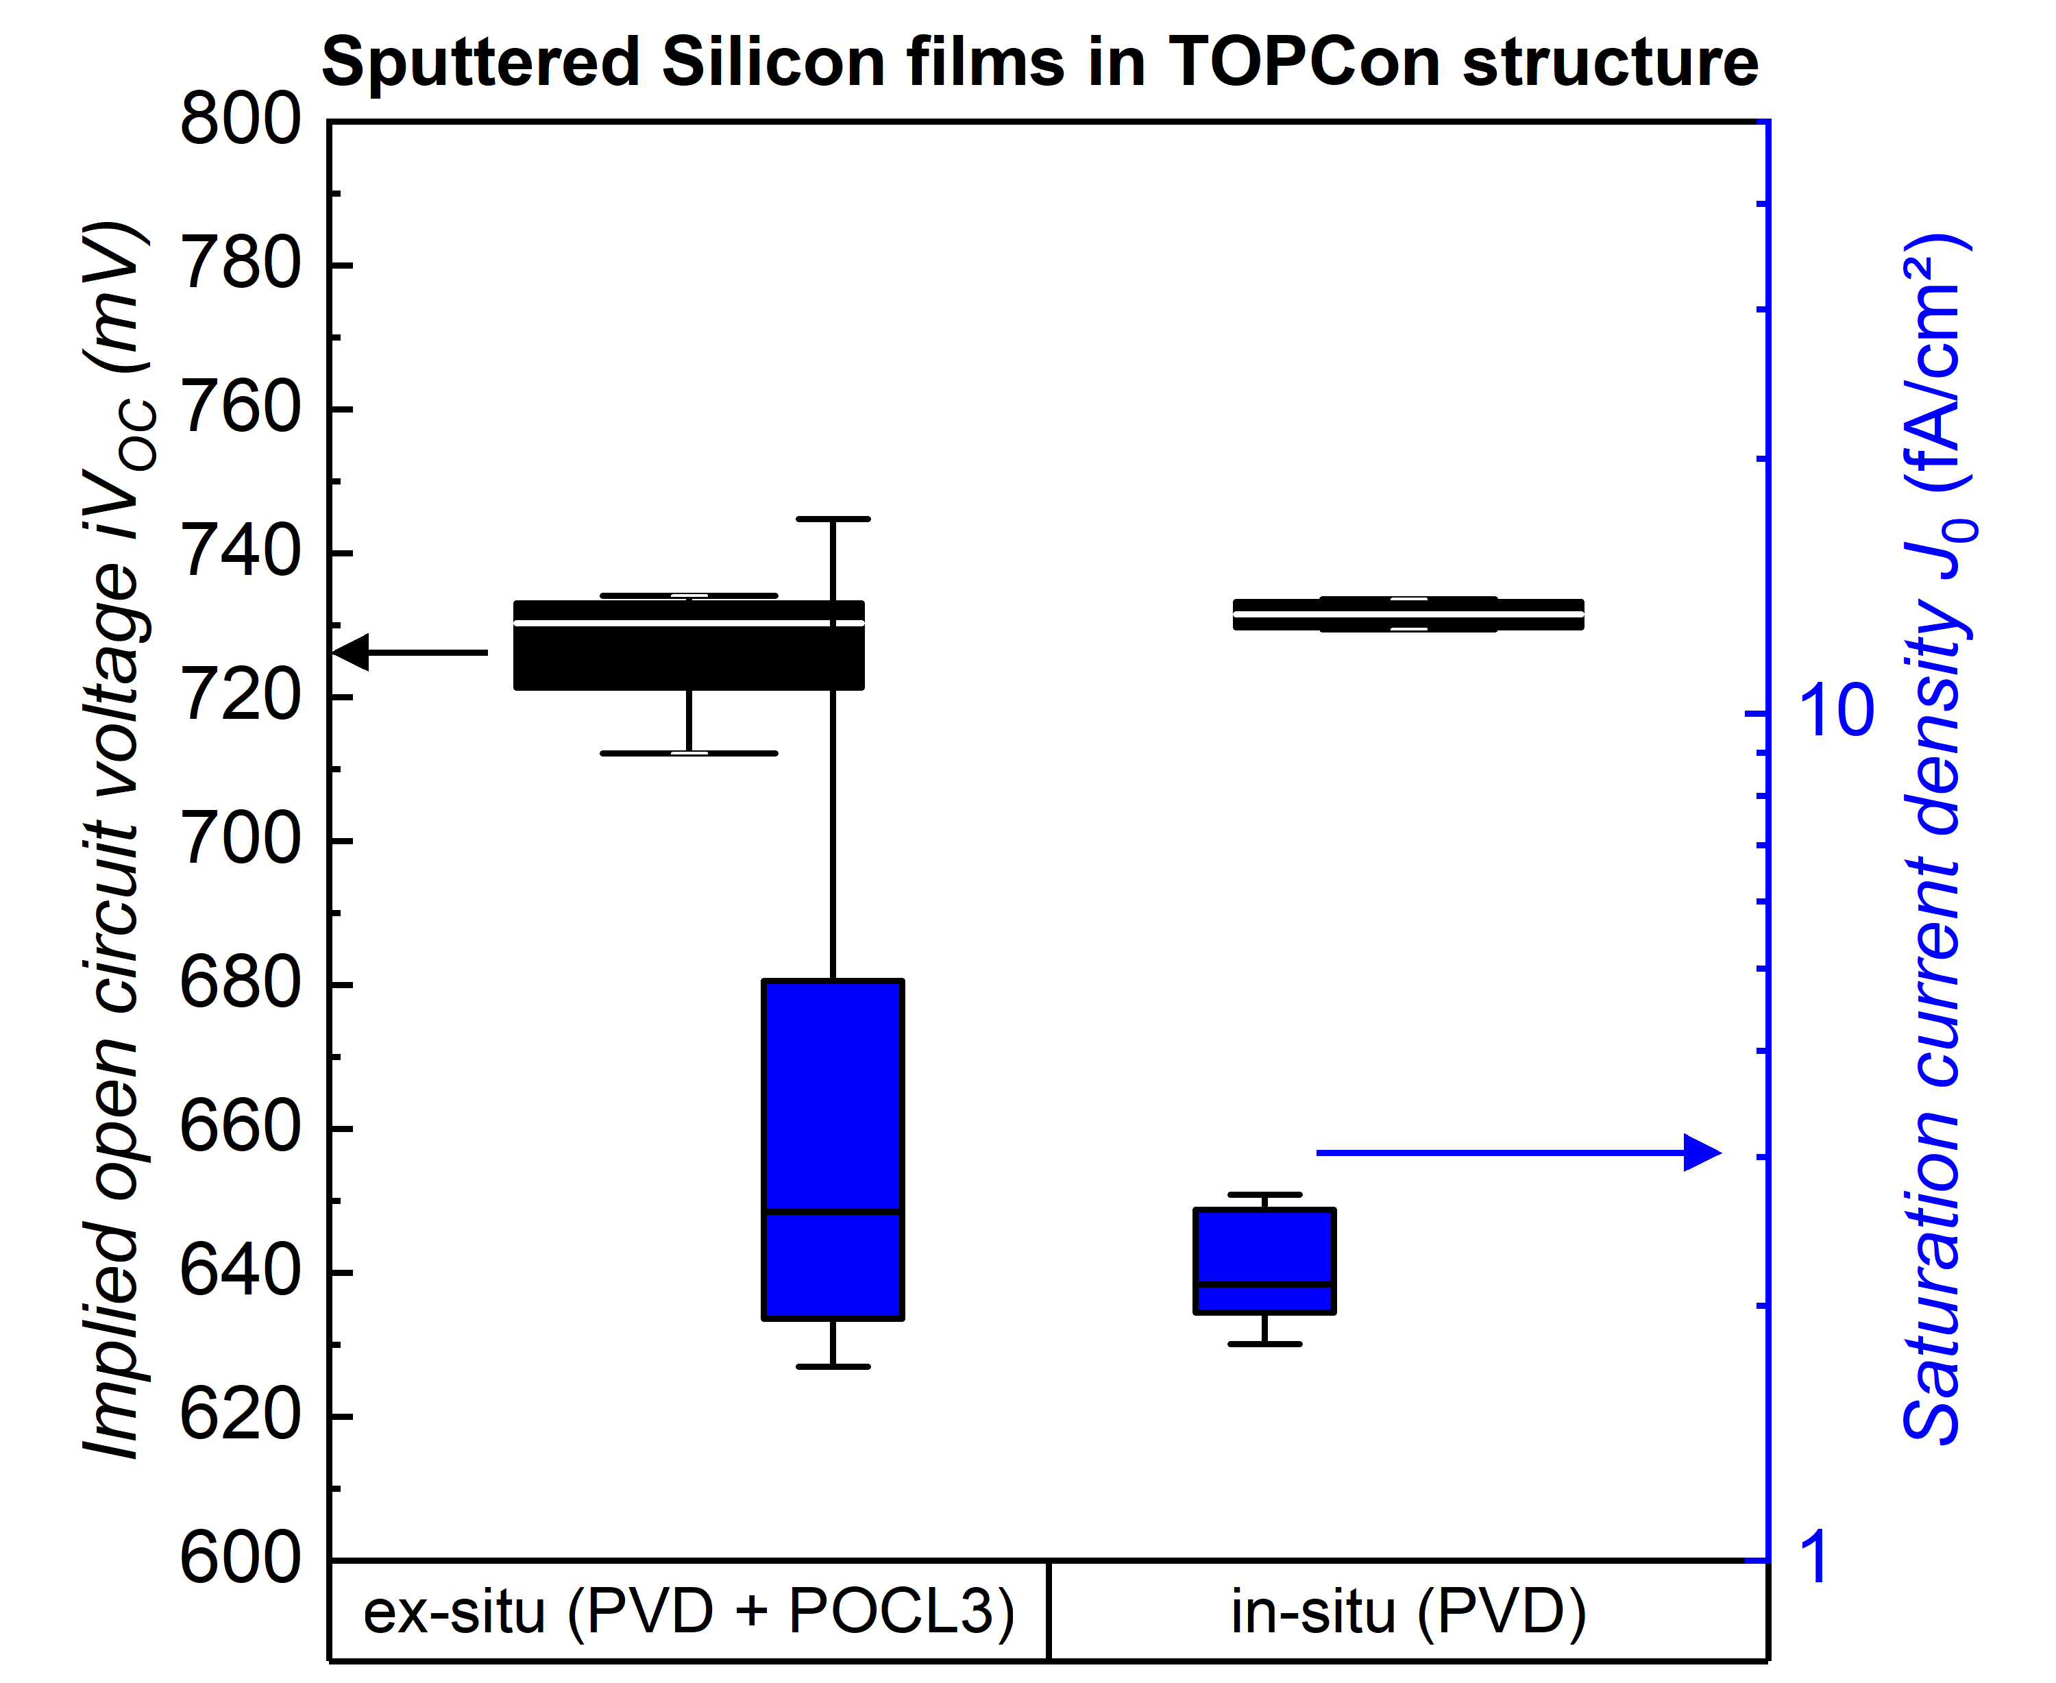
Figure 2: iVoc and J0 values of PVD sputtered n-type Si films with in-situ or ex-situ doping after anneal [6].
Beyond that, industrial c-Si cell producers are starting to seriously consider tandem solar cells, mostly based on perovskite top cells, as a future necessity to continuously increase cell efficiencies above the limit of a single junction Si solar cell. The development of industrial sputtering, evaporation and PECVD technologies for functional layers of perovskite-silicon tandem cells on industrial in-line equipment is ongoing.
We will present an actual state of development for industrial in-line vacuum deposition equipment applying PVD and PECVD processes with high throughput to achieve highest possible cell efficiency for different new crystalline silicon cell formats, including tandem structures, in a cost efficient way.
[1] Battaglia, Corsin, Andres Cuevas, and Stefaan De Wolf. "High-efficiency crystalline silicon solar cells: status and perspectives." Energy & Environmental Science 9.5 (2016): 1552-1576.
[2]https://www.pv-tech.org/news/jinkosolar-pushes-n-type-topcon-solar-cell-to-record-24.90-conversion-efficiency
[3] Chen, D. et al. 24.58% total area efficiency of screen-printed, large area industrial silicon solar cells with the tunnel oxide passivated contacts (i-TOPCon) design. Sol. Energ. Mat. Sol. Cells 206, 110258 (2020).
[4] Cheng, Xuemei. et al. High-Throughput, Low Damage Sputtering Machine For Transparent Conductive Oxides For Solar Cells. SNEC 2020.
[5] Bernd Stannowski, et al. TCOs for SHJ solar cells – What is a good choice?. 3rd SHJ workshop, October 19-21 2020
[6] L. Nasebandt, S. Hübner, B. Min, C. Hollemann, T. Dippell, P. Wohlfart, R. Peibst, R. Brendel,
EUPVSEC 2020, September 7 - 11, 2BO.1.3; and more recent results.

