(1) Title of Presentation: Long-term field proven material is the key to ensure 30 years of reliable PV modules
(2) Speaker/Presenter's short biography: Dr. Ji Xia is a Technical Specialist, mainly focusing on reliability test, field study and downstream for DuPont Photovoltaic and Advanced Materials in China. In this role, he is involved in developing solar panel applications and reliability research to support greater durability for solar panels. He has conducted extensive research on failure models and mechanisms of solar panels, especially related to the durability of backsheet, and initiated field studies of large-scale solar farms in China to evaluate long-term materials performance.
(3) Full Contact Information: Email: ji.xia@dupont.com, Tel:+86 13585518788.
(4) Topic Category: Materials (Cell, Backplate, Glass, Tin Coated Strip, EVA, Frame, Silica Gel, Junction Box, etc.)

Abstract: The global solar photovoltaic (PV) market is expected to increase by 158 GW, an increase of 34% over its expected 2020 figure. However, along with the rapid development, failure mechanisms of PV modules and their components under different specific environments in field have not been well understood yet. Since 2011, DuPont has conducted global field surveys to inspect, assess and understand the state of degradation of fielded PV modules and materials. In this study, we will provide an overview of DuPont’s field reliability efforts, share the latest global field study results from 2020 and highlight several specific failure cases in China. The 2020 update was compiled from inspection of 551 installations (>9 million modules at 3 GW) around the globe. About 35% of this data comes from China, and includes analysis of field data, components, materials, ages, and failure modes. The results indicate that 30% of surveyed modules show defects, where backsheet defects are 16%, cell defects are 12%, and encapsulant defects are 7%.
China, as the country with the fastest development of the PV industry, has installed many solar farms with different BoMs in different climate zones during recent decades. During our field inspections, we found module failures and component material failure. These include PVDF based backsheet outer layers cracking and inner layer defects in different climates, FEVE coating based backsheets having mildew, abrasion issues and inner layer cracks, and Glass/Glass modules suffering from bowing and bending leading to cracking and eventual damage of glass, and delamination of the glass from encapsulants.. Based on such field inspection data, it is very critical and crucial to select reliable module type and materials for PV systems to ensure long-term reliability, as low-quality, unproven materials will degrade quickly when exposed to environmental stresses, which will bring irreparable losses for both module makers and stakeholders.

Keywords: Backsheet defect; PV module; field analysis; Glass/Glass.

Extended Abstract
It is expected that 158 GW of new PV will be installed worldwide next year. That would represent a 34% increase over its expected 2020 figure, and the analysts expect a “wild ride” for the PV industry in 2021.The firm expects 2020 installations to come in at around 118 GW, a 5% decline compared with 2019 caused by Covid-19 pandemic.
With the high-speed growth of the PV industry, more and more owners and developers, and other parts of the PV supply chain, are concerned about the quality of solar farms being built. For the module and its components, combining field results with accelerated tests gives powerful insights on performance of today’s materials in the future.
Since 2011, DuPont has conducted worldwide field surveys to inspect, assess and understand the state of degradation of fielded PV modules and materials. The 2020 update was compiled from inspection and analysis of 551 installations (>9 million modules at 3 GW) around the globe, including field data, components, material, age, failure mode. The majority of modules we inspected were defect free. Various defects were observed in 30% of the modules inspected, among which, backsheet defects were 16%, cell defects were 12%, and encapsulant defects were 7%.
In this study, we focus our attention on backsheet and glass durability in the field. Various kinds of backsheet and glass defects have been observed in our field study, including backsheet outer-layer (air side) and inner-layer (cell side) cracking, backsheet delamination, backsheet out-layer and inner-layer yellowing, backsheet bubble formation, glass bowing and bending, glass delamination, glass breakage etc., which can cause high leakage currents that trip inverters, leading to power loss, and module fires. Backsheet defects increased from 14% to 16% vs. 2019, and cracking comprises 64% of all backsheet defects.
In some typical cases, more than 10% of inspected PVDF fields 4 years or older show significant cracking. We have found at least 5 PVDF cracking cases last year under different climates in China, and total 20+ cases worldwide. Fig.1 shows clear and sharp edges of cracks. The visible cracks along machine direction of PVDF (tri-layer PVDF) backsheets exposed in Gansu for 5.5 years are also observed, the cracking ratio is up to 30% of total 20MW capacity, and power loss is about 10% after only 5.5 years’ service. From SEM analysis in Fig.1, through cracking of tri-layer PVDF were observed, which indicated that the outer-layer PVDF has completely cracked. Fig.2 shows serious cracking of PVDF (single layer PVDF) based backsheets exposed in the Qinghai for 5 years. The cracking ratio is up to 90% of 20MW capacity, almost all modules suffered backsheet cracking. These PVDF widespread cracks facilitate delamination, resulting in direct exposure of the backsheet core layer to the environment. From these cases, we can see that both single layer PVDF and tri-layer PVDF based backsheet might not meet the long-term outdoor reliability requirements of PV modules.
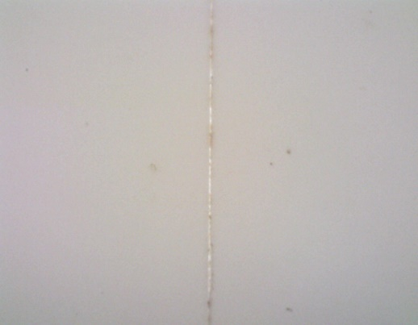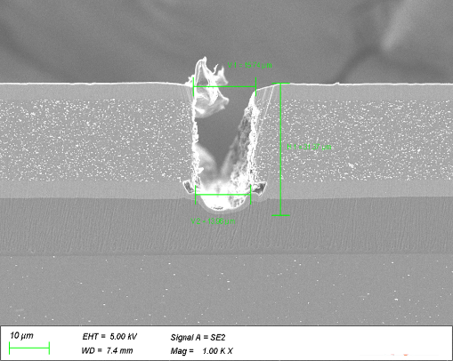
Fig 1: Cracking of PVDF backsheet exposed in Gansu for 5.5 years(left); cross section SEM of cracking backsheet(right).
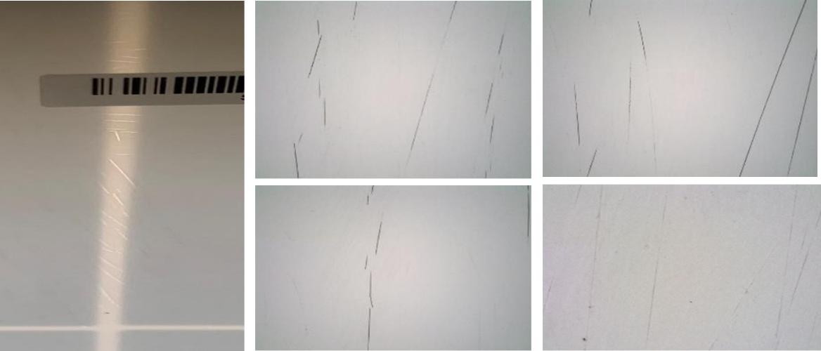
Fig 2: Cracking of PVDF backsheet exposed in Qinghai for 6 years
In a 6-year-old PV installation in western China, FEVE based backsheets shows serious quality issues. Fig.4 shows several abrasion and corrosion on the outer surface of the backsheets. Fig.5 shows serious mildew and vestige of moisture penetration on the surface. These are only observed in FEVE based backsheet，which may be caused by noncompactness and poor anti abrasion performance of FEVE backsheet. These failures facilitate moisture ingress, often leading to busbar corrosion, and will further develop to electrical shorting and power loss, and in several instances have led to module fires.
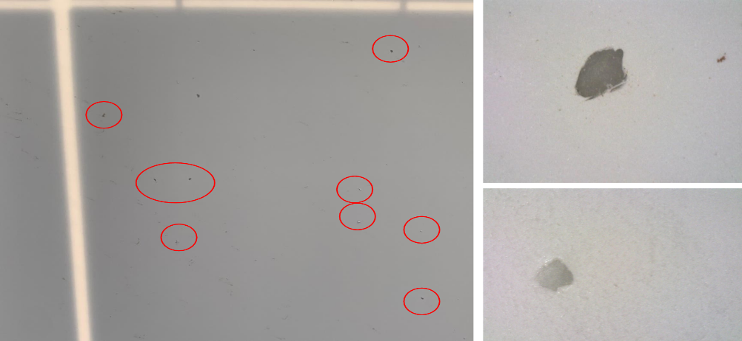
Fig 3: Abrasion and corrosion of FEVE based backsheet exposed in western China for 6 years
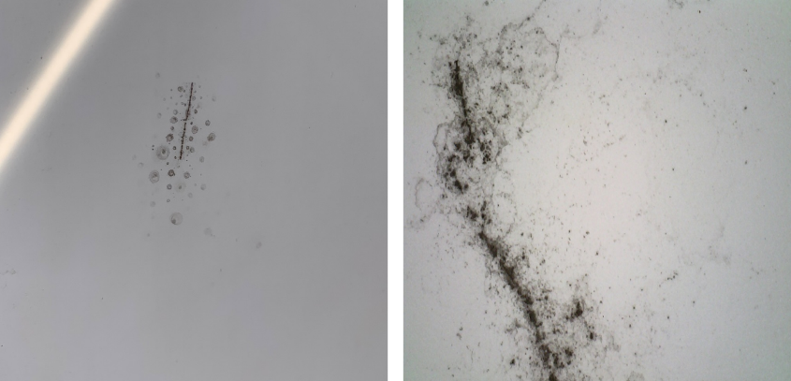
Fig 4: Mildew of FEVE based backsheet exposed in western China for 6 years
Due to the recent blooming of bi-facial cells and modules, some developers have adopted G/G modules, but a large number of operation and maintenance personnel complaints about high glass breakage rate during transportation, installation and operation, large scale G/G failure due to simple bracket issues. Fig.5 shows glass breakage in G/G modules during normal outdoor service after only 2- and 4-years’ service. The glass breakage rate is about 10% and 20%, respectively. Fig.6 shows large scale G/G failure caused by support system failure, which will cause electrical shorting, power loss, and safety problems.
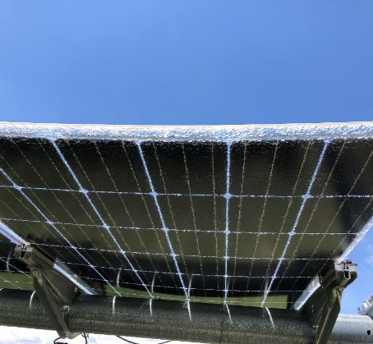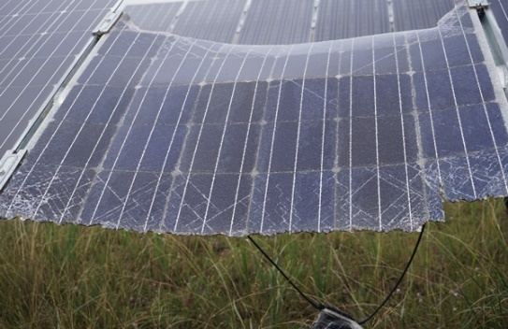
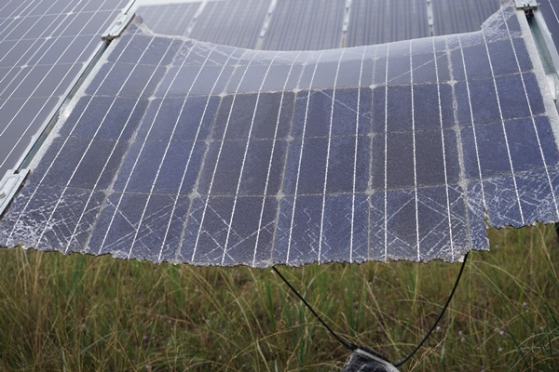
Fig 5: 10% glass breakage in western China for 2 years(left) and 20% for 4 years(right) 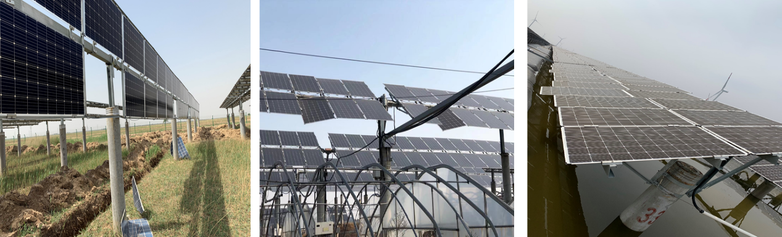
Fig 6: Large scale G/G failure due to simple bracket issues in northern and eastern China
Module durability is important to deliver expected financial results to system their owners. We will continue field investigations to understand failures and degradation mechanisms and use field results to guide development of lab accelerated aging test methods to qualify durable designs and materials.

