新闻稿
共赏 共建 共治 共享
全球绿色能源产业数字金融平台——GreenGold(绿金)助力绿色能源数字化发展
Witnessing, Building, Governing and Sharing
Global Green Energy Industry Digital Financial Platform -- GreenGold
To Help the Development of Digital Green Energy

全球绿色能源理事会（Global Green Energy Industry Council，简称“GGEIC”）于西班牙马德里当地时间12月6日在第二十五届联合国气候变化大会(COP25)期间正式启动全球绿色能源产业数字金融平台——GreenGold(绿金)，助力绿色能源数字化发展。
The Global Green Energy Industry Council (GGEIC) officially launched the global green energy industry digital financial platform - GreenGold during the 25th United Nations Climate Change Conference (COP25) on December 6, local time in Madrid, Spain, to help the digital development of green energy.

GreenGold(绿金)由国际绿色能源组织如全球绿色能源理事会(GGEIC)，学术研究机构如清华x-lab数权经济实验室，国际科技金融组织如国际数权经济合作联盟（香港），绿色能源领军企业协鑫、天合、上迈、阿特斯、中国电建贵州工程公司等共同发起，将基于区块链技术，建设全球绿色能源产业数字金融平台，推动能源数字金融投资、数字资产交易。
GreenGold is launched by international green energy groups such as Global Green Energy Industry Council (GGEIC), academic research institutions such as Tsinghua University’s x-lab digital rights economy laboratory, international financial organizations such as Hong Kong Branch of International Digital Rights Economic Cooperation Alliance (IDREC), leading green energy enterprises such as GCL, Trina Solar, Sunman, Canadian Solar inc., POWERCHINA Guizhou Engineering Co., Ltd. Based on blockchain technologies , GreenGold aims to build a global digital financial platform for green energy industry, and promotes energy digital financial investment and digital asset transaction

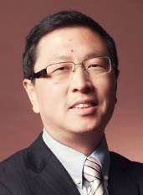 | 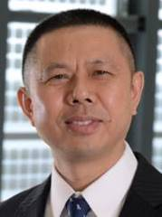 | 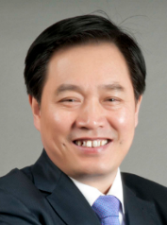 | 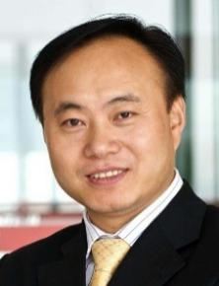 | 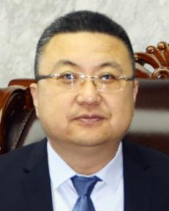
瞿晓铧 博士  阿特斯阳光电力集团董事长兼CEO | 高纪凡 先生  中国光伏行业协会理事长；天合光能有限公司董事长 | 朱共山 先生  全球太阳能理事会(GSC)主席；亚洲光伏行业协会(APVIA)主席；协鑫（集团）控股有限公司董事长 | 施正荣 博士  澳大利亚国家科学和工程技术院院士；上迈（上海）新能源科技有限公司董事长 | 郭玮 先生  中国电建集团贵州工程公司董事长
Dr. Xiaohua Qu  Chairman and CEO of Canadian Solar Inc. | Mr. Jifan Gao  Chairman of China Photovoltaic Industry Association；  Chairman of Trina Solar Co., Ltd | Mr. Gongshan Zhu  Chairman of Global Solar Council(GSC)；  Chairman of Asian Photovoltaic Industry Association (APVIA);  Chairman of GCL Power (Group) Co., Ltd | Dr Zhengrong SHI  Fellow of ATSE, Australia; Chairman of SUNMAN | Mr GuoWei  Power China Guizhou Engineering Co., Ltd

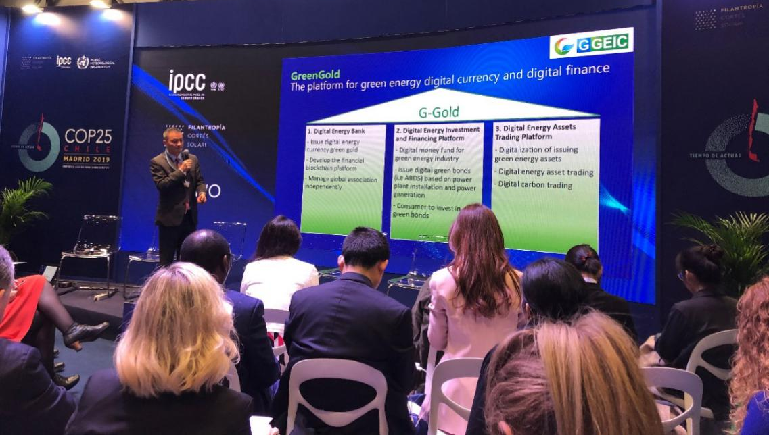
全球绿色能源理事会(GGEIC)主席朱共山先生与秘书长Angela Grassi女士的代表米月女士和全球绿色能源理事会(GGEIC)常务副秘书长罗鑫先生一同出席了此次大会。罗鑫先生在会上详细介绍了GreenGold(绿金)平台创建的宗旨、目标与规划。他指出“区块链技术作为数字时代的前沿创新技术已开始引领新一轮的科技革命和产业变革，极大推动着数字产业化的整体发展。随着区块链底层技术的不断发展，区块链的价值在于与能源交易，以及在能源领域数字化相关的过程实现融合发展，可以安全高效的存储数据，实现数据的有效共享，加速绿色能源的发展。”
On behalf of Mr. Zhu Gongshan, President of the Global Green Energy Council (GGEIC), and Ms. Angela Grassi, Secretary General of GGEIC, Ms. Mi Yue attended the conference,together with Mr. Luo Xin, Deputy Secretary-General of GGEIC. At the meeting, Mr. Luo Xin introduced in detail the purpose, goal and plan of the platform, GreenGold. He said: “Blockchain technology, as a cutting-edge innovation technology in the digital era, has begun to lead a new round of scientific and technological revolution and industrial transformation, greatly promoting the overall development of digital industrialization.The value of blockchain technology, whose underlying technology develops continuously, lies in the integration and development of the processes related to energy trading and the digitalization in the energy field, which can store data safely and efficiently, realize the effective sharing of data, and accelerate the development of green energy. ”
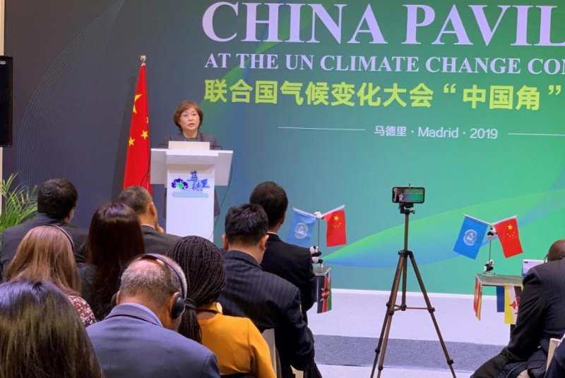
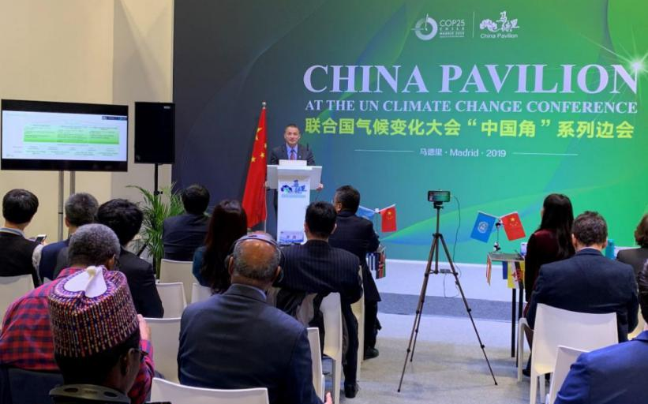
全球能源互联网发展合作组织合作局徐明副局长、21世纪可再生能源政策平台执行秘书拉娜阿迪布女士、欧洲太阳能热电协会主席、西班牙太阳能热电产业协会主席路易斯克雷斯波博士、新能源基金会有限公司总裁王昭孟琦女士、金风科技旗下北京光合加科技有限公司总经理刘哲女士等国际组织代表与行业人士对GreenGold(绿金)的启动表示祝贺，并希望未来有更多机会与全球绿色能源理事会及GreenGold(绿金)平台展开合作。
The launching of GreenGold have received a wide range of congratulations from many representatives of international organizations and industry, including Dr. Xu Ming, Deputy Director of Global Energy Interconnection Development and Cooperation Organization; Ms. Lana Adib, Executive Secretary of the 21st Century Renewable Energy Policy Platform; Dr Louis Crespo, Chairman of the European Solar Thermal Electricity Association, Chairman of the Spanish Solar Thermal Electricity Association; Ms. Mengqi Wangzhao, President of the New Energy Foundation Co., Ltd.; Ms. Liu Zhe, General Manager of Beijing Green Plus Technology Co., Ltd., a subsidiary of Goldwind Technology Group. Meanwhile, they also expressed hope to see more opportunities in the future to cooperate with the Global Green Energy Industry Council (GGEICE) and the GreenGold (Green Gold) platform.
发展绿色能源是应对气候变化的重要举措，离不开全球绿色能源体系的大联合、大协作。全球绿色能源理事会(GGEIC)衷心希望能与全球践行绿色发展理念的同仁一道，为促进世界能源绿色、可持续发展，落实《巴黎协定》和联合国21世纪行动计划作出应有的贡献。
The development of green energy is an important measure to cope with climate change, which is inseparable from the global green energy system. The Global Green Energy Council (GGEIC) sincerely hopes to make contributions to promoting the green and sustainable development of the world's energy, and to make contributions to implementing the Paris Agreement and the 21st century United Nations action plan together with global colleagues who practice the concept of green development.

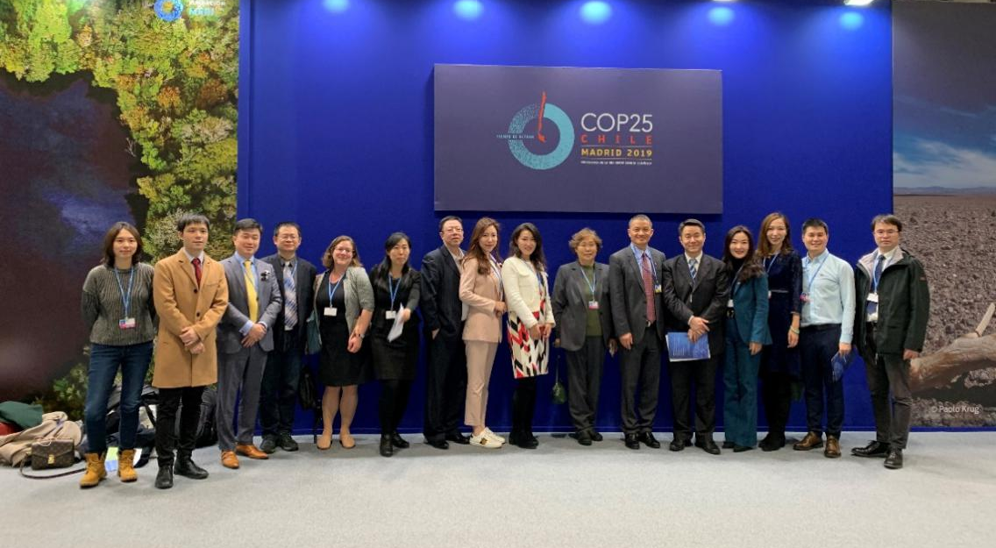

全球绿色能源理事会(GGEIC)：
全球绿色能源理事会(GGEIC)由欧洲生物质工业协会(EUBIA)、亚太新能源产业协会(NEIAAP)和亚洲光伏产业协会(APVIA)等国际性及区域性组织共同发起，阳光动力基金会(SIF)、全球太阳能理事会(GSC)、全球储能联盟(GESA)、能源政策创新国际研究院(IIEPI)以及来自西班牙、法国、意大利、中国、印度、韩国、澳大利亚、马来西亚、菲律宾、新加坡、沙特、以色列等国家的太阳能或可再生能源行业机构支持。理事会旨在促进和推动绿色能源产业在全球的发展，是绿色能源的信息共享平台和社交网络中心。

Global Green Energy Industry Council (GGEIC)
Global Green Energy Industry Council (GGEIC) is initiated and co-founded by the international or regional organizations: European Biomass Industry Association (EUBIA), New Energy Industry Association Asia Pacific (NEIAAP), Asian Photovoltaic Industry Association (APVIA), etc. Supporting organizations include Solar Impulse Foundation (SIF), Global Solar Council (GSC), Global Energy Storage Alliance (GESA), International Institute for Energy Policy Innovation (IIEPI), and national solar or renewable associations from Spain, France, Italy, China, India, South Korea, Australia, Malaysia, Philippines, Singapore, Saudi Arabia, Israel, etc.

