SNEC 2021
High Performance and Durability of Transparent PV Backsheets, William Gambogi
January 13, 2021
The adoption of bifacial PV modules presents new challenges in the selection of materials appropriate for long term performance. Monofacial PV modules have been produced for more than 30 years and the packaging materials appropriate for these PV modules have been tested and performed well in the field including backsheets using Tedlar® PVF based backsheets. A key consideration for successful performance has been accelerated tested based on the expected outdoor exposure of these materials in the field. In recent years, accelerated test results have predicted durability issues with some new backsheet materials including polyamide (PA) and polyvinyldifluoride (PVDF) based backsheets that have later been found to have failures in the field.
Transparent backsheets used in bifacial PV modules present new challenges in the assessment of the durability. The accelerated test methods for backsheet evaluation for monofacial modules has been established within the industry and is now being adopted within industrial standard. Similar accelerated test methods can be applied to transparent backsheets for bifacial modules but some modification and additional performance characterizations need to be considered. As an example, transparent films and backsheets are expected to maintain their mechanical properties and high light transmission over the life of the module so that the output power of the bifacial module is maintained. Examples of the stability of these properties is shown in Figure 1 and 2 below.
There are common performance and durability requirements that transparent backsheets need to meet to insure long term performance. The mechanical and optical properties need to be maintained under accelerated testing using appropriate temperature, humidity, UV and thermal cycling. While the levels and duration of these exposure is still under study, some guidelines have been established. As an example, the use of UV durability using xenon and/or UVA fluorescent lamps are used in the PV industry as has been the case in other industries. Recently, UV metal halide (UVMH) lamps have been considered as an approach to assess UV durability due to the higher intensity of these sources and despite the mismatch of the emission spectra when compared to solar exposure. While these UVMH sources may be used for highly accelerated screening, the higher exposure intensity, the high thermal transfer and significant spectral mismatch of the UVMH makes this source suspect and renders it inappropriate for long term assessment. A comparison of the solar emission spectra is compared in Figure 3 with xenon lamp emission and the emission of two UVMH lamps. Good match is observed for xenon while poor match is observed for UVMH and high irradiance is found in the short wavelength range is found for the UVMH1 source.
Improved accelerated test methods have also been developed within the PV industry to better predict long term performance using simultaneous stress conditions. While these methods are critical to product assessment within a time commensurate with new product introduction in the PV industry, synergistic effects from these approaches need to be compared to outdoor performance and the stress conditions applied need to avoid stress conditions that are not relevant to outdoor exposure.
Comparison of accelerated test methods will be discussed and compared as they relate to their suitability to predict outdoor performance of transparent backsheets.
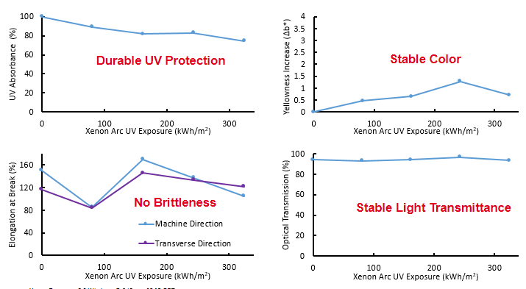
Figure 1. Stability of optical and mechanical properties of transparent PVF film
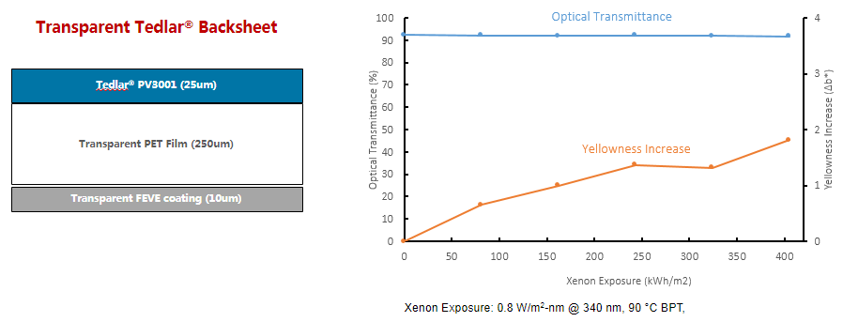
Figure 2. Structure and stability of transparent backsheet based on transparent PVF film
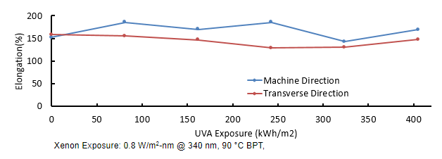
Figure 3. UV Stability of transparent PVF-based backsheet using extended xenon exposure
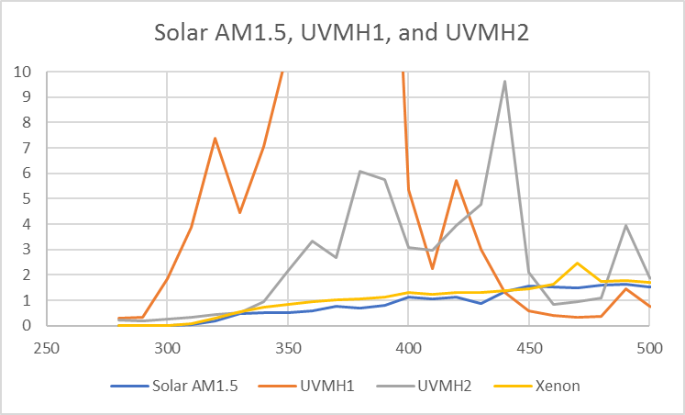
Figure 4. Comparison of UV emission spectra of various UV sources used in backsheet evaluation

