Title of the Presentation: Long term durability of transparent Tedlar®-based backsheets for bifacial PV module designs
Abstract: Transparent backsheets based on clear Tedlar® PVF have been developed based on field-proven Telar® polyvinylfluoride (PVF) films. The stability of the clear PVF has been established using accelerated stress testing of key properties needed for long term performance in the field. Backsheets have been rpoduced based on core layers and inner layers optimized for durability of optical and mechanical properties needed for bifacial photovoltaic modules. These clear backsheets include a patterned white pattern to allow more efficient use of the available incident and albedo light. Key properties are tracked through accelerated testing of backsheets and bifacial modules. The stability under expected UV exposure for harsh environments over expected PV module lifetime is demonstrated. The advantages of the field-proven glass/backsheets PV module structure are discussed including lower overall module weight, compatibility with high yield PV module manufacturing processes, improved power generation, reduced degradation, reduced O&M costs.
Topic: Crystalling Silicon Solar Cells & Materials
Author Names: William Gambogi, Michael Demko, Bao-Ling Yu, Sherly Kurian, Steven MacMaster, Kaushik Roy Choudhury, Daniel Lee, Hongjie Hu
Organization/Corporate: DuPont
Speaker/Presenter:
Position: Technical Fellow
Organization/Corporate: DuPont
Email: william .j.gambogi@dupont.com
Mobile: 302-593-9785
Country: USA
Brief introduction of speaker/presenter: William Gambogi is a Technical Fellow with DuPont Photovoltaic & Advanced Materials business. His work focuses on photovoltaic materials and their impact on performance and durability. He has worked at DuPont for more than 30 years and has been involved in several new product developments. He has contributed to over 30 patents and more than 30 technical publications, and regularly delivers technical presentations at international industry conferences.
Primary Contact
Name: William Gambogi
Position: Technical Fellow
Organization: DuPont
Email: william.j.gambogi@dupont.com
Tel: 302-593-9785
Extended abstract (not to be published)
Transparent backsheets based on Teldar® polyvinylfluoride films have advantages in performance and summarized below.
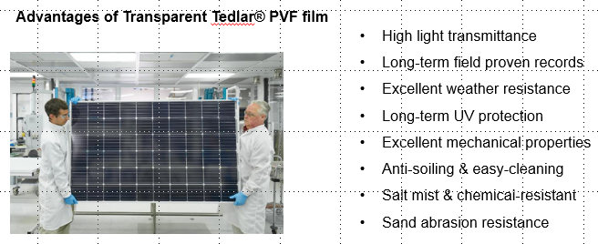
These films provide high light transmission and excellent mechanical properties as shown below.
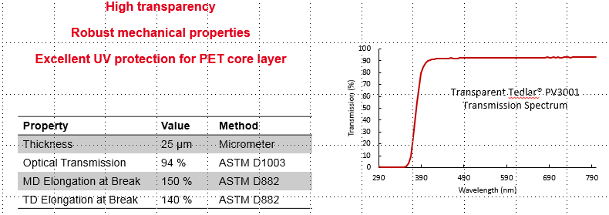
These properties are maintained in durability testing as shown below.
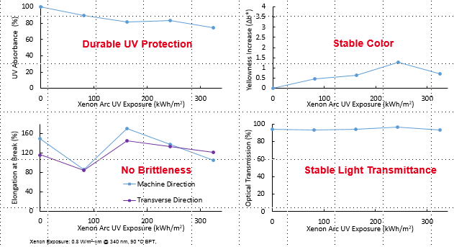
Producing transparent backsheets based on these materials has resulted in high performance and durability as shown in the figures below.
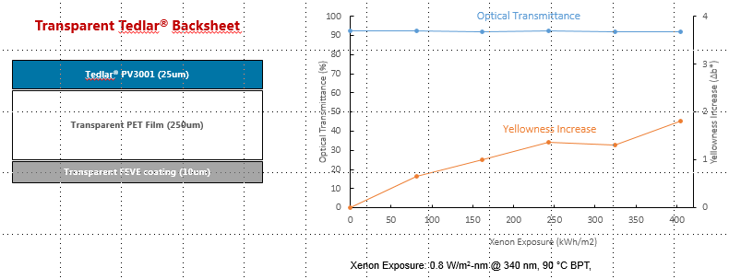
This high durability has been demonstrated has superior over other transparent pv backsheets as below.
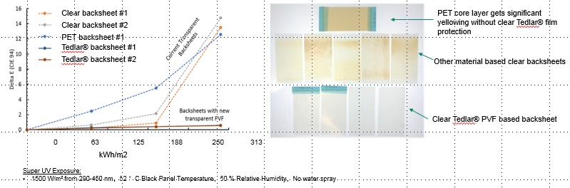
The long term durability of these Tedlar® based PV backsheets has been shown for damp heat and UV and shown better low temperature mechanical properties compared to transparent PVDF.
