综合能源局域网聚合商的能量管理平台
Energy management platform for aggregators in integrated local energy systems
可再生能源与负荷侧两端的不确定性同时不断增加，是电力系统低碳安全运行面临的最大机遇与挑战。本次演讲介绍适应综合能源局域网聚合商的分布式电/热/气资源的协调优化解决方案，合理配置储能容量，确定各能源存储与转换设备的优化运行策略，提高能源系统灵活性。通过聚合商调控源-荷-储多能流，实现平抑能源局域网的不确定性与波动性目标，有助于减轻电网公司的调峰难题。
Uncertainties from renewable energy generation and consumption are increasing, which present both opportunities and challenges for low carbon and reliable power system operation. This talk will present optimal solutions for local energy Aggregators to coordinate the operation of distributed energy resources and load aggregation across vectors (electric, heat and gas). The model will determine the size of energy storage and optimize the operation strategy of energy storage and conversion devices to increase the power system flexibility. In this modelling platform, multi-energy flows of supply, demand and storage are optimized and controlled by Aggregators to cope with the variability and uncertainty of local integrated energy systems, which will help alleviate utility companies from the undue burden of peak regulation problem.
本次演讲介绍本人基于国内外10余年经验开发的模型与平台，展示综合能源局域网（配电网、热力网与燃气网）及各类能源转换设备与储存设备的优化运行，输入与输出如下：
1）Excel文件格式输入数据：配电网、热力网与燃气网节点详细页面、节点能源转换设备页面、电/热/气节点负荷时域页面、光伏-储能节点数据页面、经济数据页面；
2）实时生成Excel文件的输出数据：各类设备出力动态效果与各网络状态变量（电压幅值与相角、热网节点供水与回水温度、管道质量流量、节点压力等，以及综合能源系统技术经济性指标分析(投资成本CAPEX/运行成本OPEX、净现值NPV、内部收益率IRR、平准化度电成本LCOE等)。
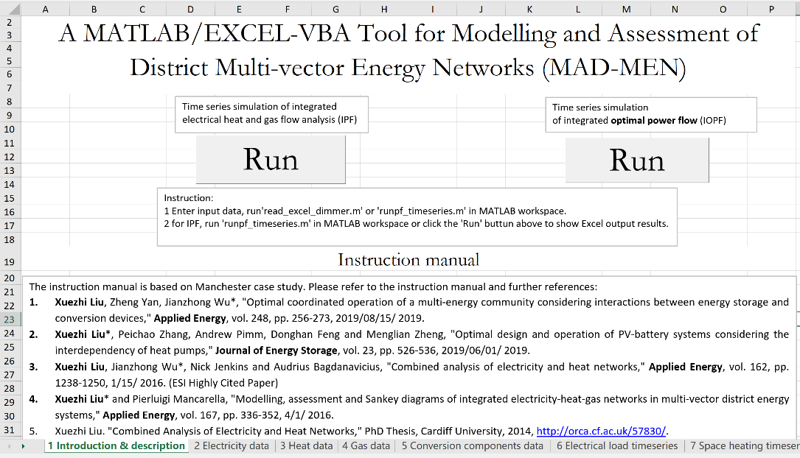

图1：聚合商能源管理平台的EXCEL用户界面
输出可视化能流图，描述能量流从供给侧到用户侧经过各能源转换设备的过程，如图2所示。通过与优化运行之前的能流图进行对比，得出燃料消耗、净购入电量、碳排放等指标的直观结果分析。
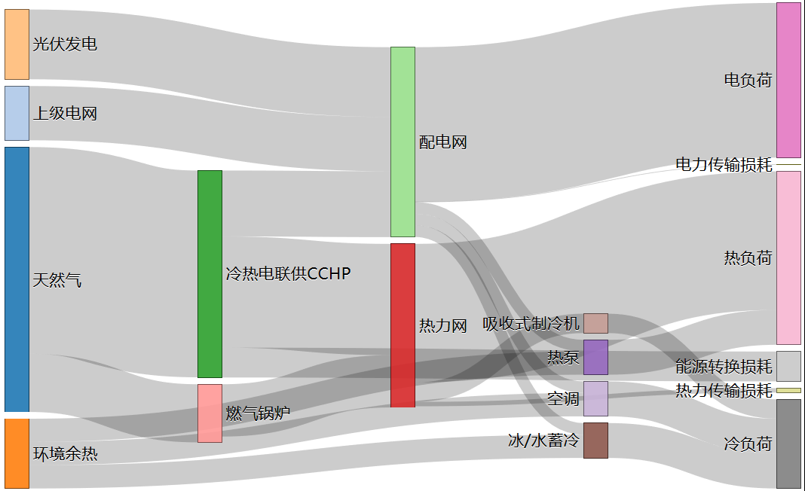
图2：能源从供给侧经各种能源转换设备到用户侧的能流图
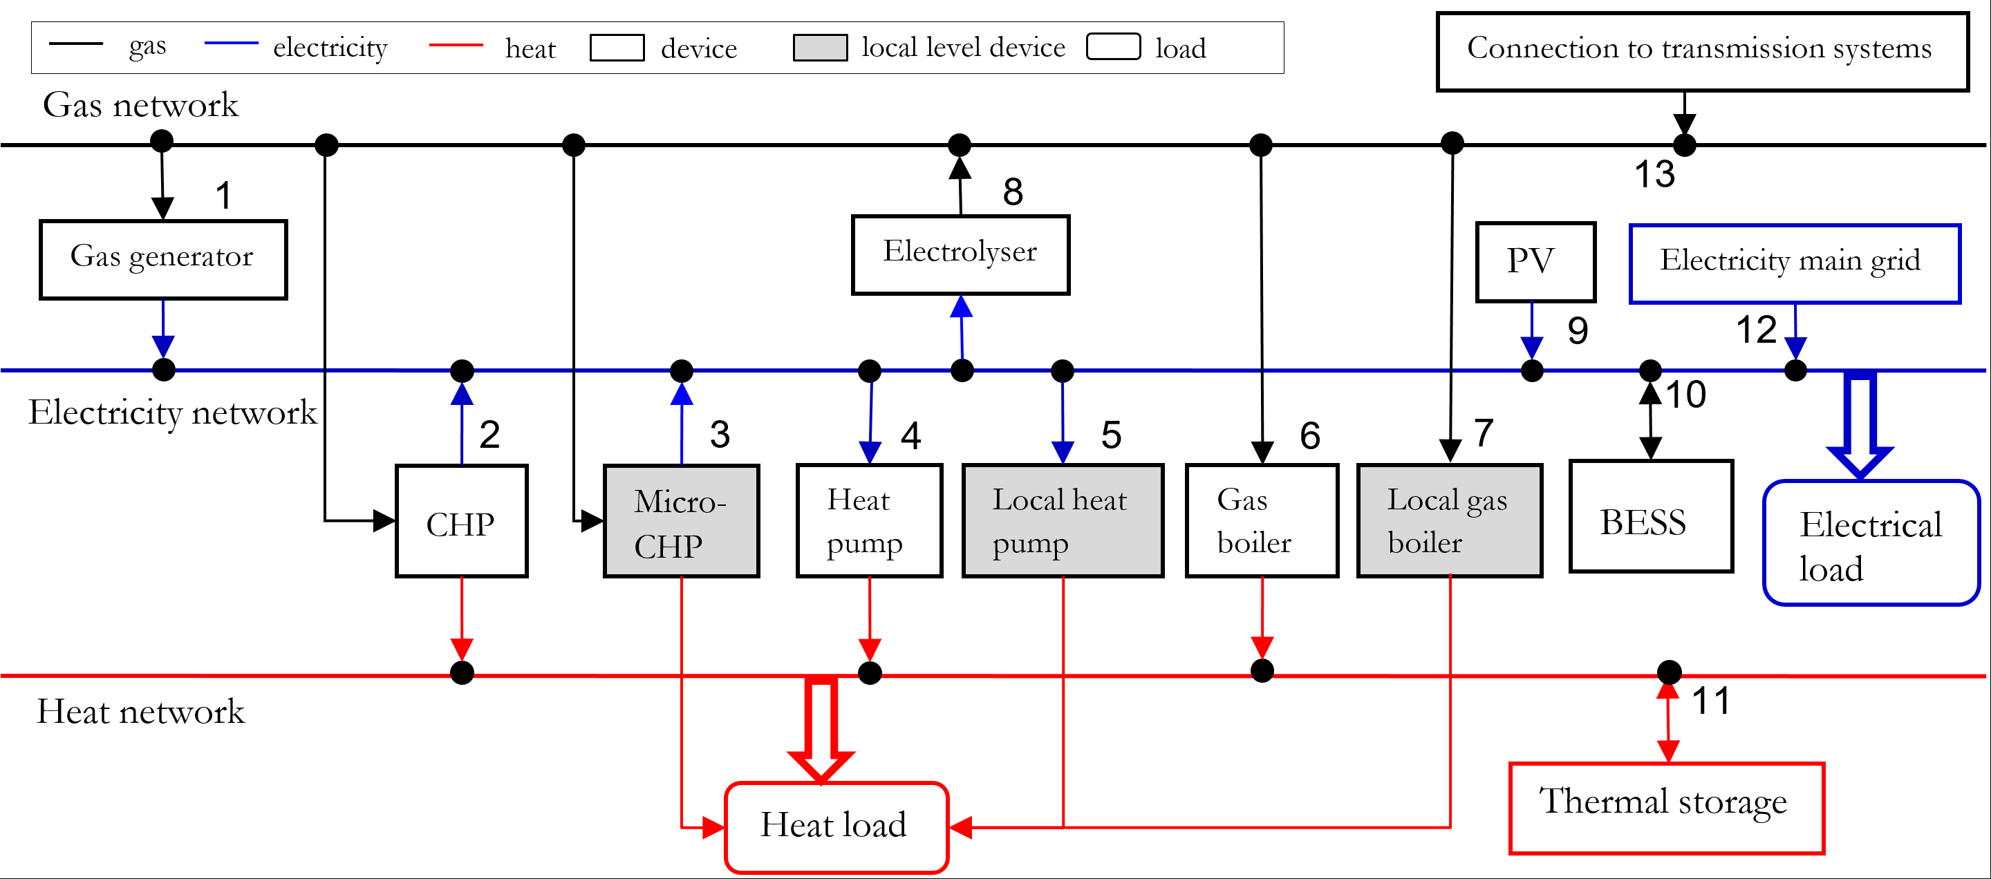
图3：多种能源存储与转换设备紧密耦合电力网、燃气网与供热网的示意图

