A innovated hydrogen energy storage system for urban residential

Abstract
Today, the world is undergoing a dramatic change in the way energy is produced, transformed, stored, and used. The public is becoming more conscious of the need to replacing fossil fuels with renewable energy. As the development of renewable energy sources in the power sector, solutions that effectively convert clean energy to the end-use sector need to be quickly introduced, particularly in the case of today's photovoltaic market. With the rapid urbanization progress in China, the already mature photovoltaic rooftop system allows an increasing number of urban buildings to transform into micro-solar farms. However, this type of micro- solar farms station rarely only use the battery for its power storage due to cost issue but instead rely on the electricity distribution grid which will certainly also bring fluctuation to the grid system. This situation calls for alternative energy storage in urban residential buildings. Hydrogen storage has become a promising solution with the developing fuel cell technology and hydrogen storage.
In this paper, we introduce a hydrogen storage system for urban residential buildings, commercial buildings, and off-grid housing. The system integrated with a compression and storage system for hydrogen, a high-efficiency polymer electrolyte membrane fuel cell (PEMFC), power electronics (e.g. DC-DC inverter), and an optional DC energy storage system (e.g. battery). By connecting with any rooftop PV system, each system can provide over 900 kWh of green electricity enough to power an average household for 45 days.

新型城市住宅储氢系统

摘要
随着可再生能源生产技术和市场的发展，将清洁能源有效转化并储存的解决方案越来越重要，特别是在目前的光伏能源领域。因光伏成本降低、电网调峰和清洁能源需求等促使以氢能作为光伏电能储存的技术的发展，但是目前该技术仍面临较多问题如氢的储存、运输问题等。目前已有的小型家用光伏制氢储能系统中多以固态合金储氢，除氢释放技术困难外，还造成储能成本上升。本文中聚焦于城市住宅区域、独立电网区域及备用电源领域等设计了一种新型光伏制氢储能系统。该储能系统集成了氢气压缩储存模块、高效聚合物电解质膜燃料电池（PEMFC）模块、光伏电源模块和电解制氢模块，本文中利用创新的氢存储技术实现了更高效率的能源转换和储能成本降低，通过连接到光伏系统，每个系统可以储存并提供超过900千瓦时的绿色电力。

A innovated hydrogen energy storage system for urban residential

Background
The household hydrogen storage system has existed for almost 2 decades, but its market growth is relatively slow compared with other energy storage technology, such as lithium batteries, mainly due to public concern of safety and cost issues. However, the situation is rapidly changing. Since 2009 Panasonic in Japan first introduced their “Ene-Farm” system to the market which generates hydrogen gas from the chemical reaction between water and methane gas. The hydrogen gas is then used to generate electricity through PEMFC and waste heat is recycled for water heating. However, this system does not include hydrogen storage and not a 100 % green hydrogen-based power system. In June 2020, Home Power Solutions (HPS) in Berlin announced their first green hydrogen-based power and heating system Picea(R) with up to 300 kWh gas hydrogen storage capability. In the same year, LAVO introduced their integrated hybrid hydrogen battery system with 40 kWh metal alloy hydrogen storage. It is clear, today hydrogen is slowly being accepted as a household energy storage solution.
However, there are still few issues for the hydrogen storage system before it can be competitive in the market. The first is the system storage capability. Currently, in the market we see system include the design of low-pressure gas tank or metal alloy hydrogen storage. The former design uses mature gas tank technology which in order to ensure storage capability, compromises the system size. The later design reduces the system dimension and ensuring system safety, but sacrifices the storage capability. The overall system energy efficiency is another main issue that eventually detriment the cost. Compared with the traditional battery storage system with up to 90% of overall system efficiency, a hydrogen storage system can lose around 50% of the energy when converting the stored hydrogen back to electricity through PEMFC.

Our Solution
Our system focus on the issues above. Instead of applying solid-state hydrogen storage which is known to be an unmatured technology with low storage capacity and strict activation requirements, our system includes 4 x 70 Mpa high-pressure gas vessels. The relatively more mature gas storage technology ensures our system’s reliability. The high-pressure design also makes up of the low storage capacity and enables up to 15 kg of hydrogen storage in each vessel. All components are integrated into an impact system with a dimension of 1700 x 1300 x 1000 mm. During a power shortage, the system is able to provide 900 kWh of energy to a household, enough to last for 45 days. The system can also act as a temporary battery for the rooftop solar array, allowing the residence to have access to this solar energy even at night. Our high-efficiency fuel cell allows 50 kWh of daily output, enough for average household energy demand with excess electricity sell to the grid during peak hours.
Table 1. Technical Specification
System Dimentions (H x W x D) | 1700 x 1300 x 1000 mm | Maximum Output Power | 5 kW
High Pressure Vessels | 4 | Electrical Energy Hydrogen Storage (short-term daily usage) | 50 kWh
Vessel Pressure | 70 Mpa | Electrical Energy Hydrogen Storage (long-term seasonal usage) | 900 kWh
Vessel Weight | 30 kg/each | Operating Voltage Range (single phase system) | 350 – 560 v
Vessel Dimentions (Radius / length) | 200 mm / 1000mm | Operating Voltage Range (three phase system) | 600 -980 v

System Design
The flow chart of the system is shown in Figure 1. In the morning, the rooftop solar array generates energy for household demand. However, during this period of the day, the urban residence typically has the minimum electricity demand while the selling price to the electricity grid is low. A typical stand-alone system stores the solar energy use battery whose cost increases dramatically with its size. A hydrogen storage system instead converted the excess solar electricity to hydrogen using the electrolyzer and stored it in our high-pressure gas vessels by an integrated compression system for later use. The solar system is also charging a small traditional Lithium-ion battery for the fast response time and as a start-up power source during power shortage. At night, the stored solar energy is released through the fuel cell which produces electricity. A power conversion system (DC-DC converter) is used to regulate the electrical output from the fuel cell, providing a matching and steady input for the hybrid inverter. The waste heat generated during the entire process can be stored in the household hot water tank through a heat exchange system, further promote the energy efficiency of the entire system.
In conclusion, the hydrogen storage technologies are ready. Rapid market growth is what now needed to achieve the necessary cost reductions and ensure the economic competitiveness for the household hydrogen storage system.
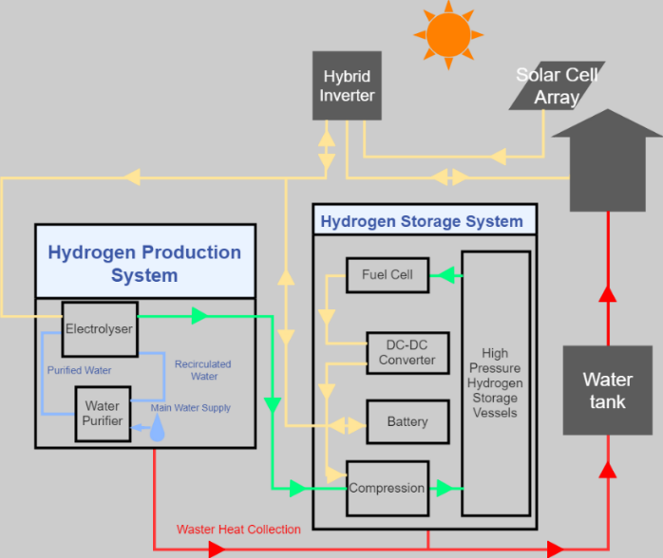
Figure 1. Flow diagram of the system

